# ERA User Guide: Searching for an Evacuee without ID

1. Navigate to <https://ess.gov.bc.ca/>

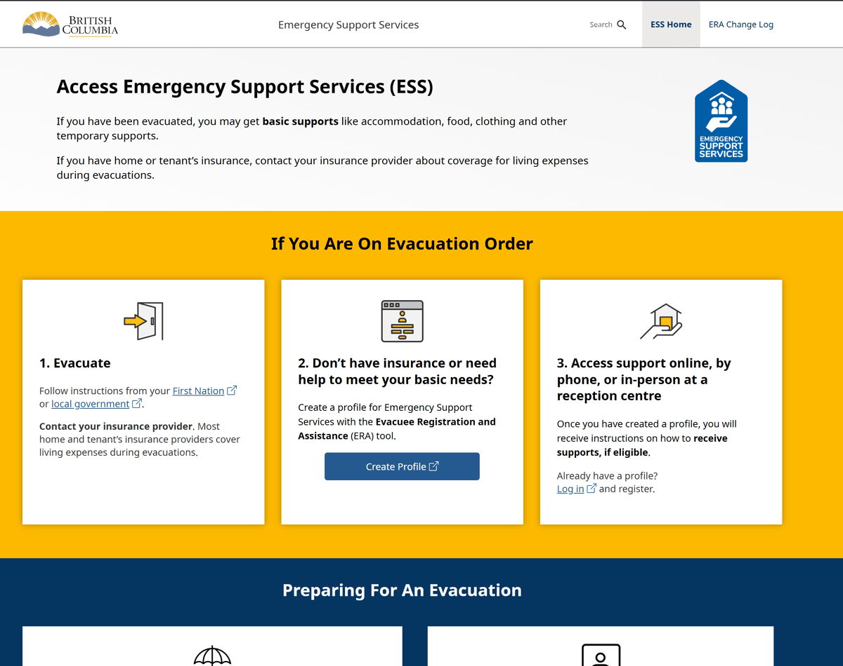

1. Scroll down and click "Responder Portal Login"

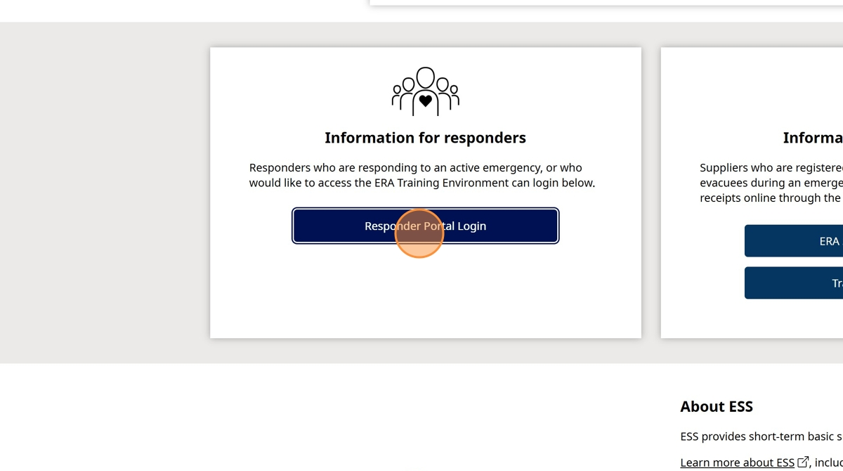

1. Click "Log in to Live"

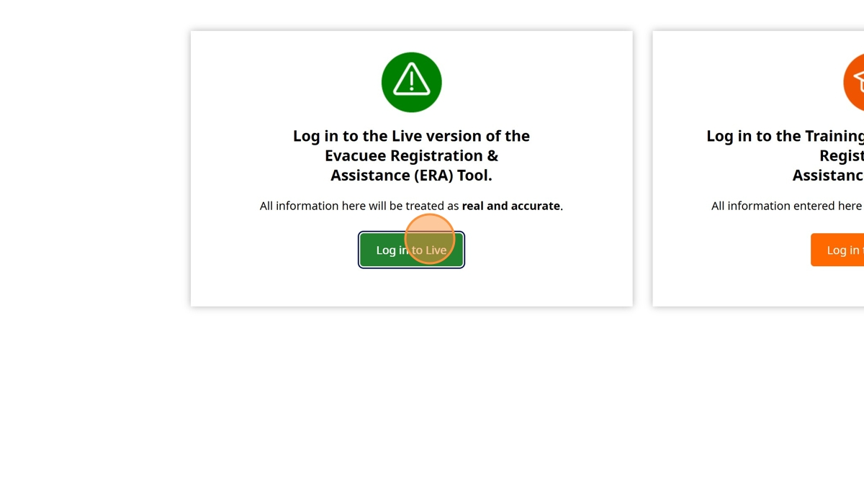

1. Enter your BCeID

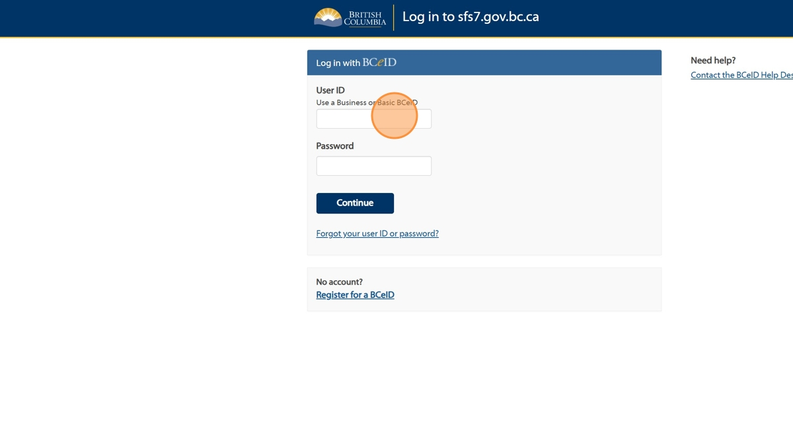

1. Enter your Password

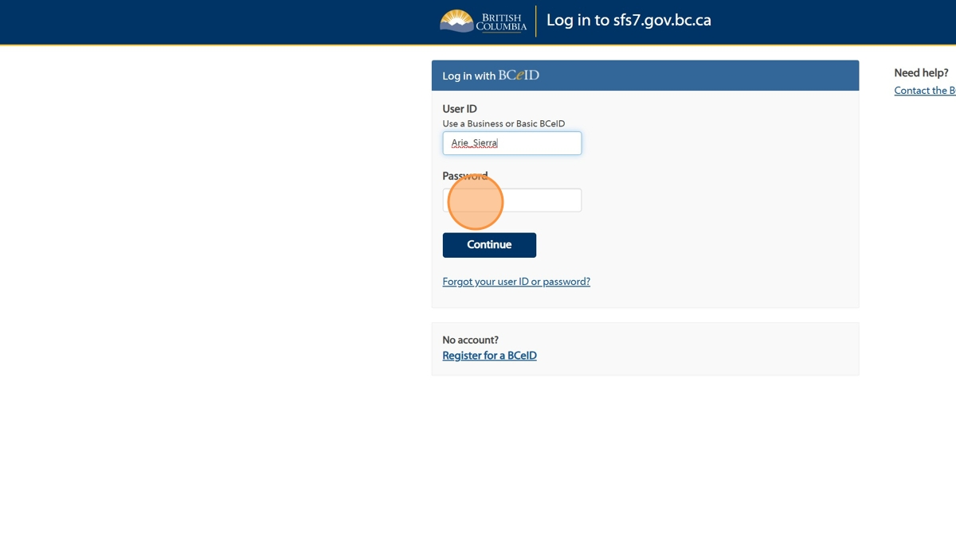

1. Click "Continue".

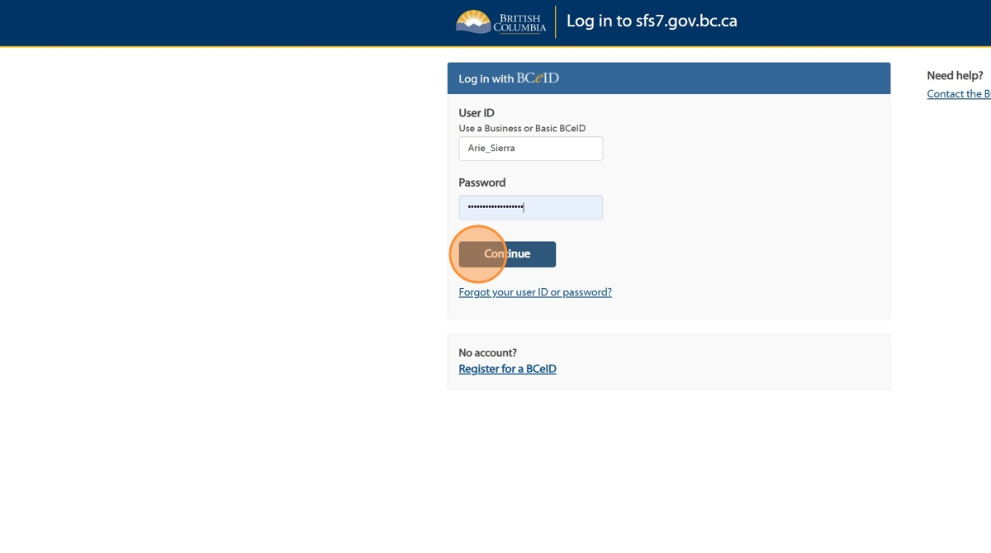

1. Click "Sign in to the Task #"

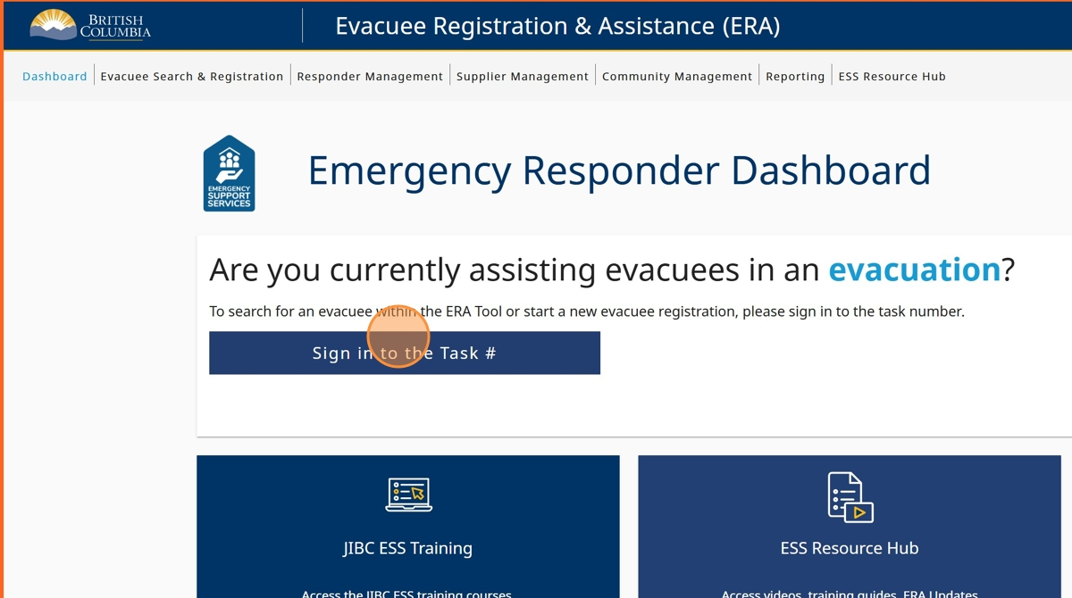

1. Click the "Enter Task #" field and enter your task number

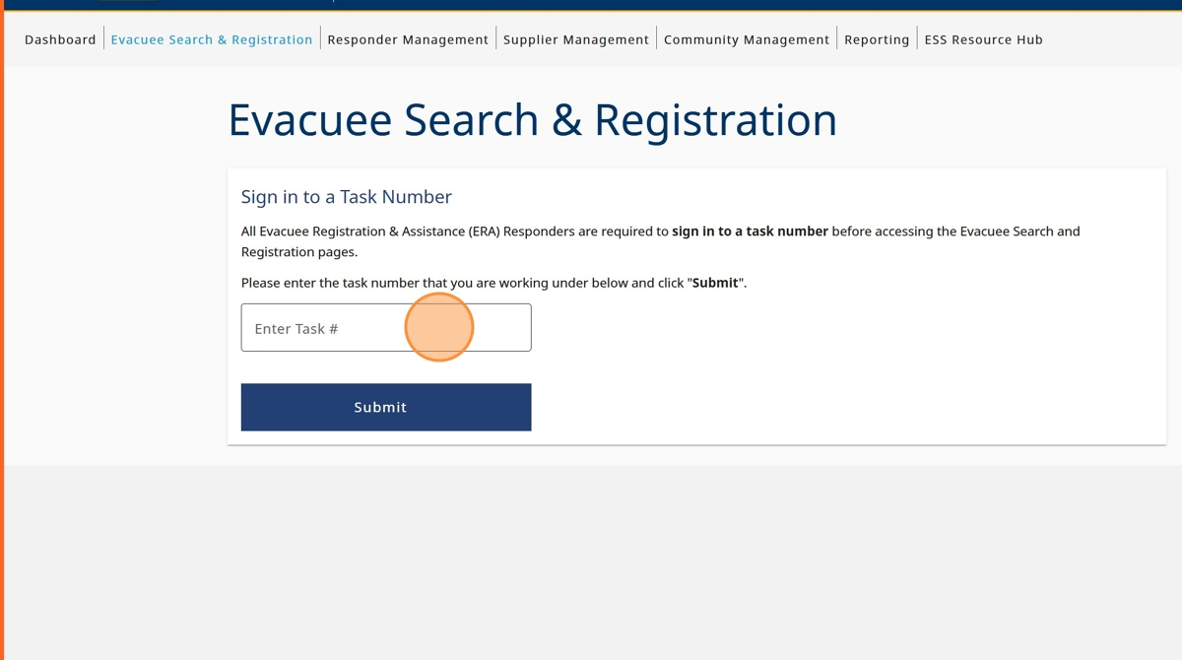

1. Click "Submit"

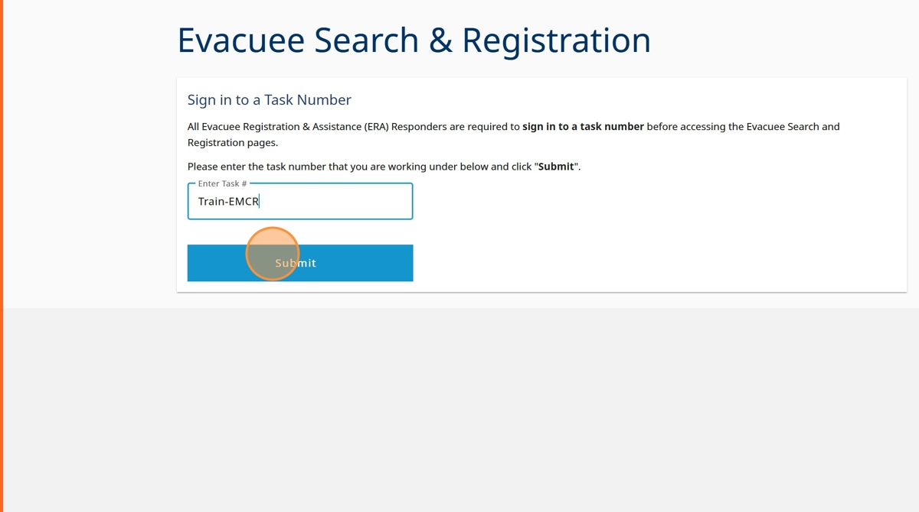

1. Click "Sign in to Task"

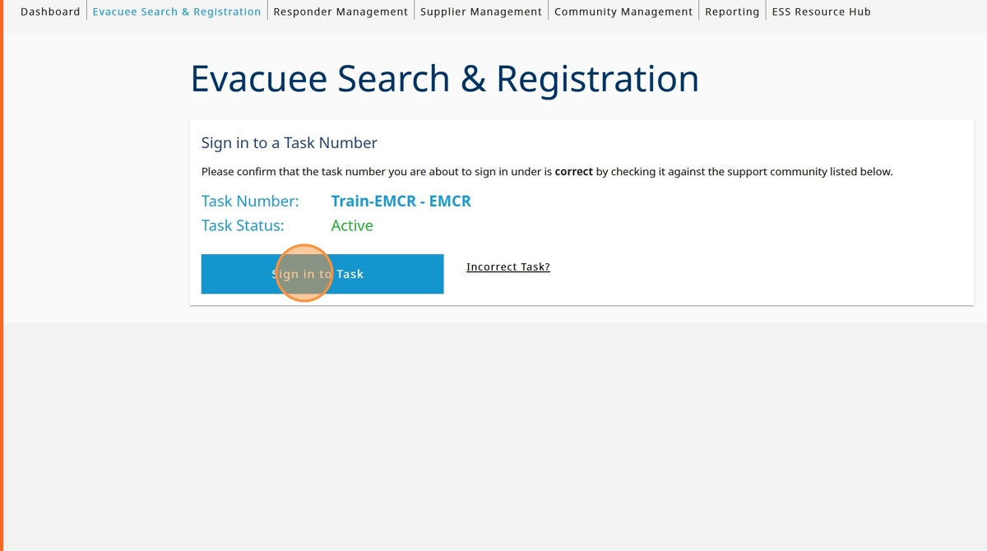

1. Click the "I am doing evacuee registration & extensions" field.

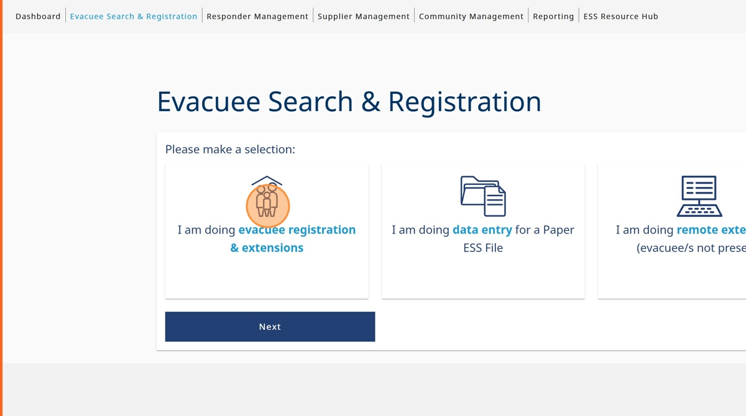

1. Click "Next"

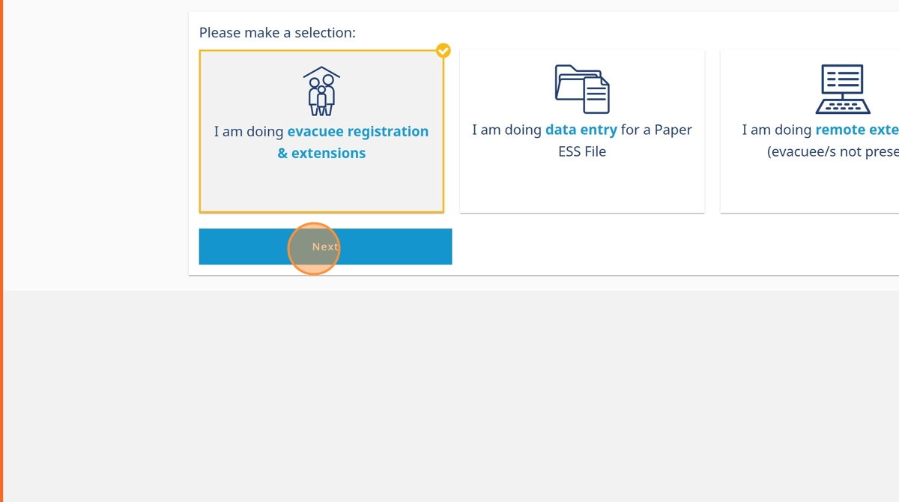

1. Click the "No - the evacuee did not provide valid government issued photo identification." field.

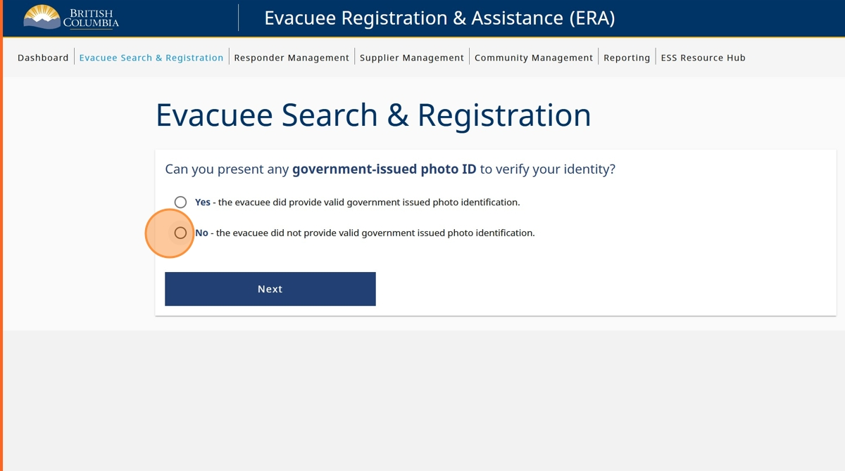

1. Click "Last Name" and enter evacuee last name

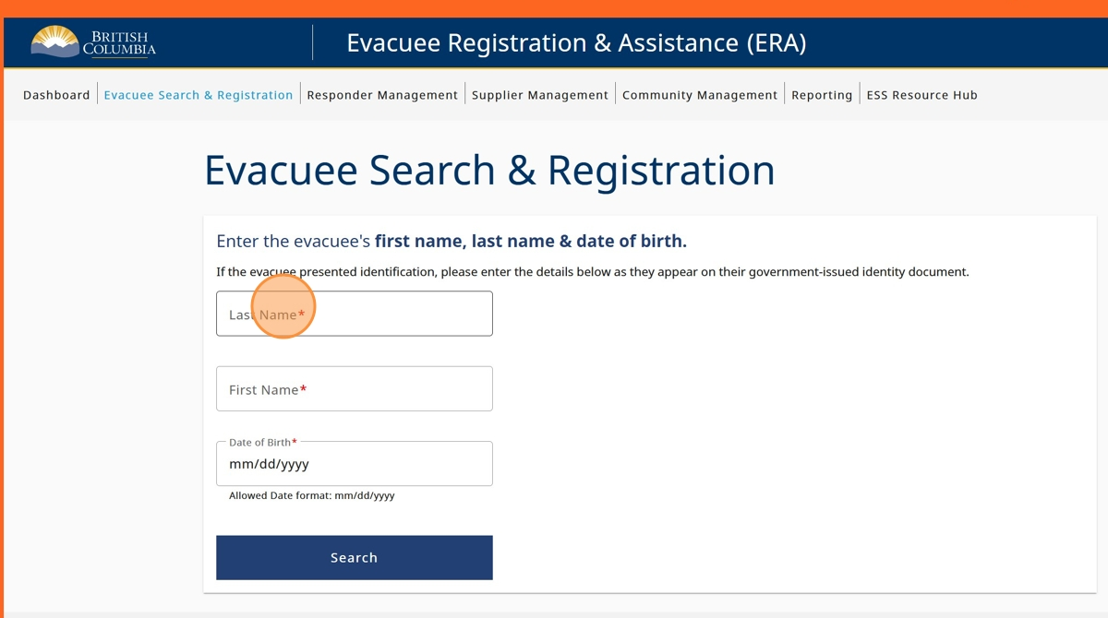

1. Click "First Name" and enter evacuee first name

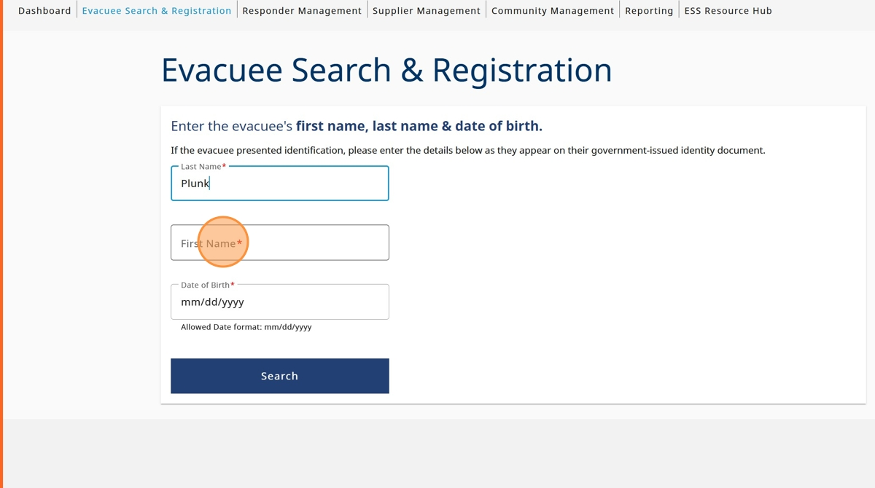

1. Click the "Date of Birth" field and enter evacuee date of birth

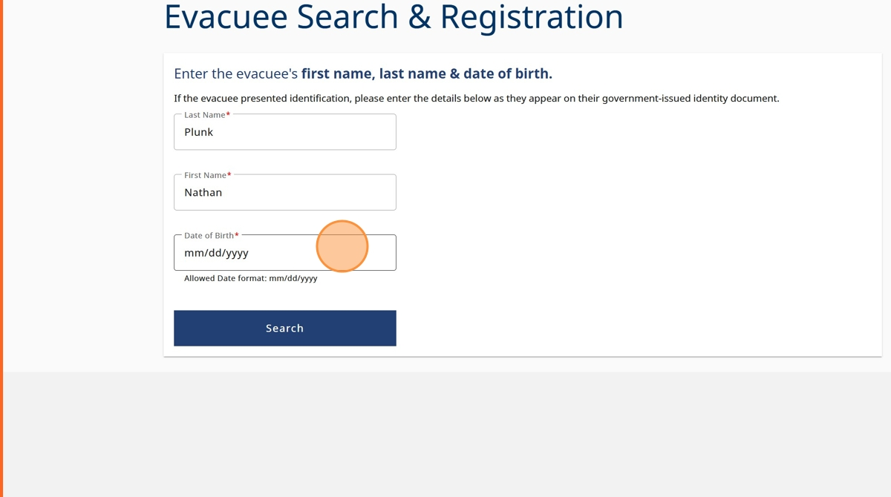

1. Click "search"

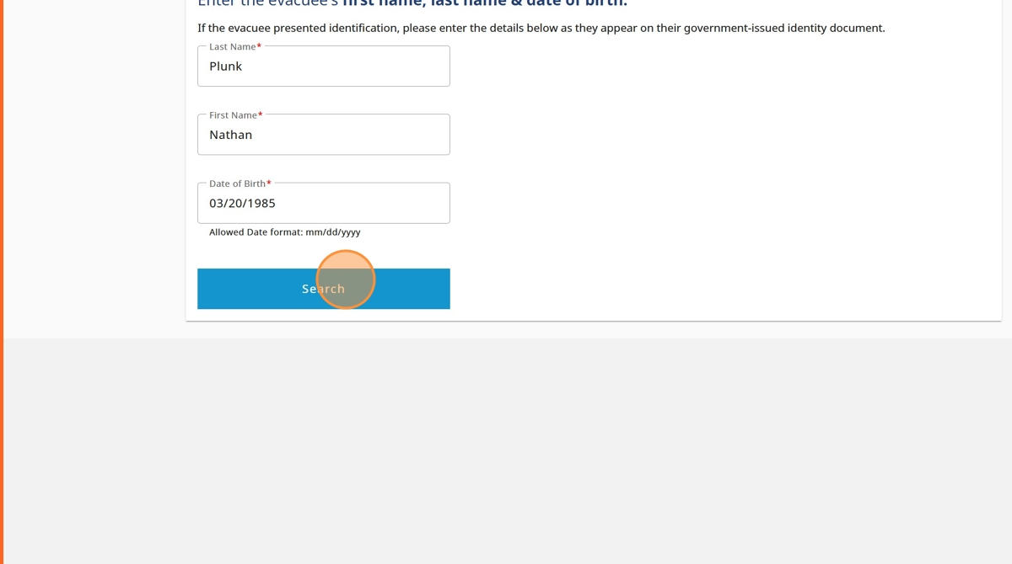

1. After viewing the search results, click on the name of the profile you'd like to view

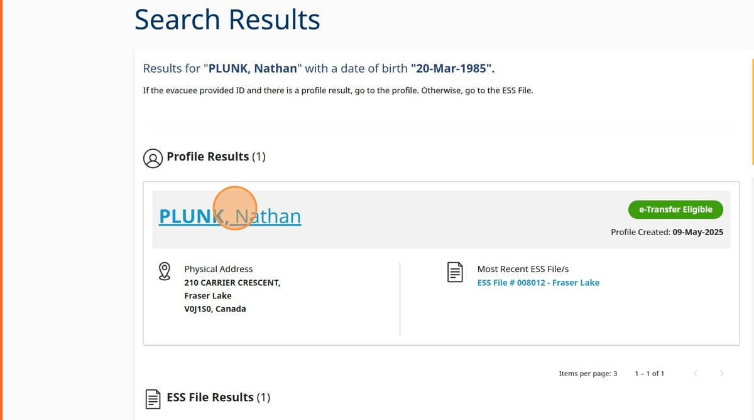

1. Select the reason you are accessing the evacuee profile

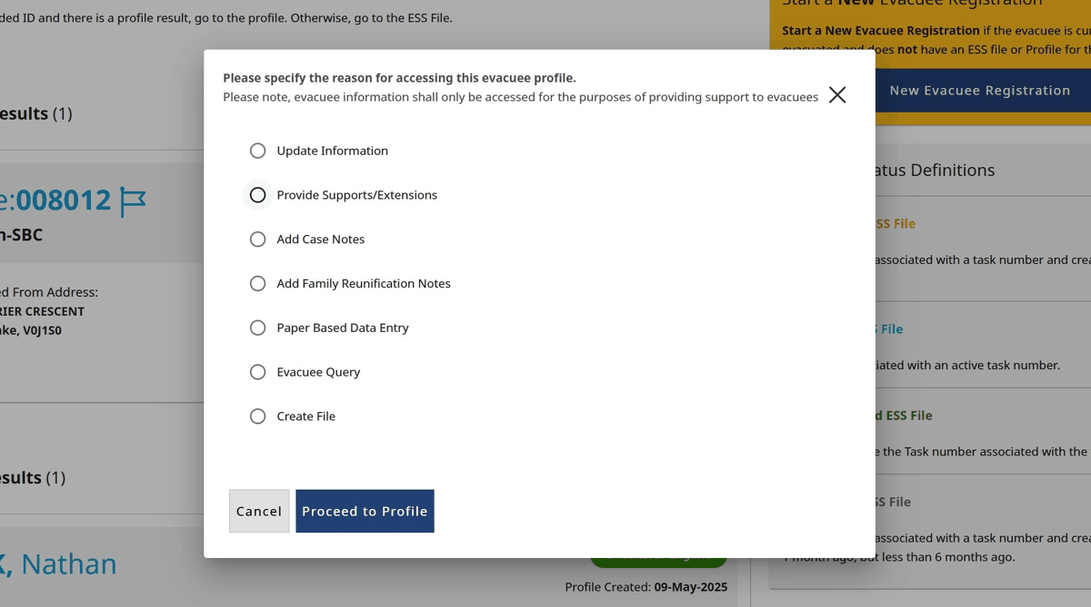

1. Click "Proceed to Profile"

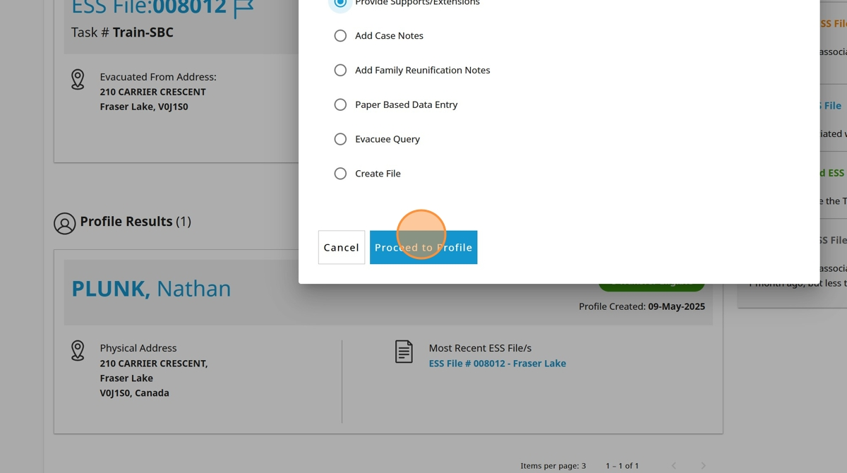

1. The evacuee will now need to provide answers to their profile security questions. Click on the Answer field to type the answer

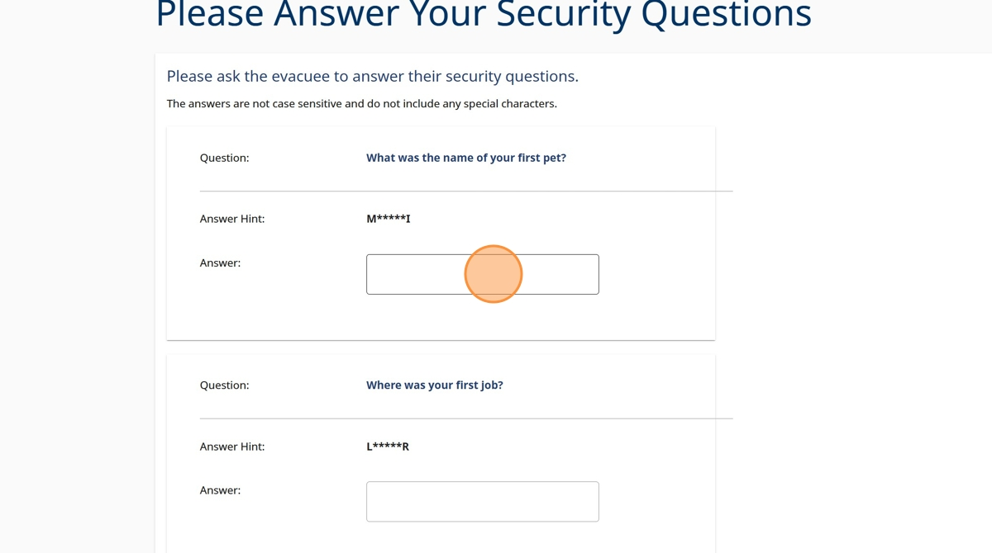

1. Click "Continue" once the evacuee has answered the security questions

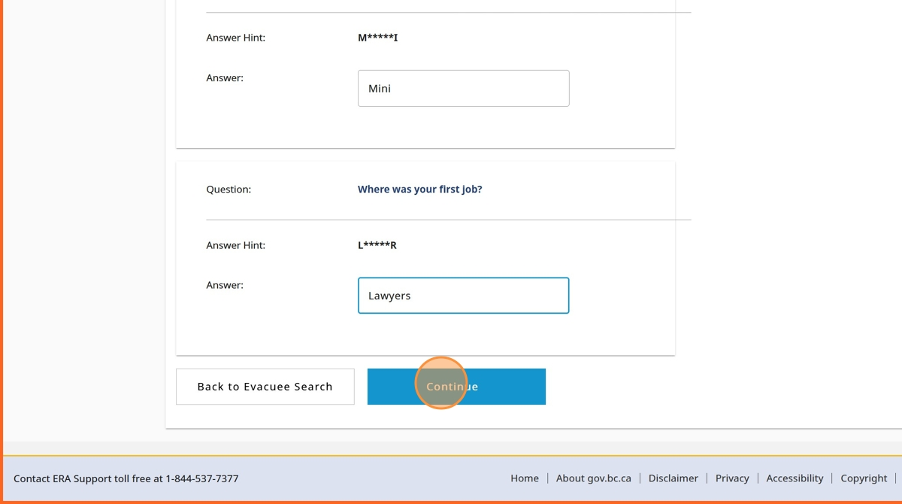

1. If any of the two answers are wrong, the evacuee will be asked to provide the answer for a third security question

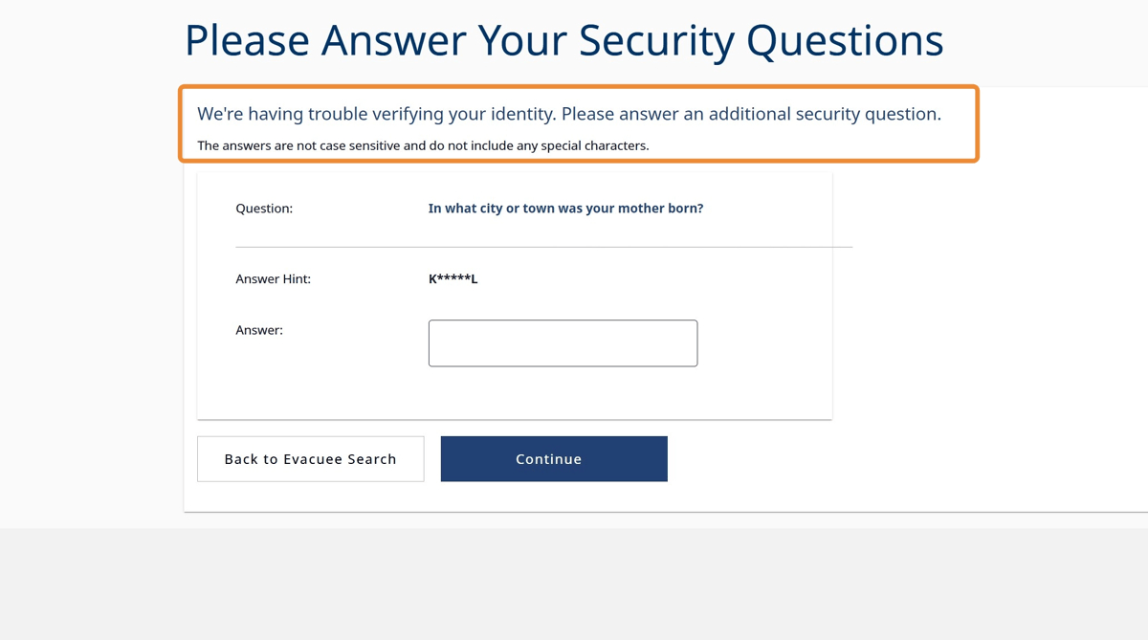

1. When the evacuee has correctly answered the security questions, you will be directed to the evacuee profile homepage

