# ERA User Guide: Searching for an evacuee with ID

1. Navigate to <https://ess.gov.bc.ca/>

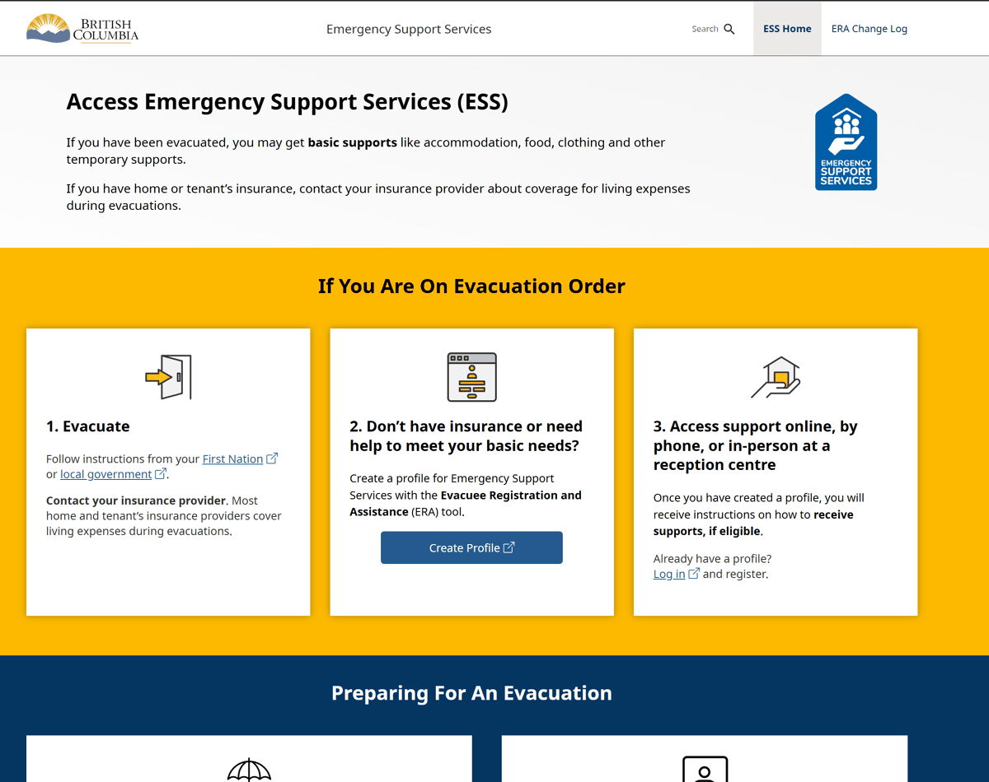

1. Scroll down and click "Responder Portal Login"

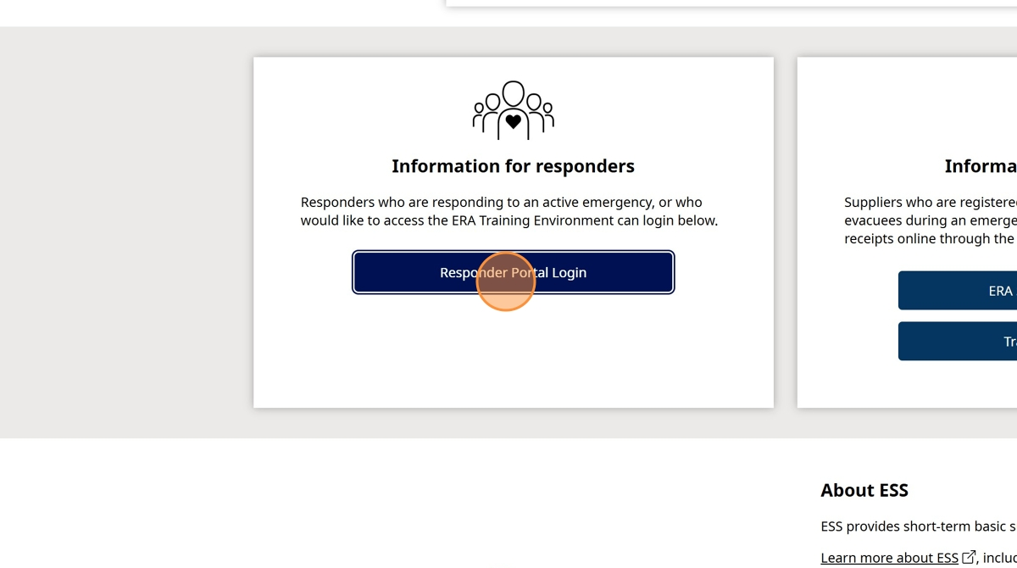

1. Click "Log in to Live"

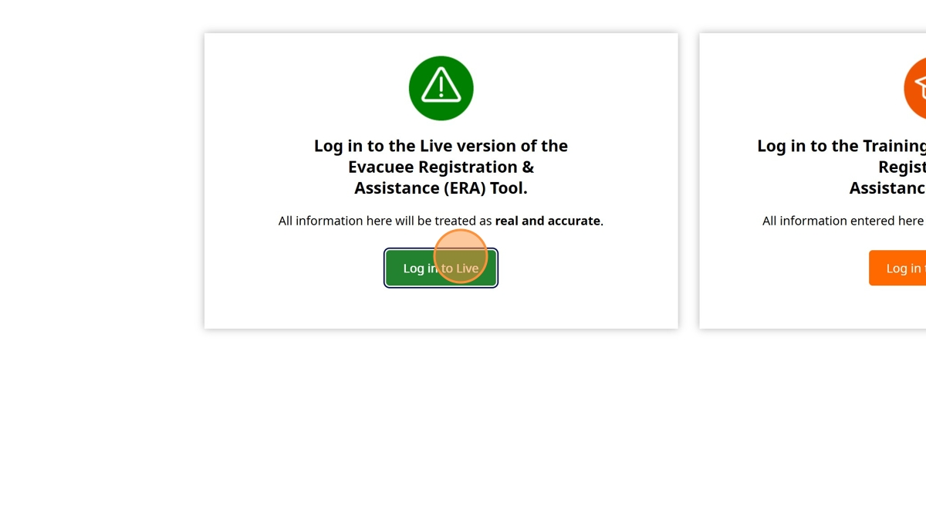

1. Enter your BCeID

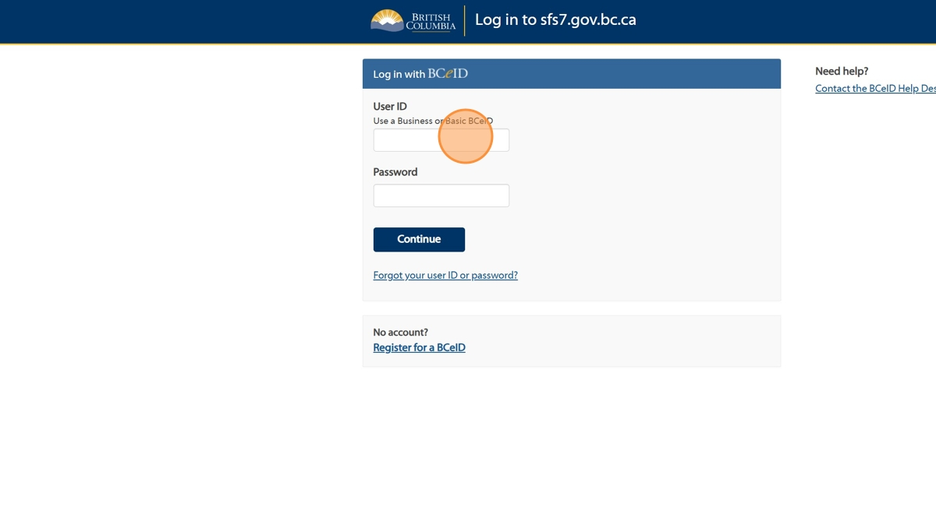

1. Enter your Password

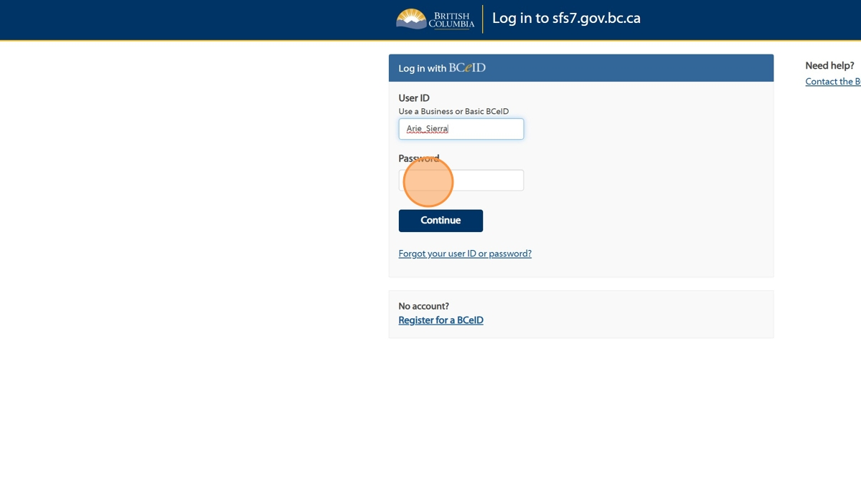

1. Click "Continue".

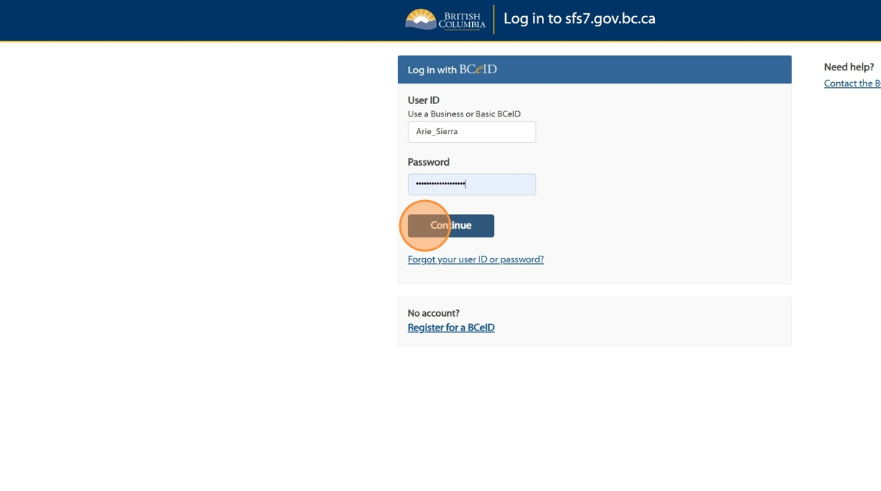

1. Click "Sign in to the Task #"

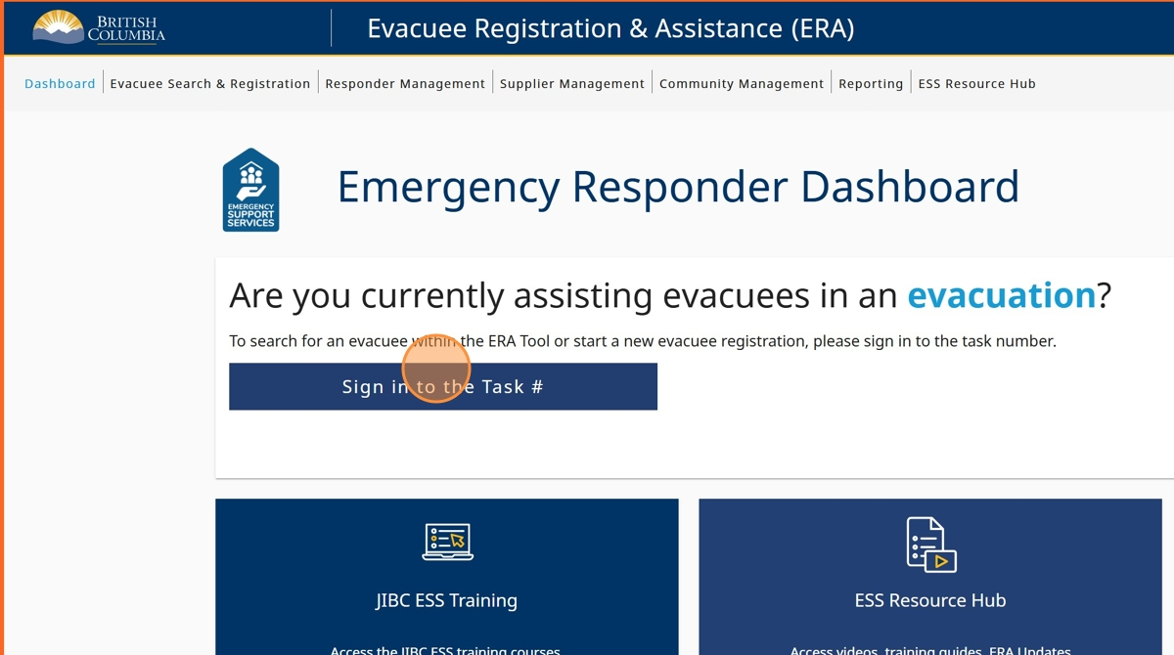

1. Click the "Enter Task #" field and enter your task number

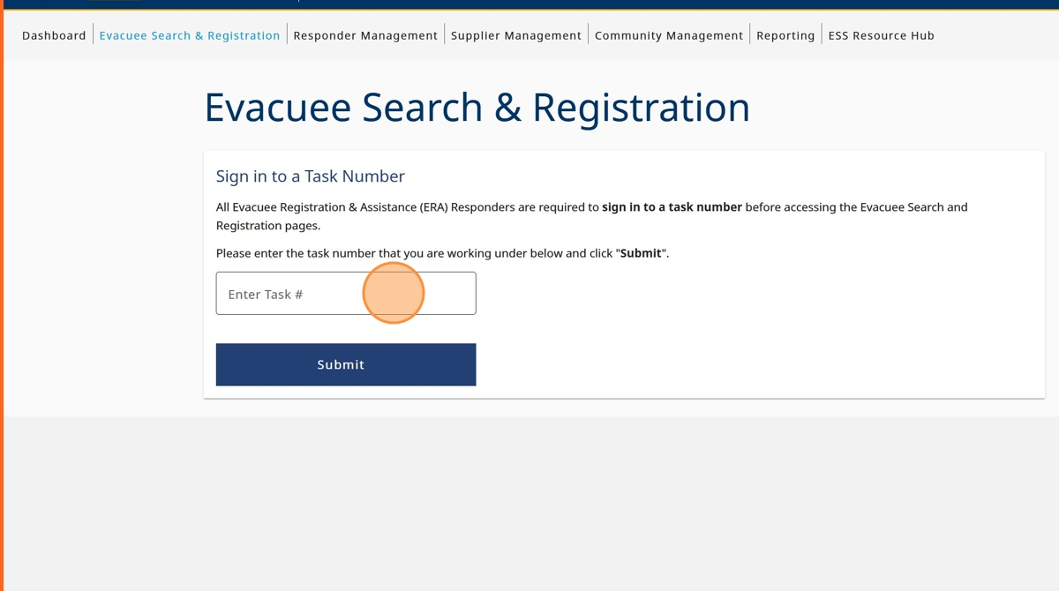

1. Click "Submit"

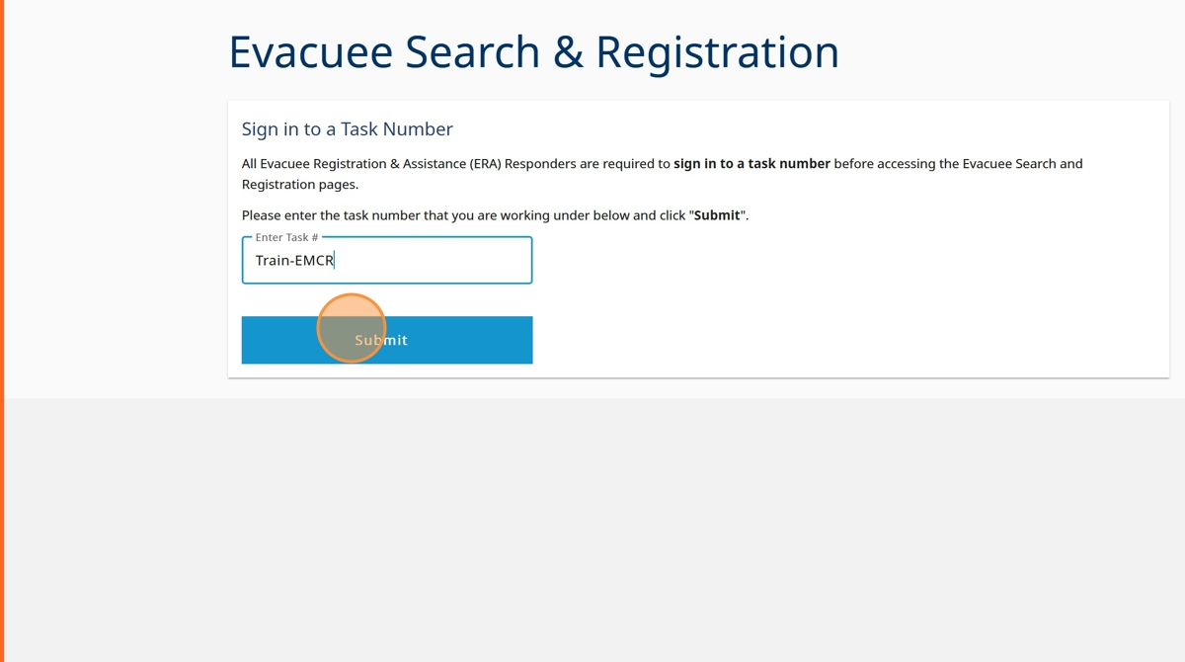

1. Click "Sign in to Task"

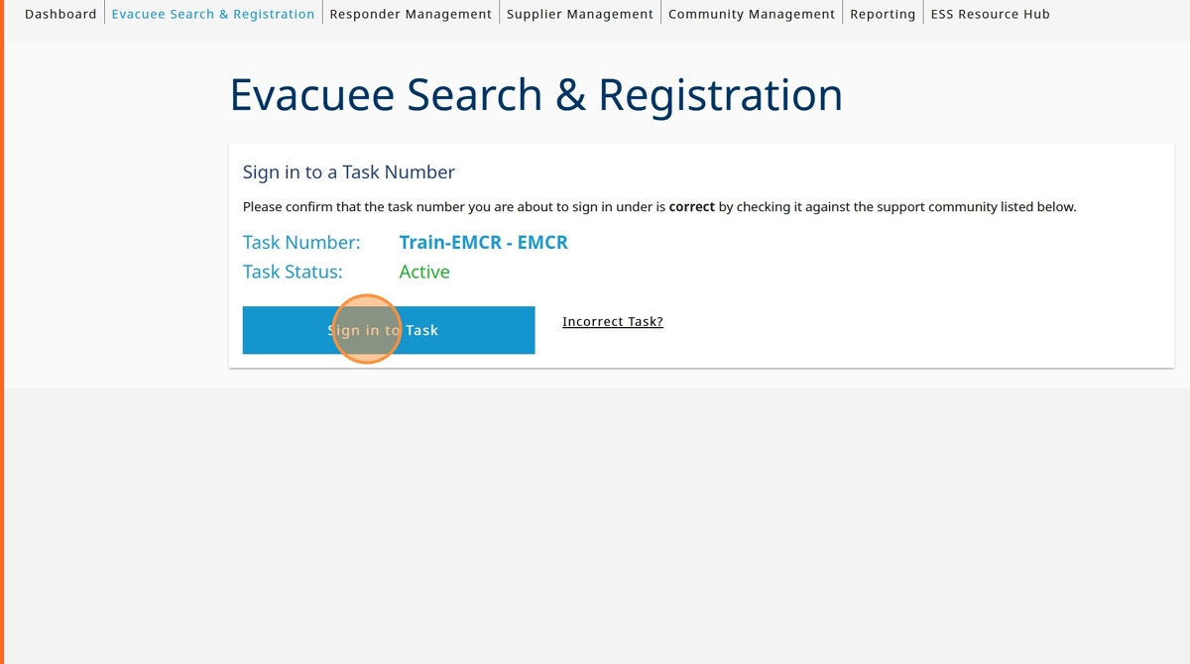

1. Click the "I am doing evacuee registration & extensions" field.

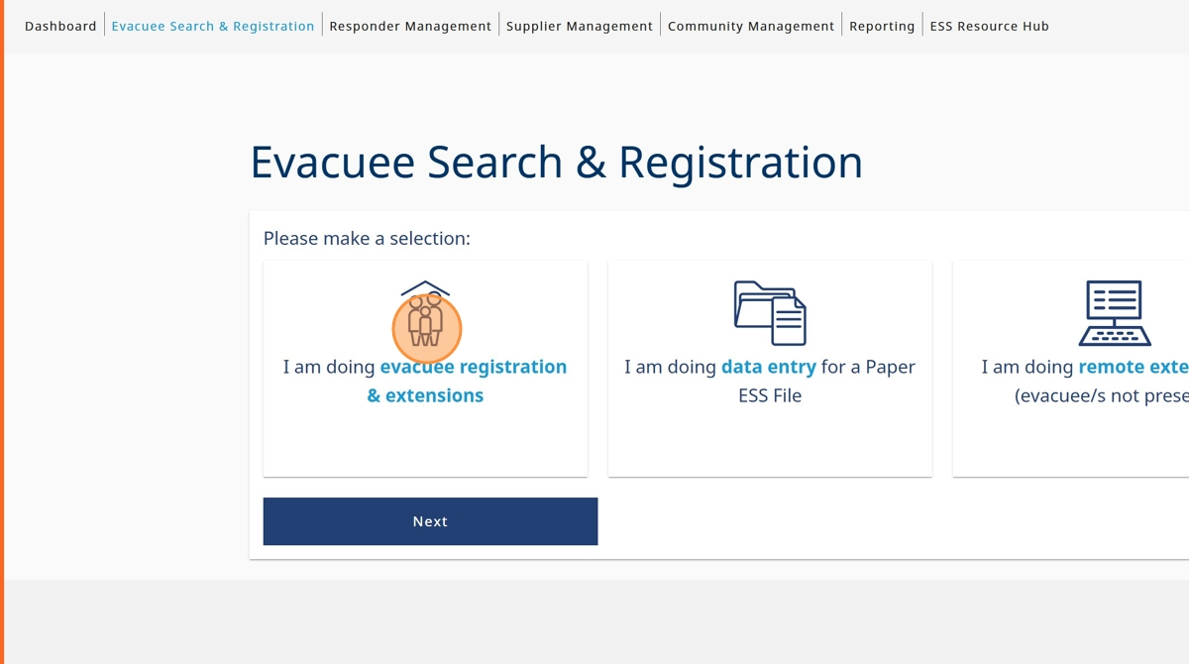

1. Click "Next"

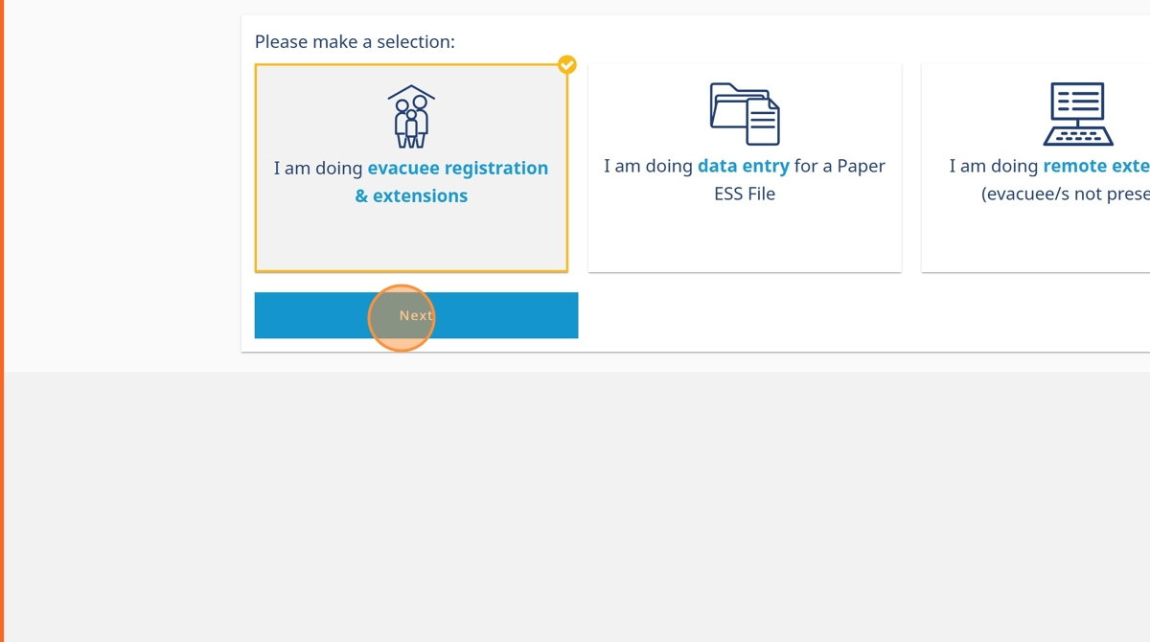

1. Click the "Yes - the evacuee did provide valid government issued photo identification." field.

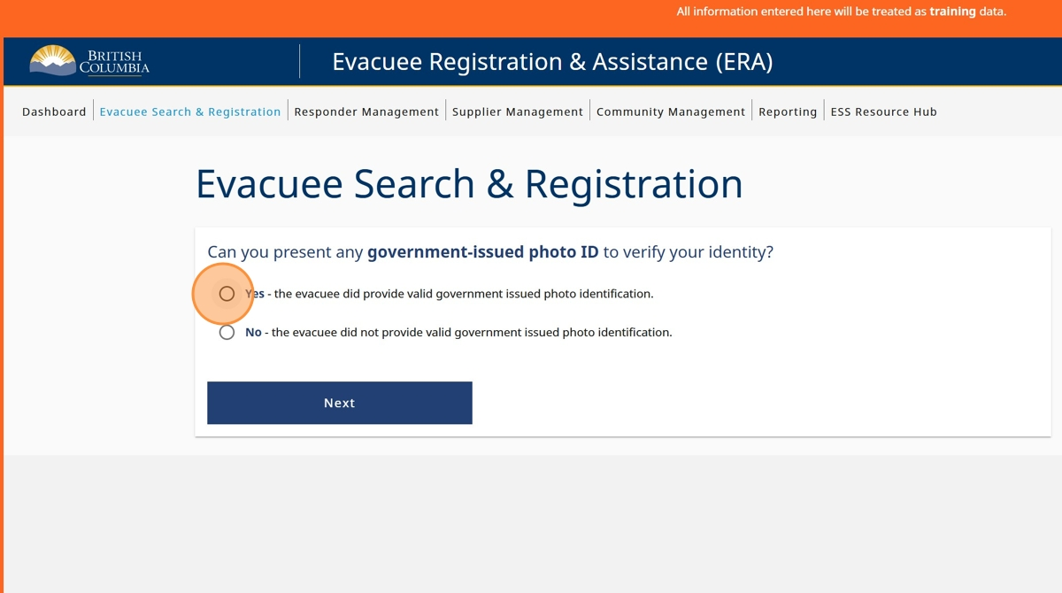

1. Click "Next"

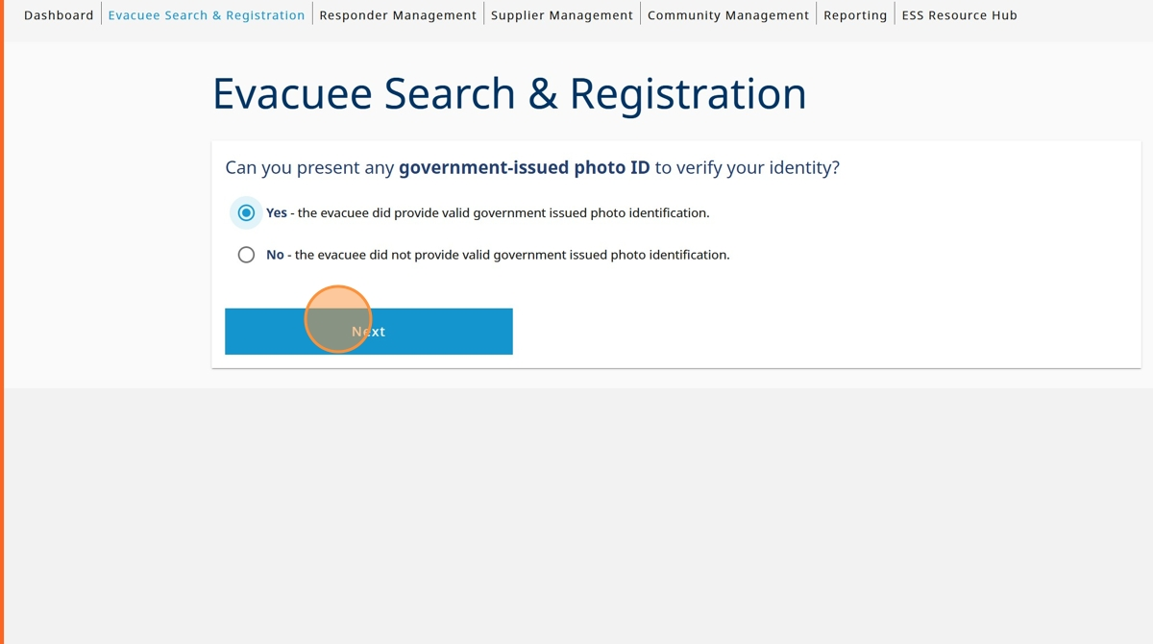

1. Click "Last Name" and enter evacuee last name

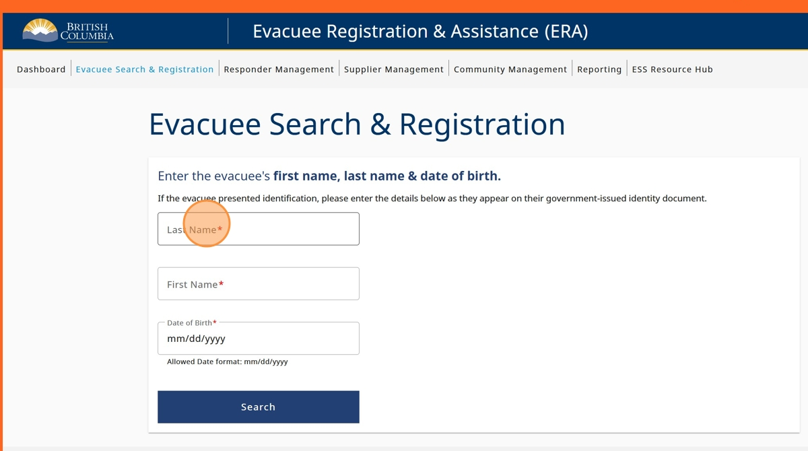

1. Click "First Name" and enter evacuee first name

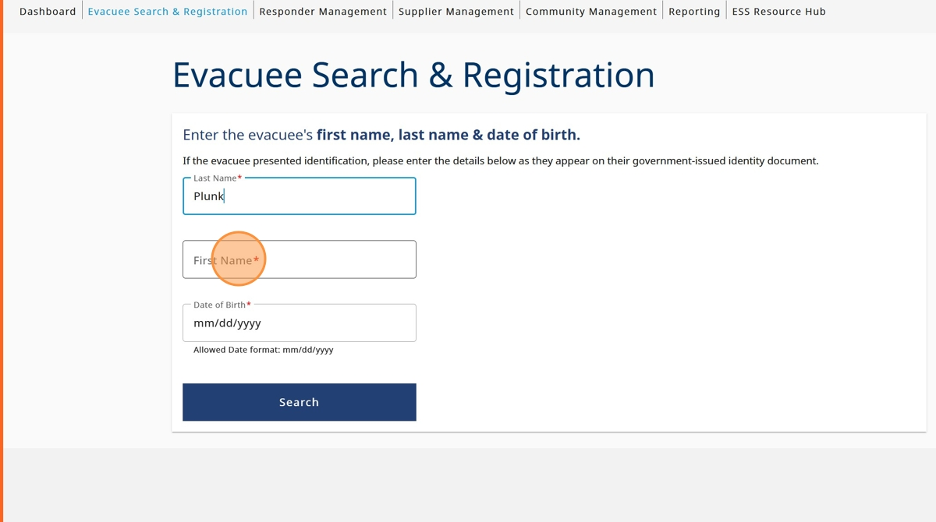

1. Click the "Date of Birth" field and enter evacuee date of birth

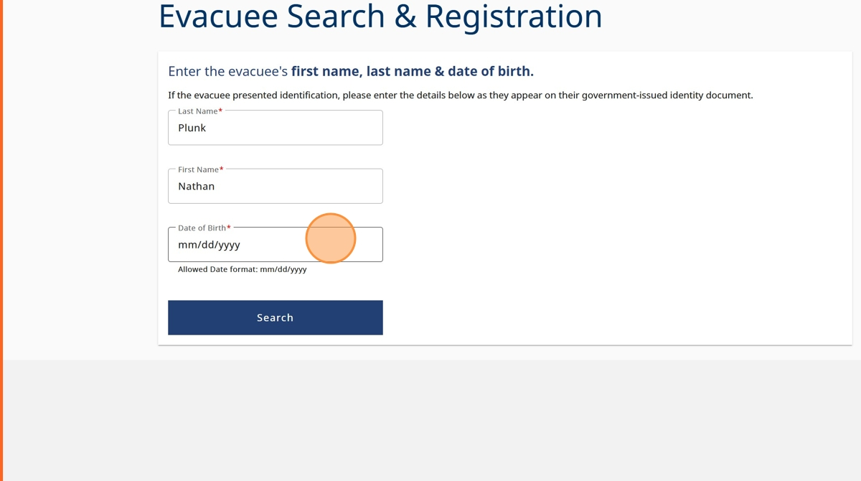

1. Click "search"

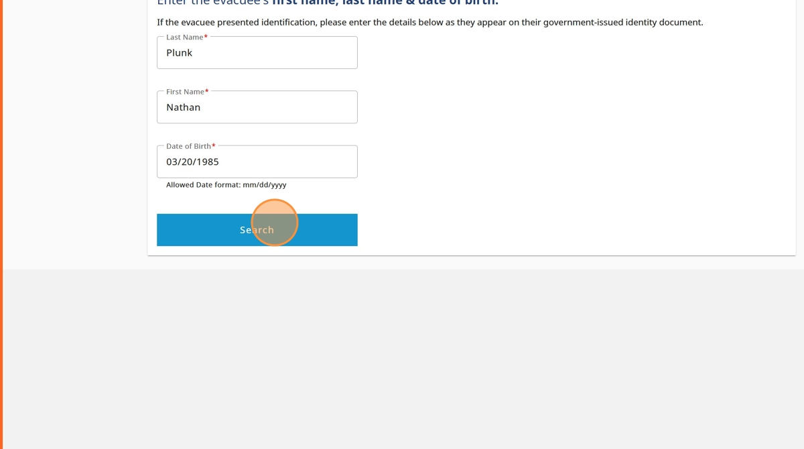

1. After viewing the search results, click on the name of the profile you'd like to view

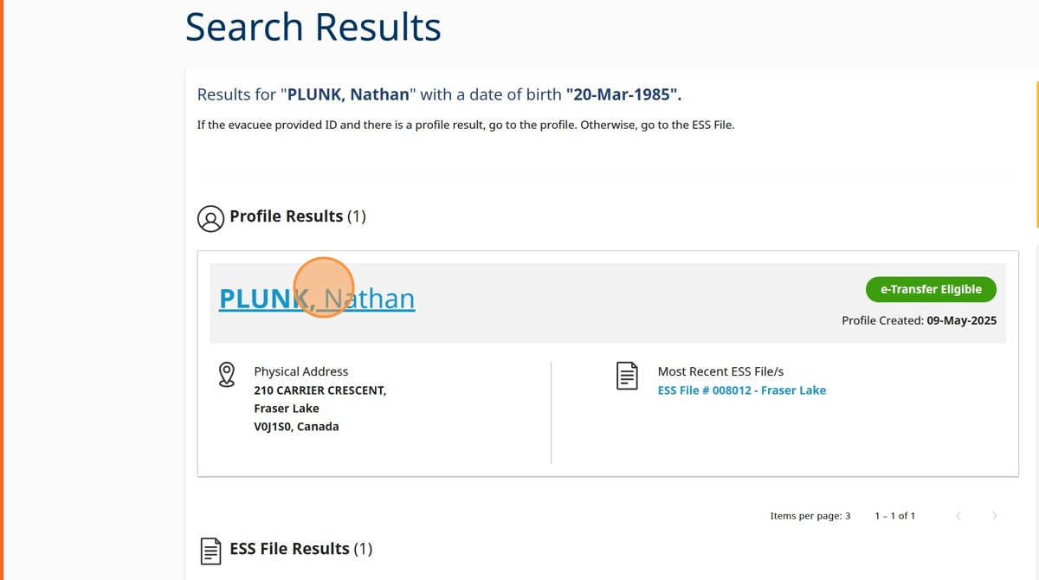

1. Click on the reason why you are accessing the profile

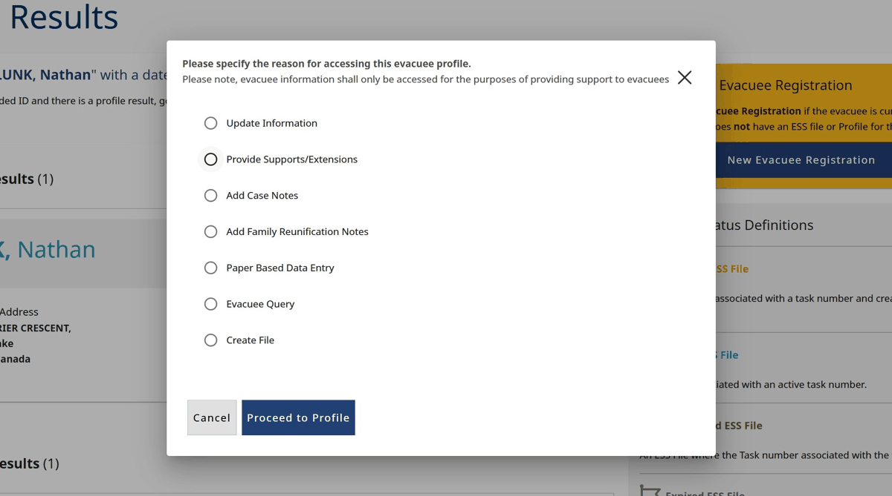

1. Click "Proceed to Profile"

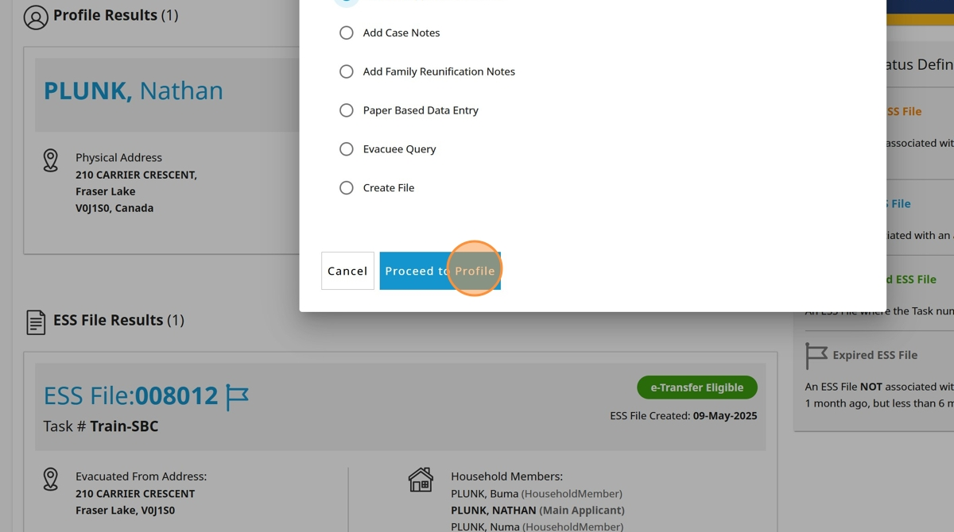

1. You will now be directed to the evacuee profile homepage

