# ERA user Guide: Log-in to ERA Profile using mobile device

1. Open the "BC Services Card App"

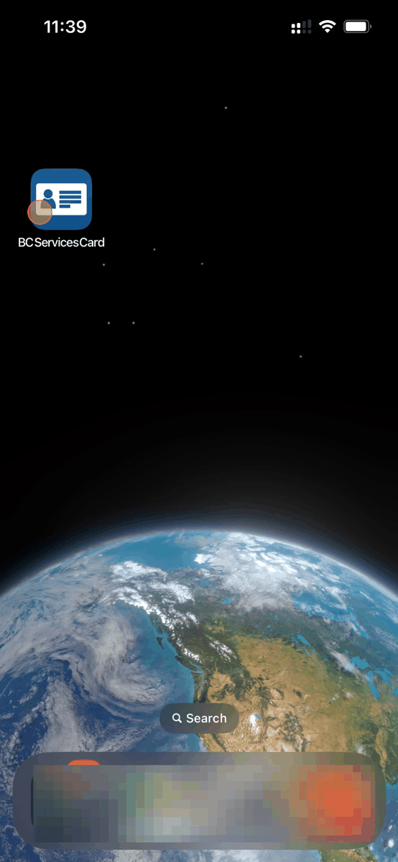

1. Click "Services"

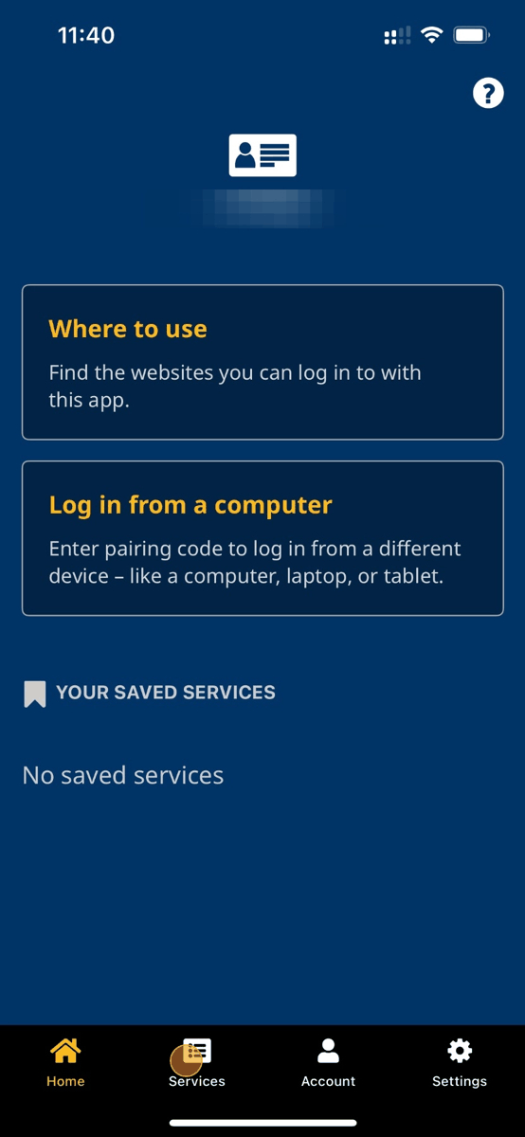

1. Click "Evacuee Registration and Assistance"

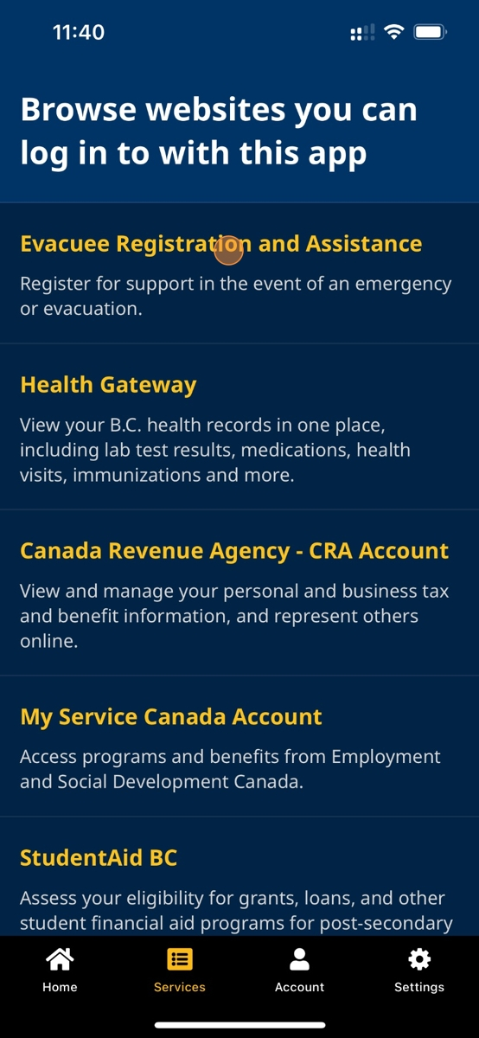

1. Click "Go to Evacuee Registration and Assistance"

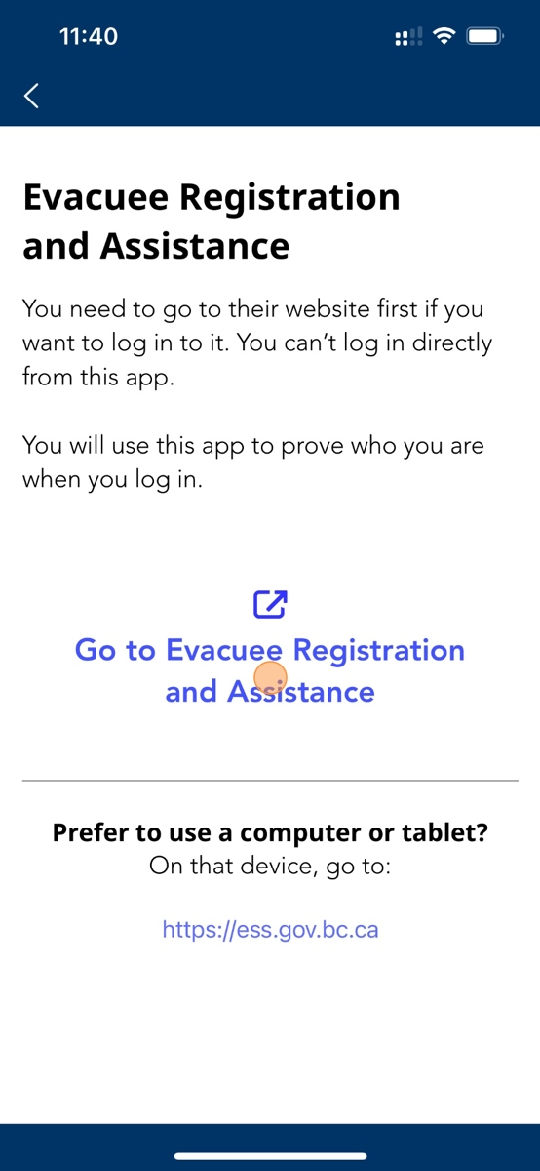

1. You will be re-directed to the [ess.gov.bc.ca](https://ess.gov.bc.ca) website

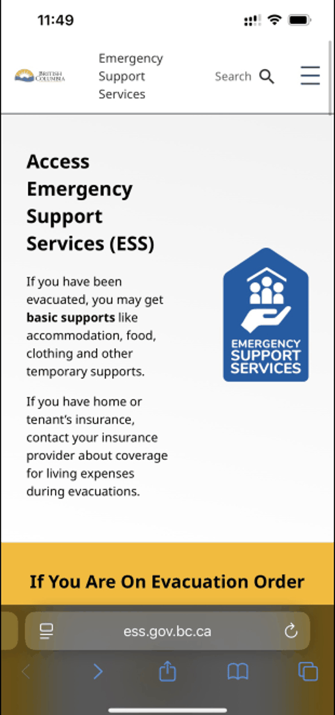

1. Scroll down and click "Log-in"

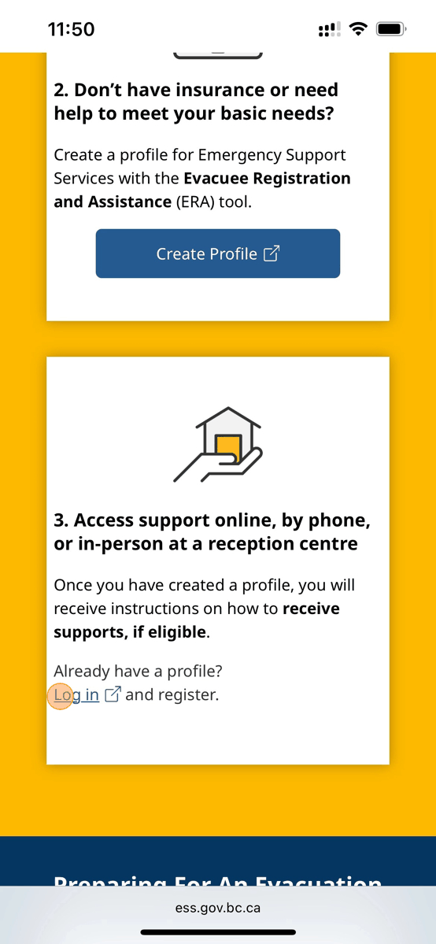

1. Click "BC Services Card app"

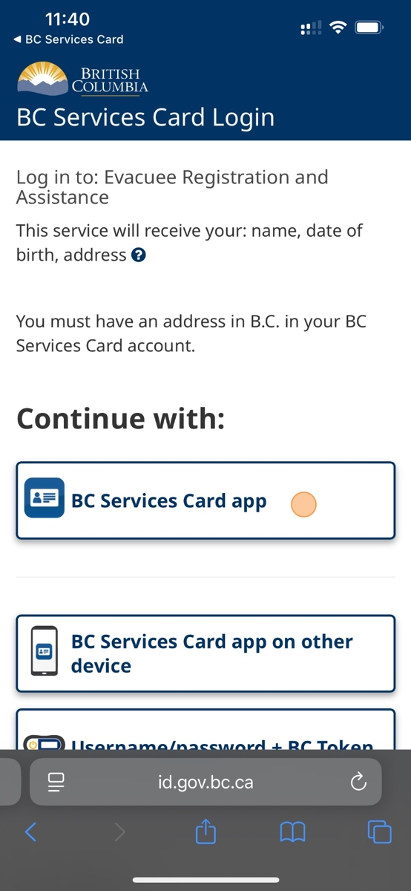

1. Click "Open"

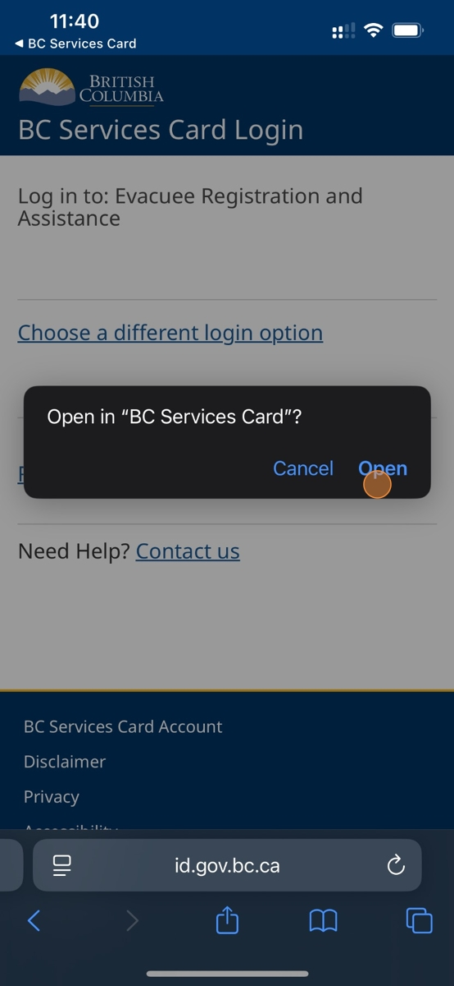

1. Click "Continue"

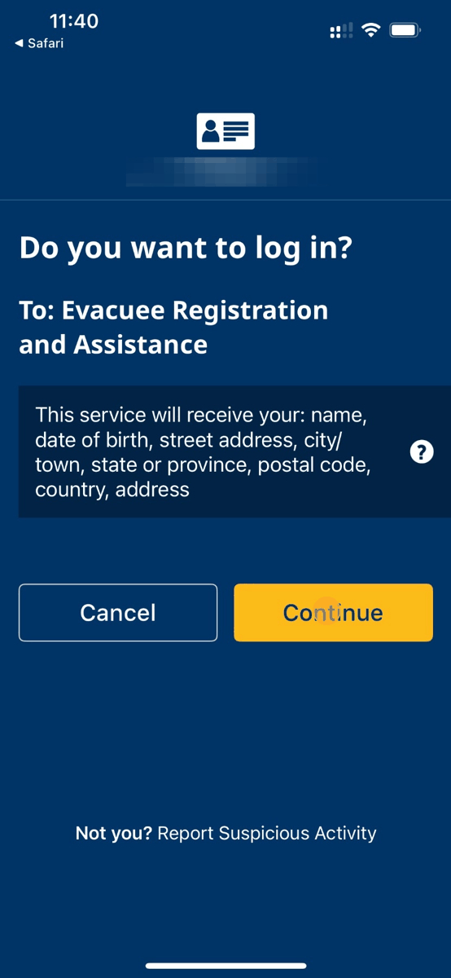

1. Click the browser name top left corner

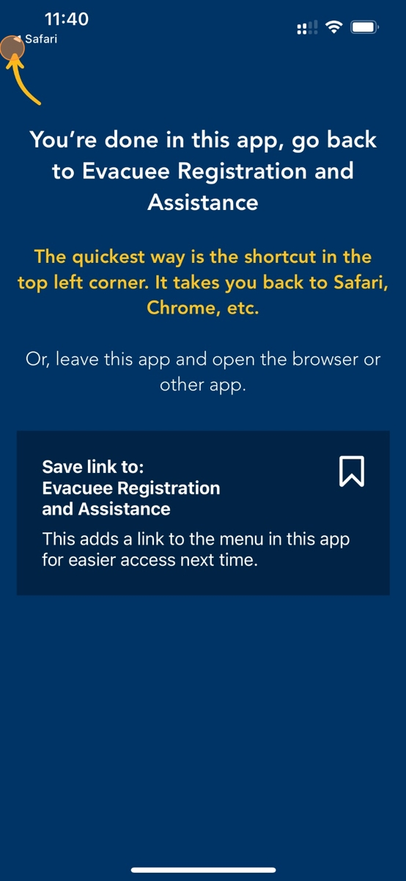

1. You will be directed to your ERA profile homeapge

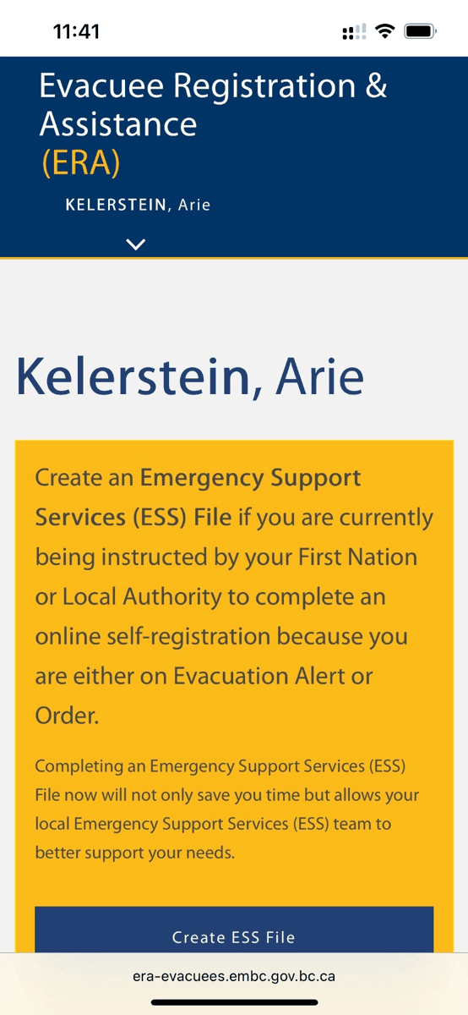

1. If you are under an Evacuation Order or Alert, click on 'Create ESS File'

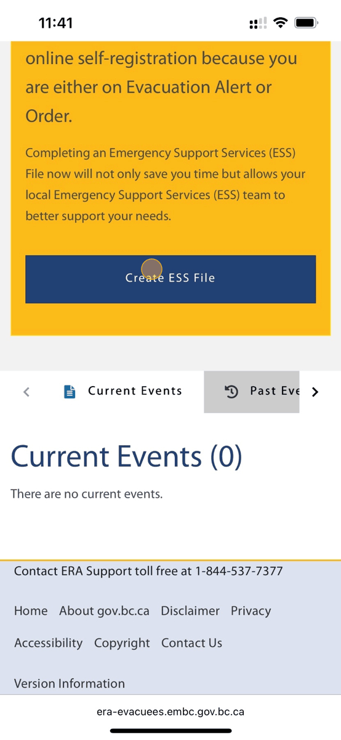

1. To edit your profile details, click "Profile"

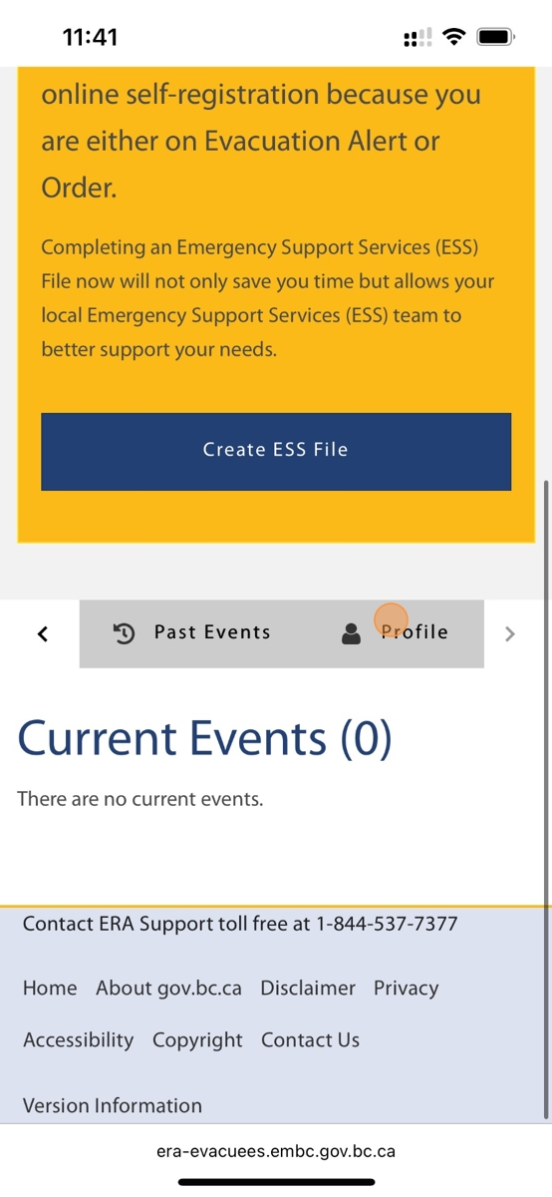

1. Click on the "Pencil" icons to edit any profile details

