# ERA User Guide: Link Existing ERA Profile with a BC Services Card Account

## This guide provides step-by-step instructions for sending email invitations to evacuees through the ERA Responder Portal to link an ERA profile with a BC Services Card Account. By following these detailed steps, responders can effectively link evacuees' BC Services Card accounts to their profiles, facilitating access to assistance and resources

# ERA Responder Portal

1. Navigate to <https://ess.gov.bc.ca/>

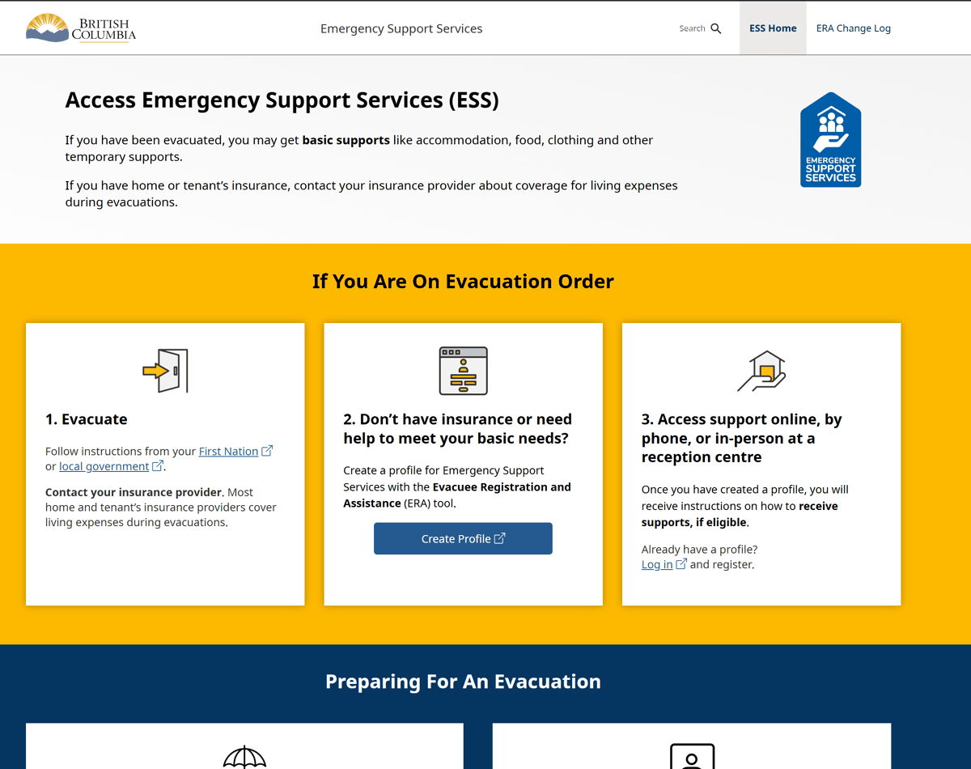

1. Scroll down and click "Responder Portal Login"

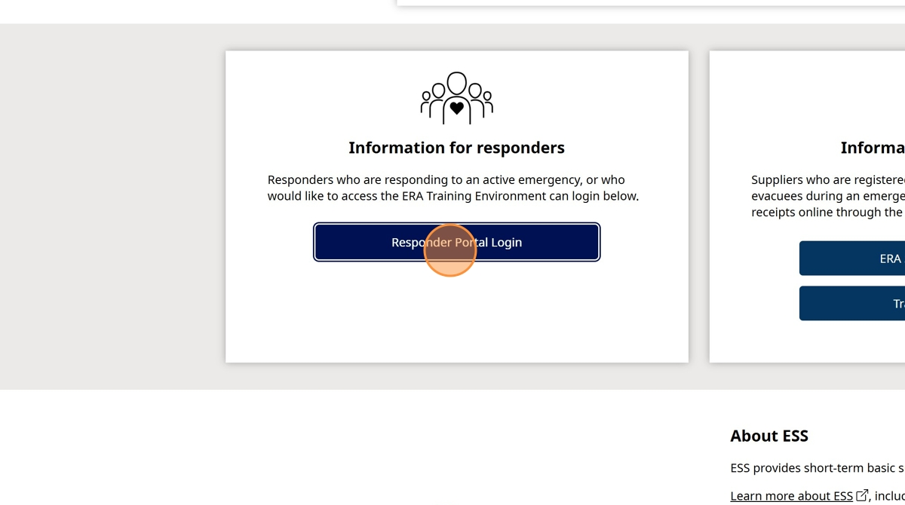

1. Click "Log in to Live"

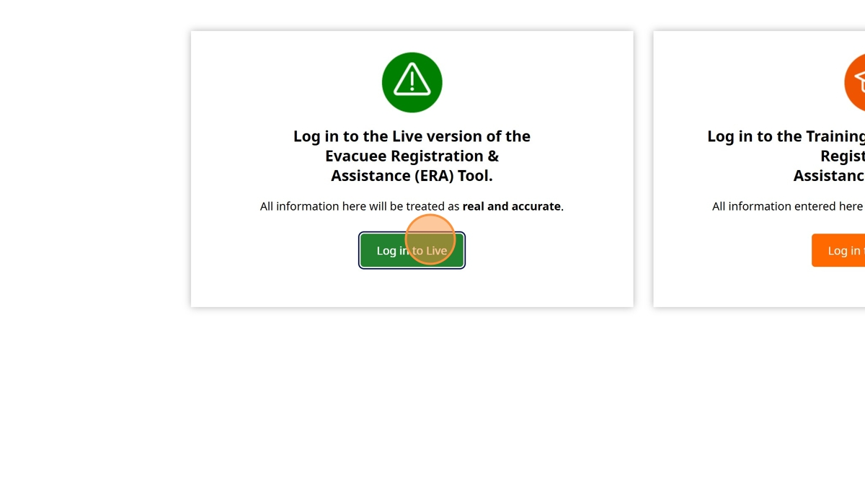

1. Enter your BCeID

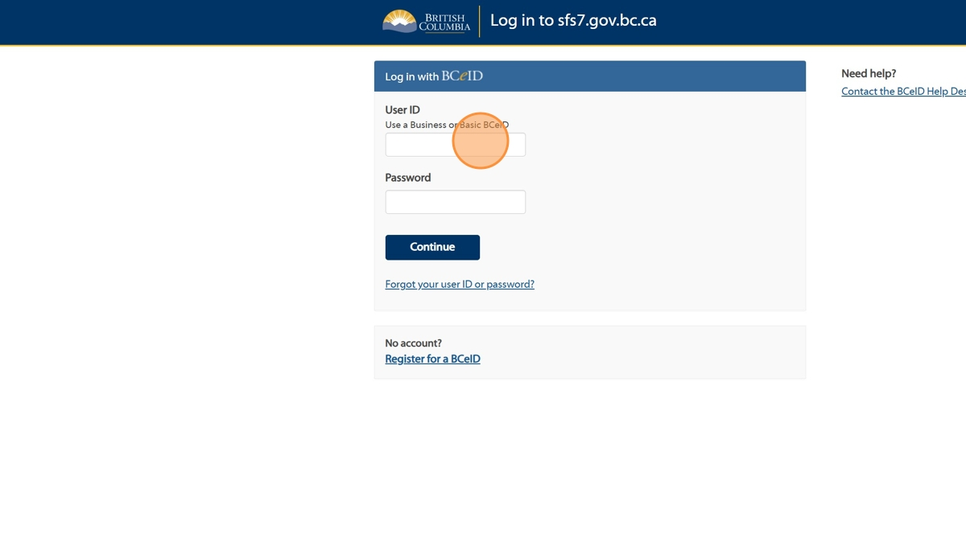

1. Enter your Password

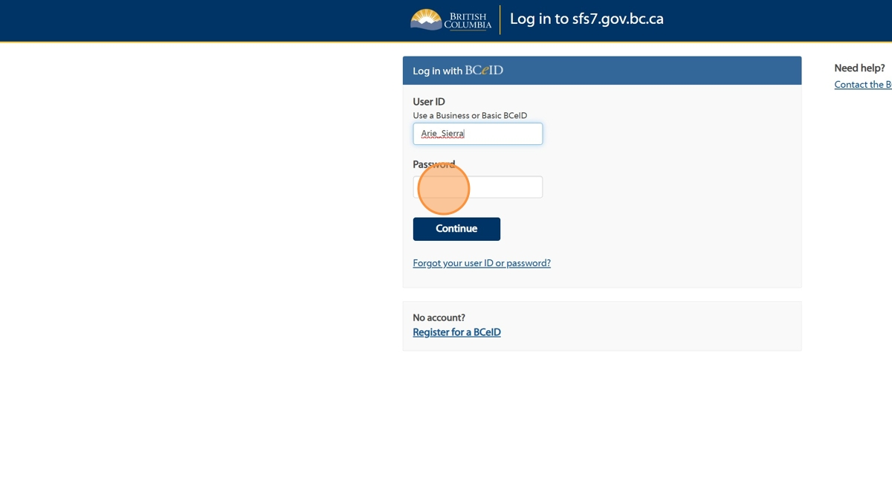

1. Click "Continue".

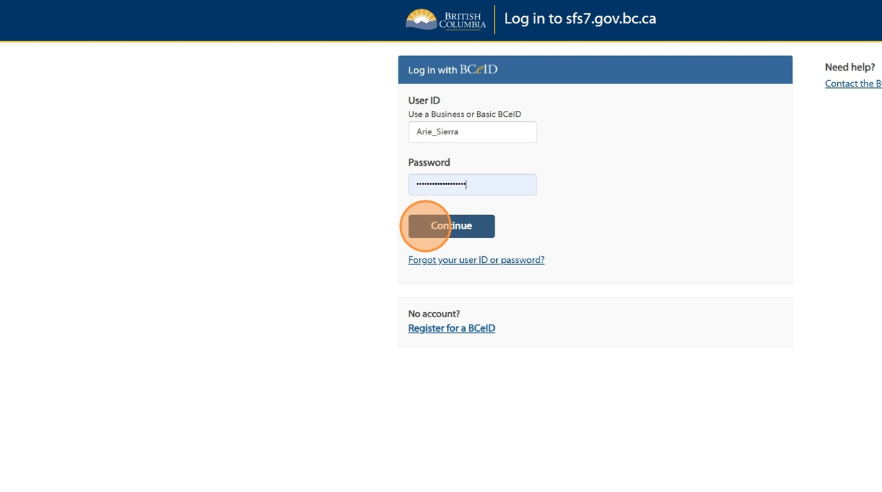

1. Click "Sign in to the Task #"

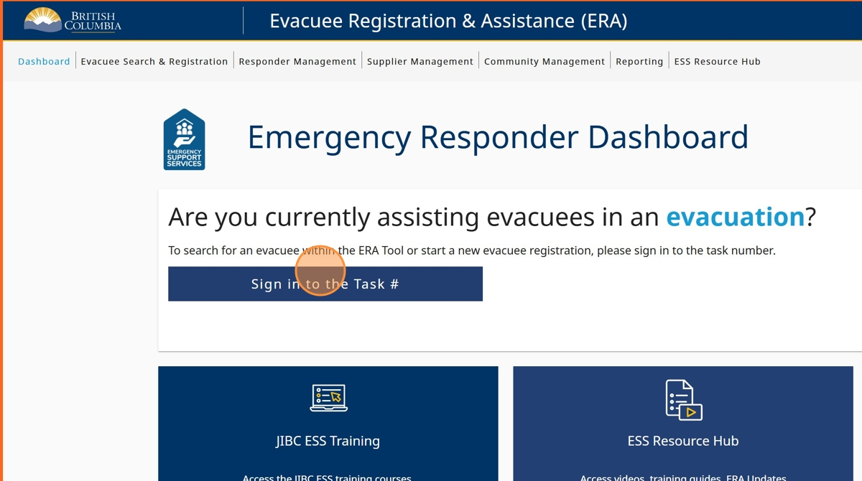

1. Click the "Enter Task #" field and enter your task number

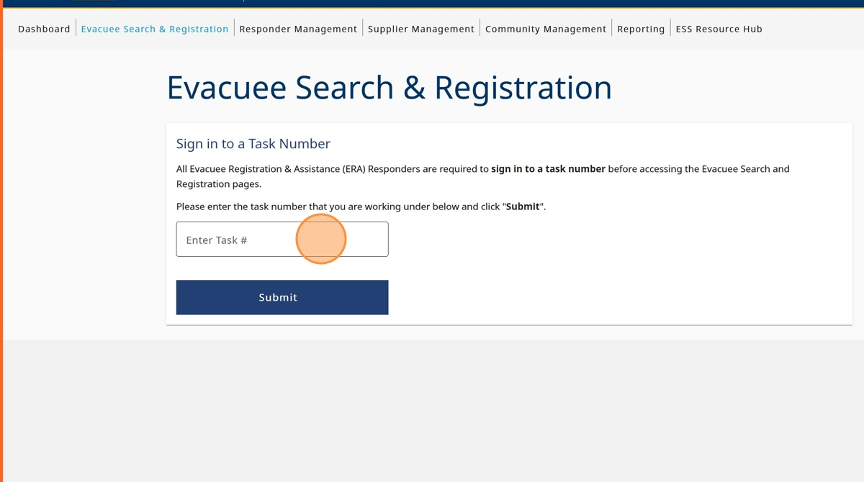

1. Click "Submit"

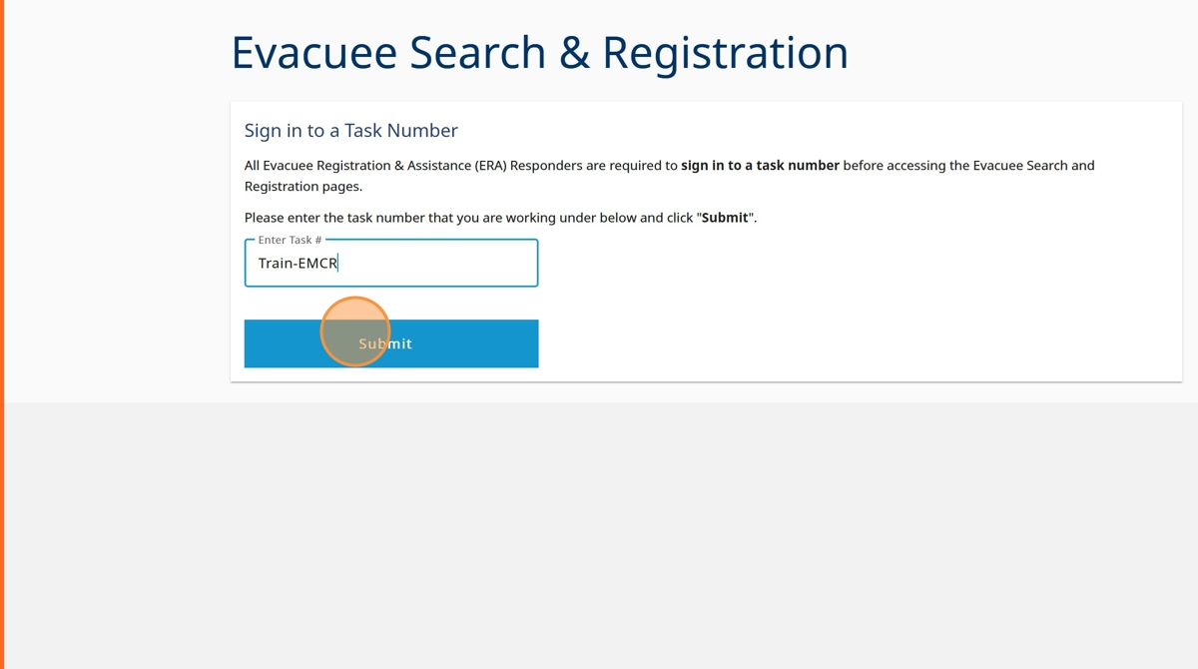

1. Click "Sign in to Task"

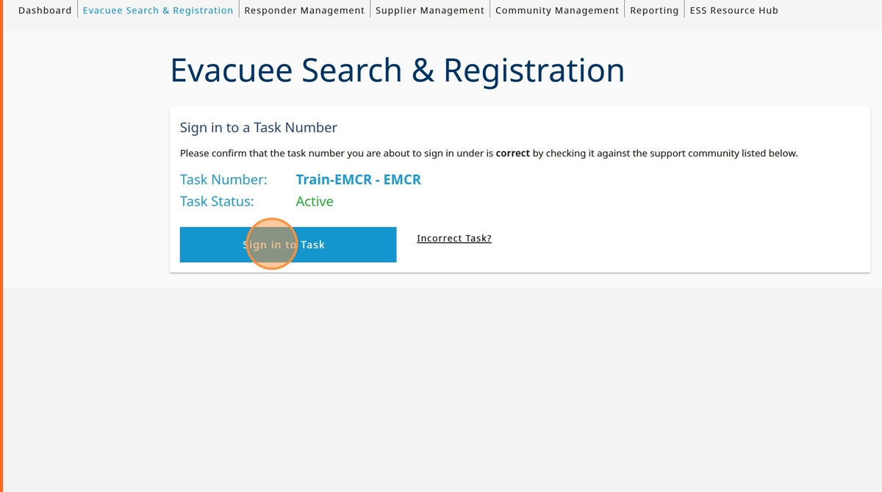

1. Click on "I am doing evacuee registration & extensions"

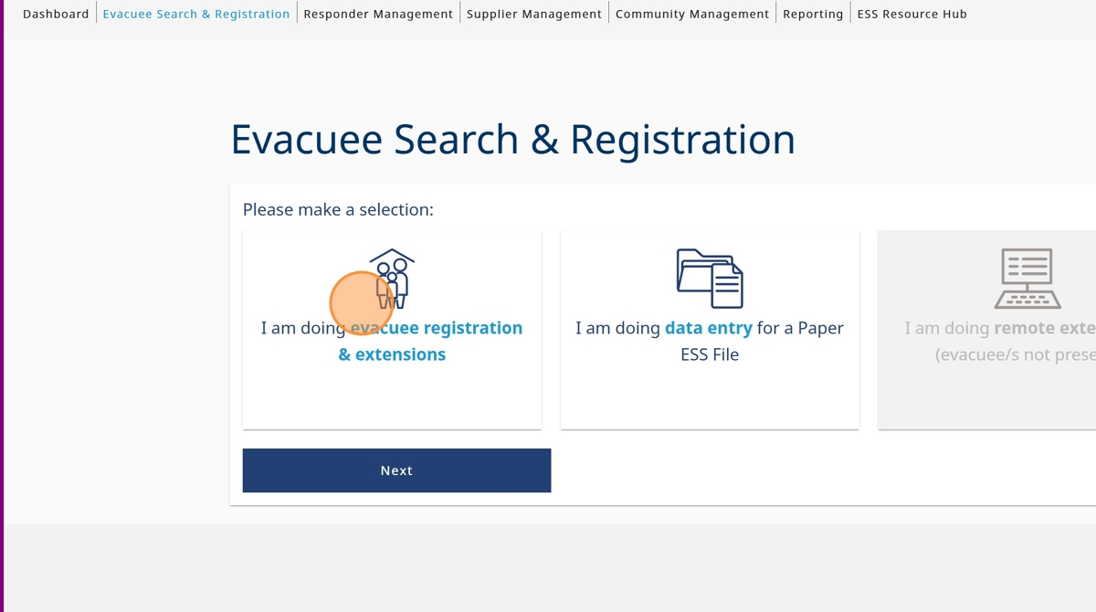

1. Click "Next"

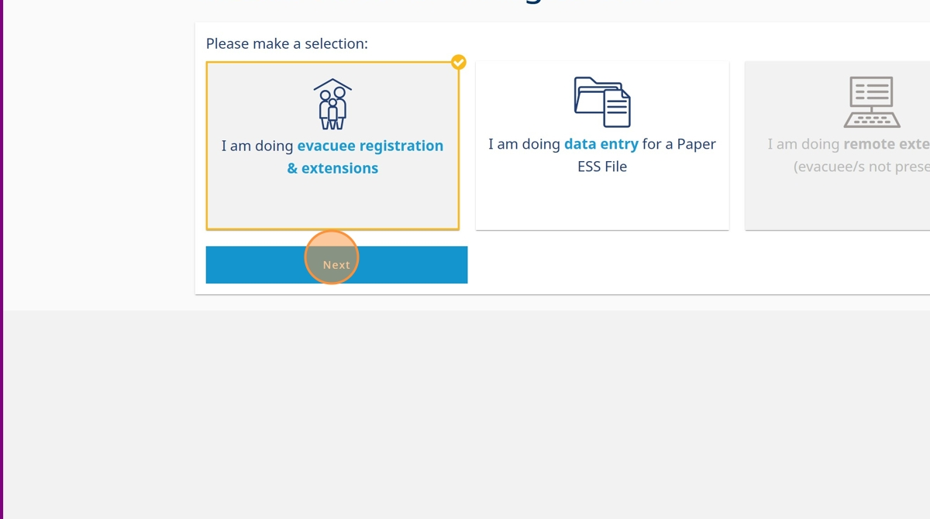

1. Click on the appropriate option concerning government-issued photo ID the evacuee presented

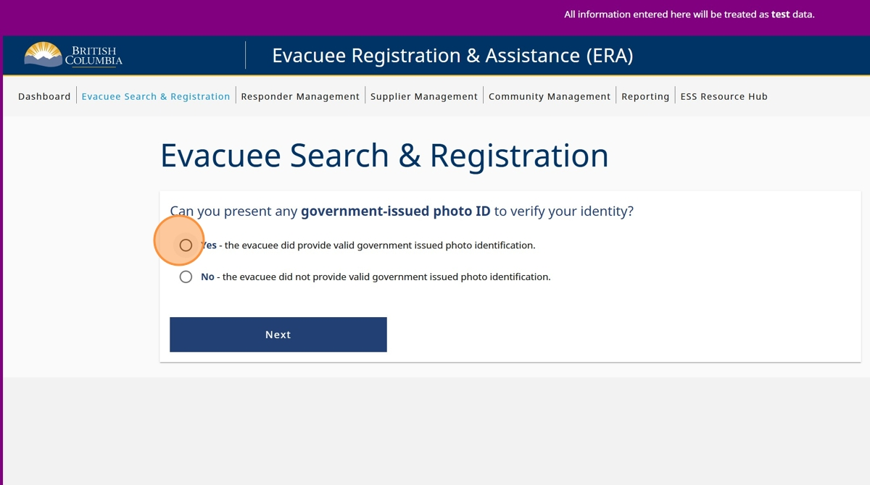

1. Click "Next"

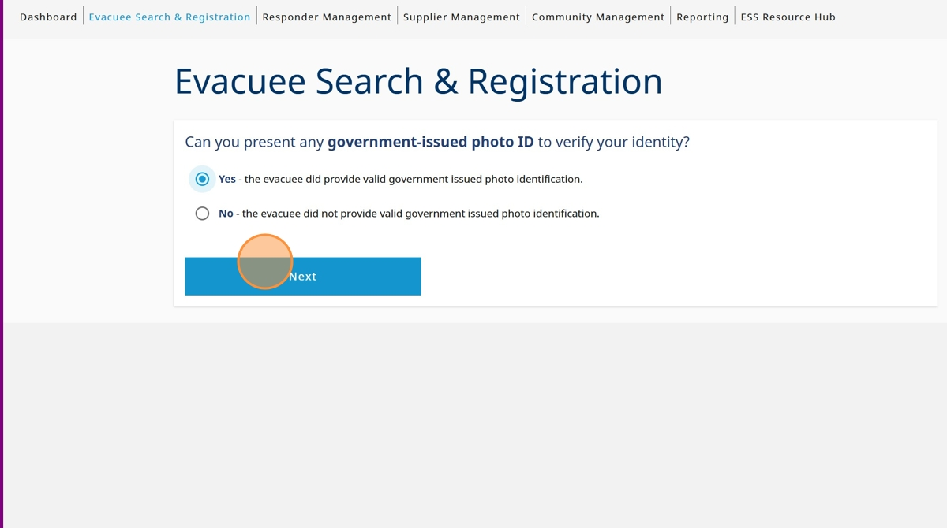

1. Click "Last Name" and enter the last name

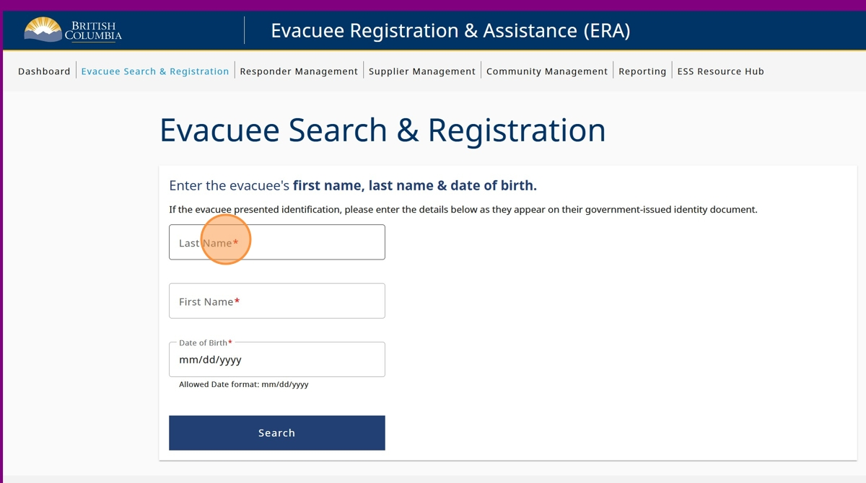

1. Click the "First Name" field and enter the first name

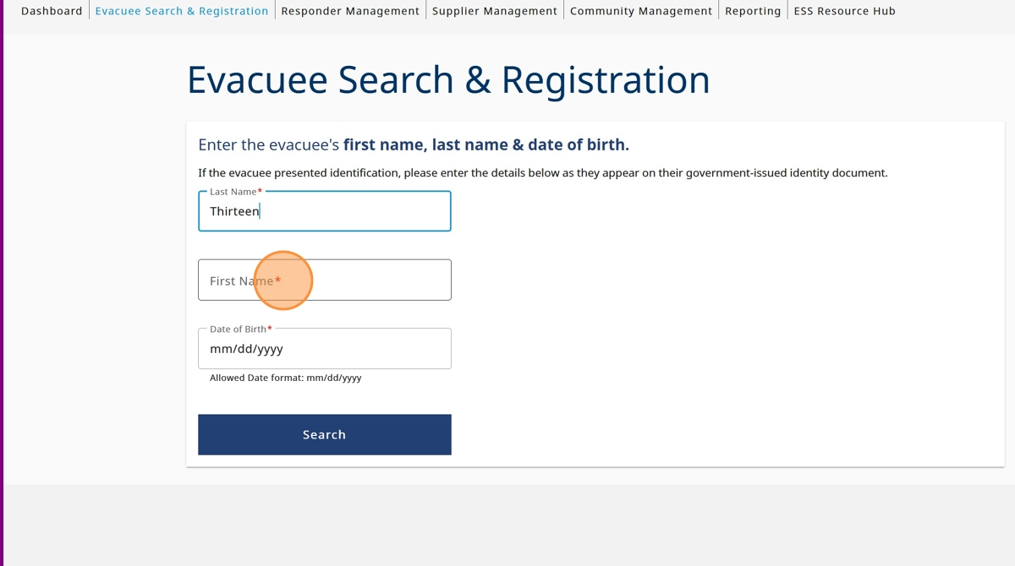

1. Click the "Date of Birth" field and enter the date of birth

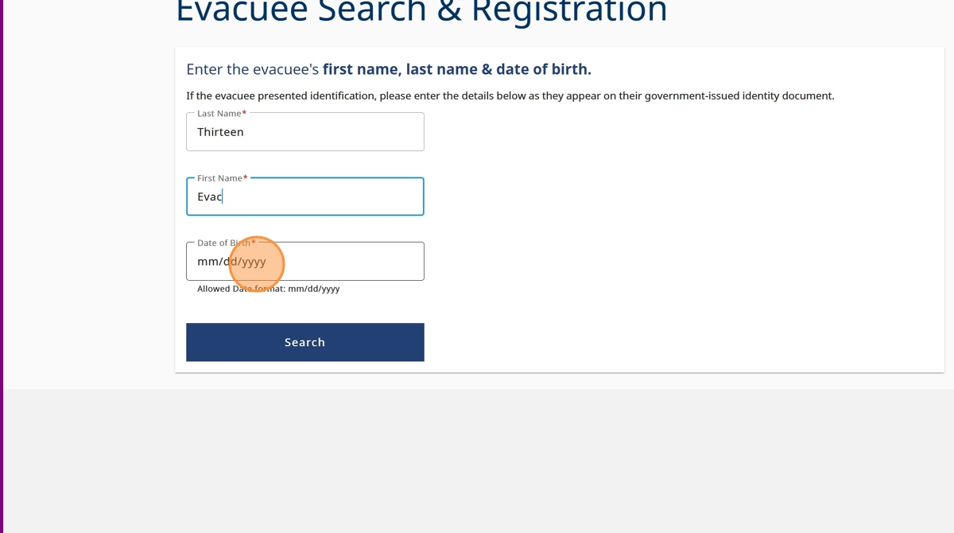

1. Click "Search"

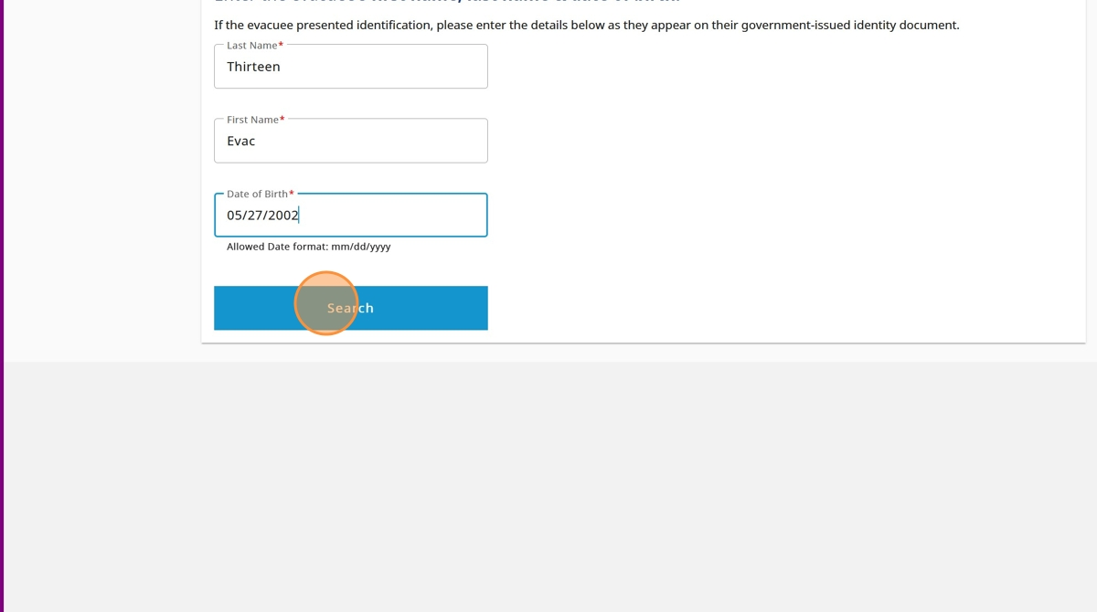

1. Click on the name of the profile you'd like to link with the BC Services Card Account

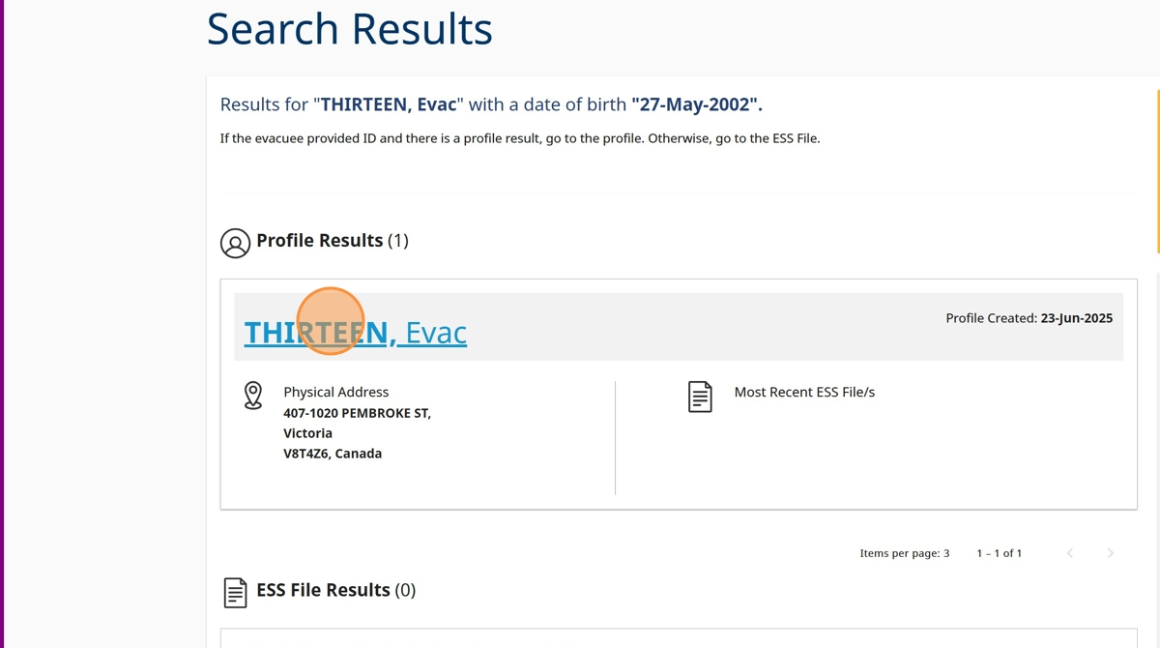

1. Click the "Update Information" field.

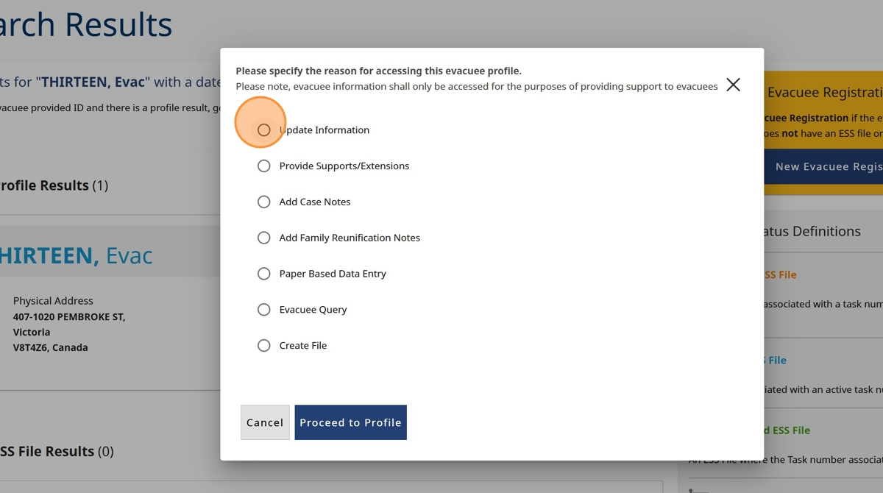

1. Click "Proceed to Profile"

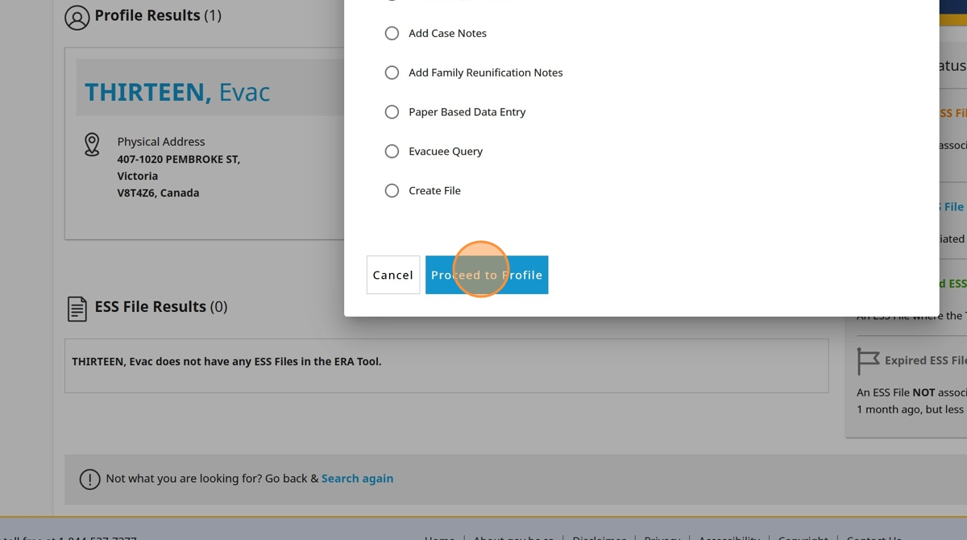

1. Click "Send email invitation"

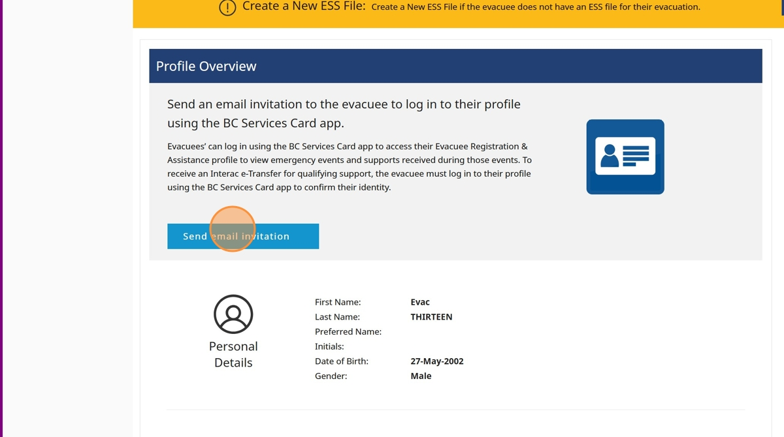

1. The evacuee's email associated with their profile will appear, click "send" if the evacuee would like to use this email address. We recommend sending the email to the same email associated with the evacuees BC Services Card Account

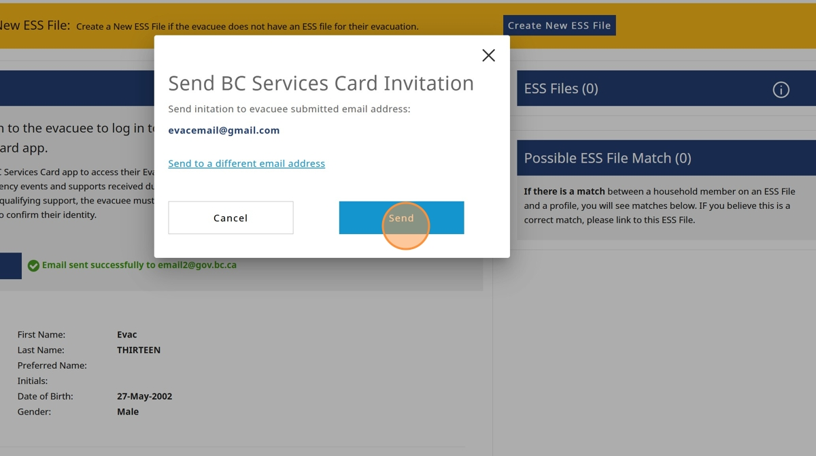

1. If the evacuee wants to use a different email address, click "Send to a different email address"

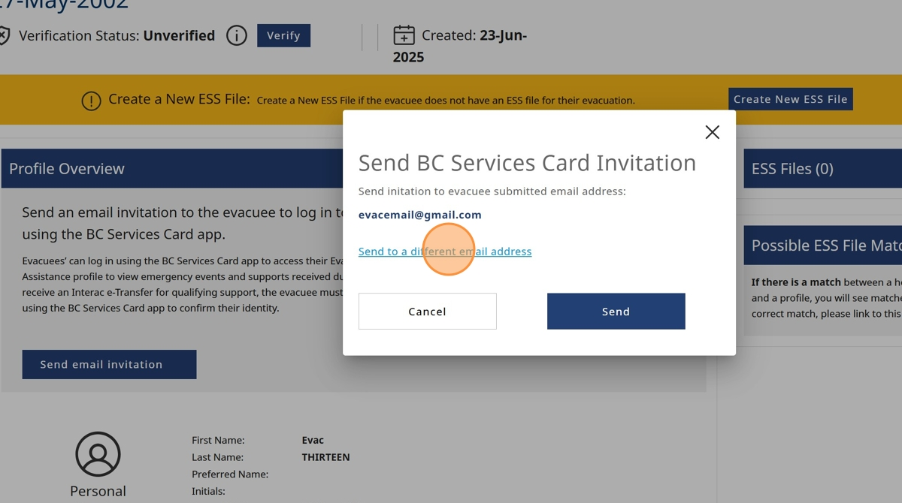

1. Click the "Email Address" field and enter email

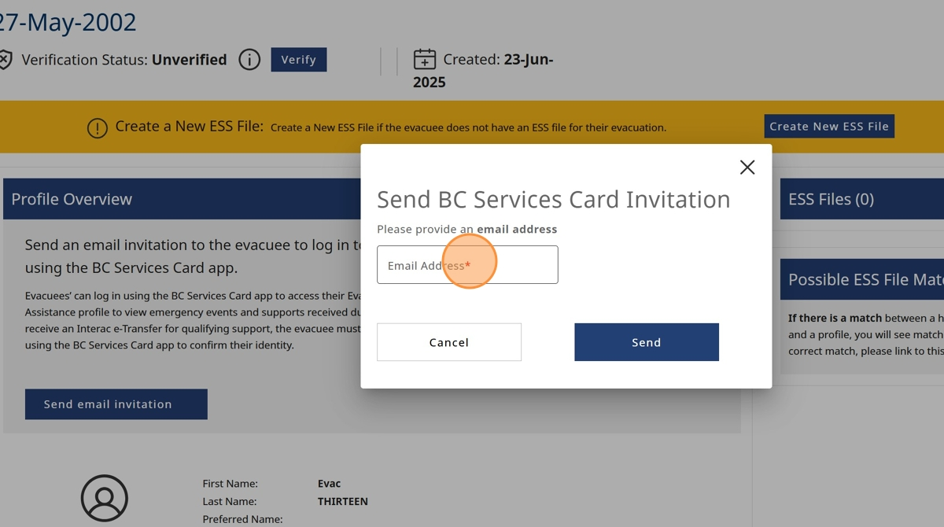

1. Click "Send"

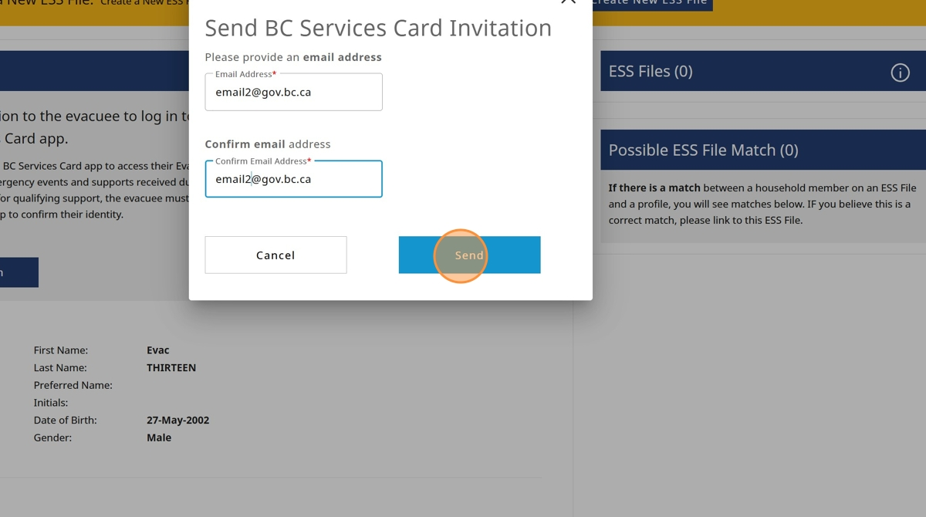

1. You will receive a green notification advising that the email has been successfully sent

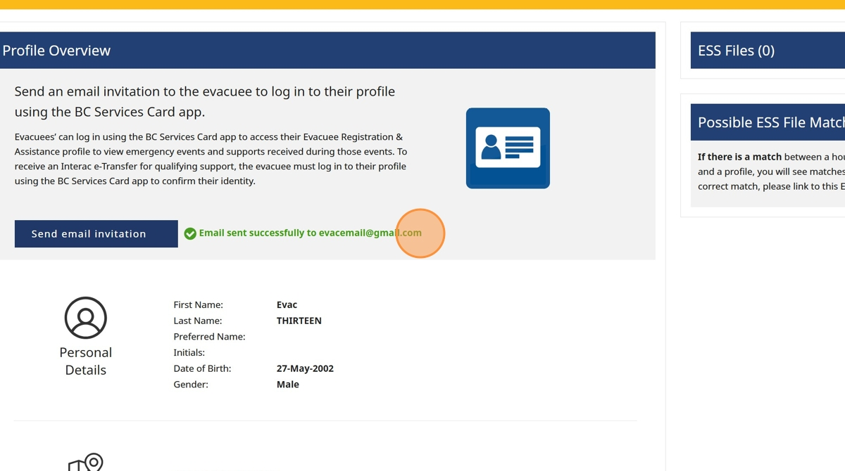

# Evacuee Opens their Email Account (Recommend they do this on the same mobile device with their BC Services Card App)

1. The evacuee will receive an email with the subject title "Log in to your Evacuee Registration & Assistance (ERA) User Profile using the BC Services Card app

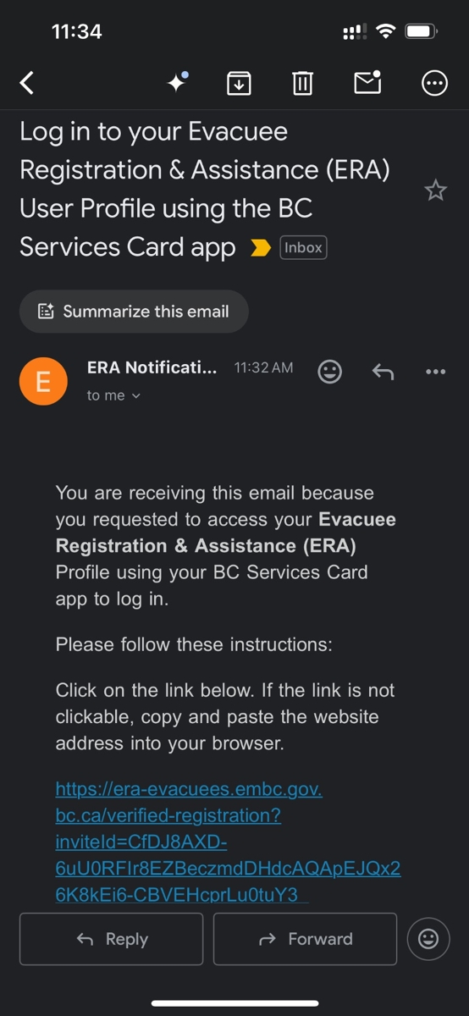

1. The evacuee should click the link

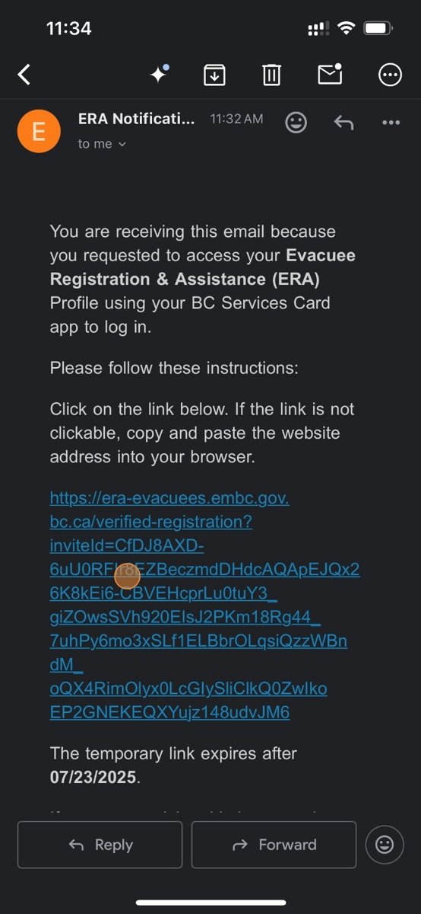

1. The evacuee will have to decide how to sign-in to their BC Services Card account. It is recommended the evacuee chooses the "BC Services Card app" if the evacuee has the app

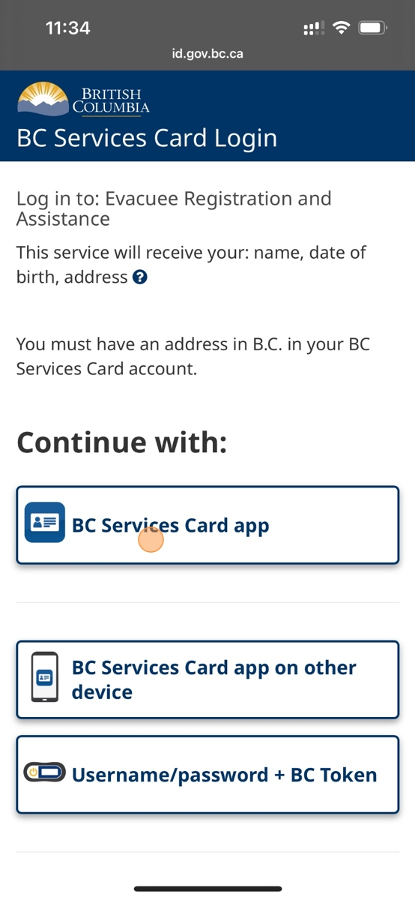

1. Click "Open"

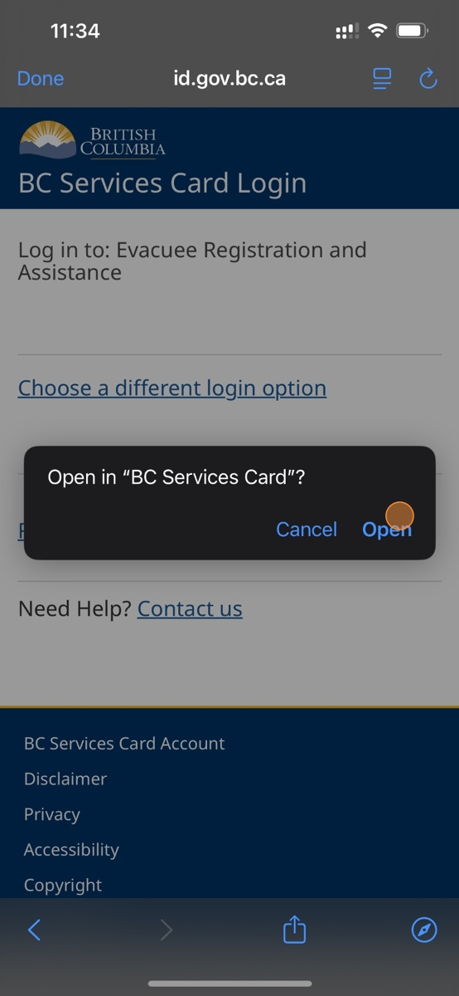

1. The BC Services Card Account app will open with the name of the individual logged in, click on the name to continue

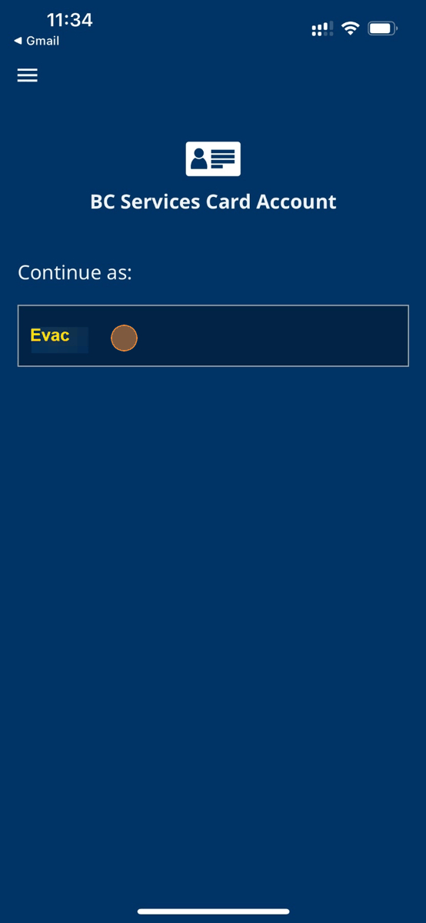

1. Click "Continue"

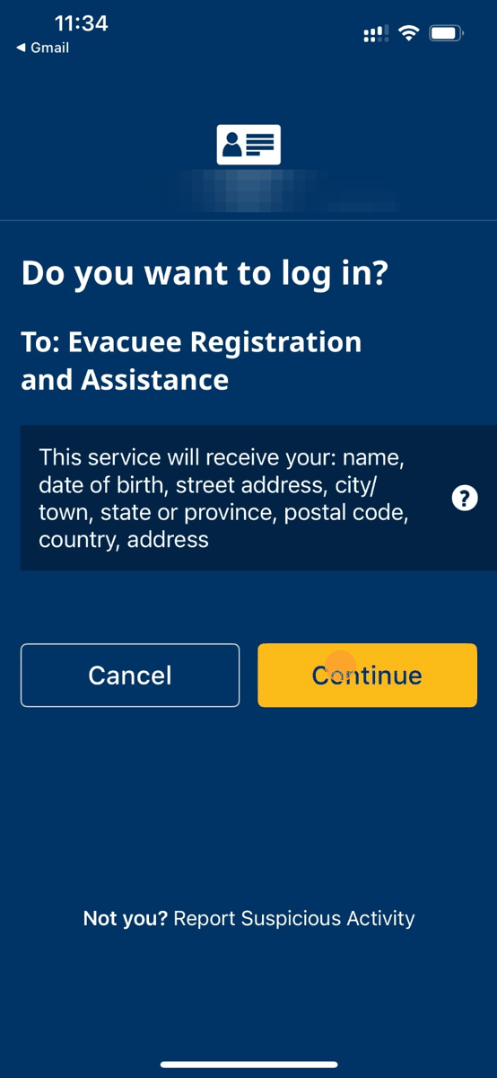

1. Click where the yellow arrow is pointing

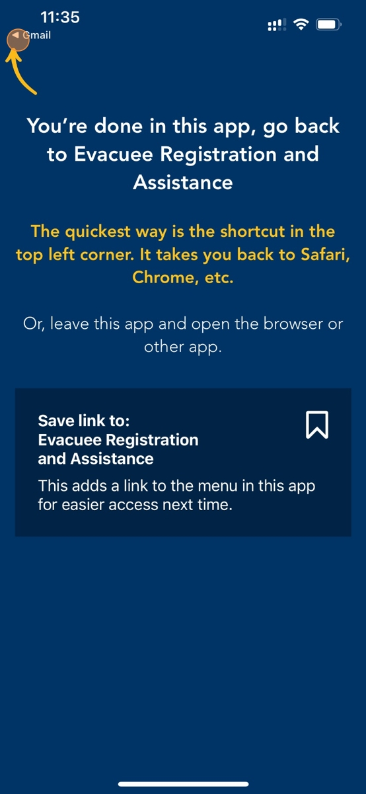

1. The evacuee should read the Terms of Use and then click on the box besides "I agree to the BC Login Service Terms of Use"

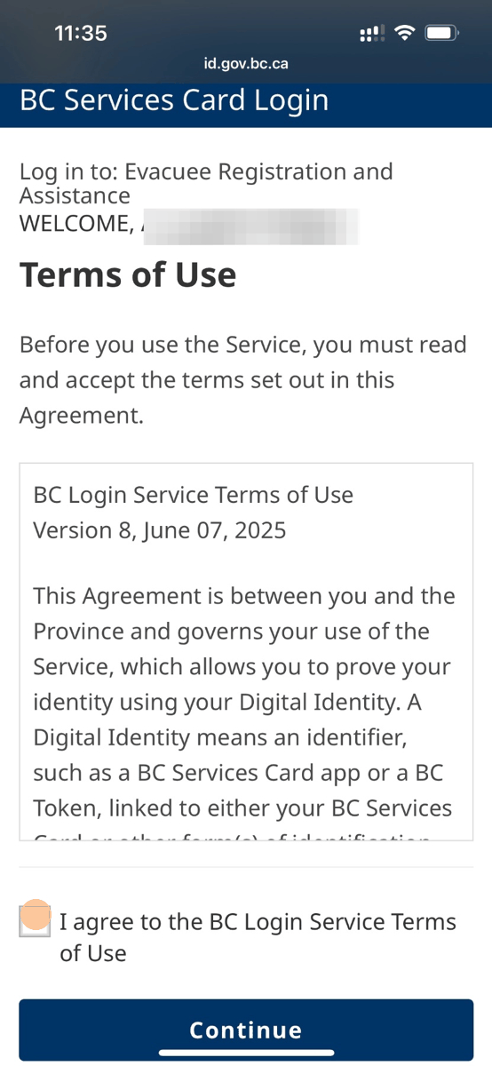

1. Click "Continue"

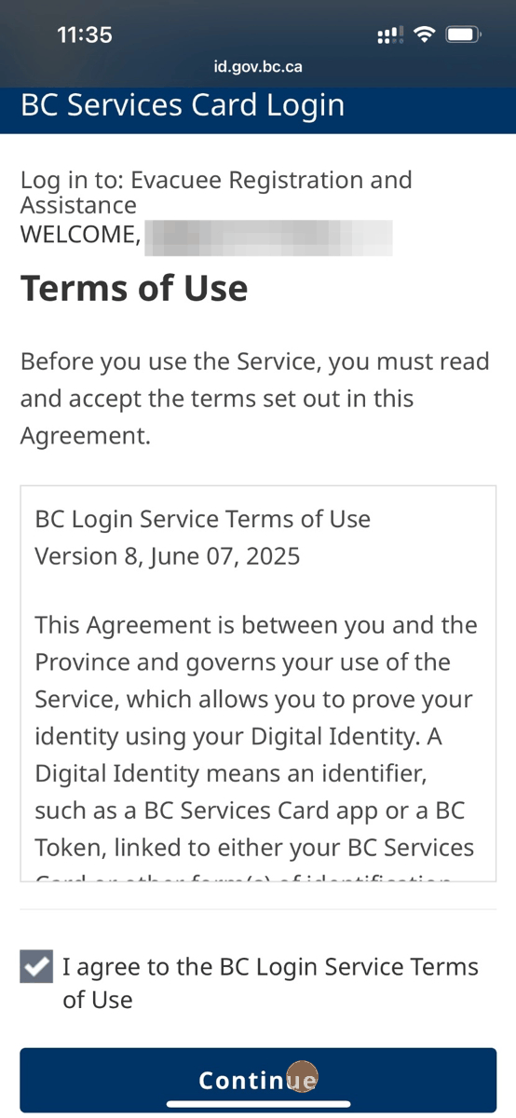

1. The evacuee will be re-directed to their ERA profile homepage. The BC Services Card account is now linked to their existing profile. A responder can now search for the evacuee and an 'e-Transfer eligible' flag will appear besides the user profile and any related ESS files

