# ERA User Guide: How To Reprint Evacuee Support Referrals

1. From the Responder Portal Dashboard, click "Evacuee Search & Registration"

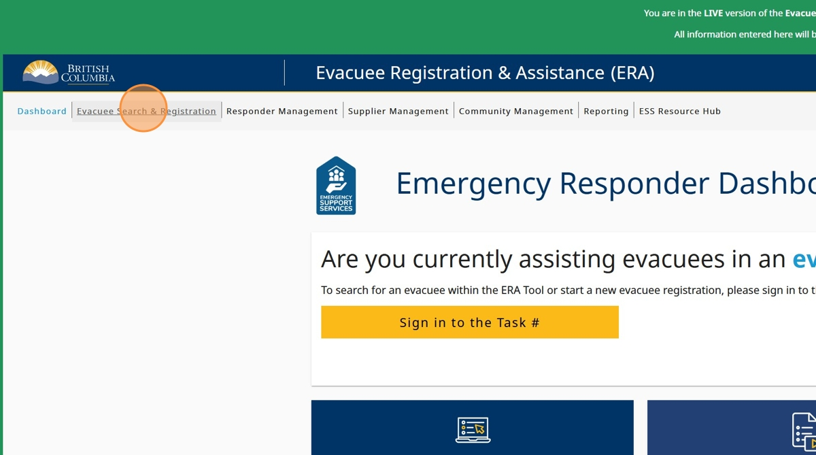

1. Click the "Enter Task #" field and enter the task number

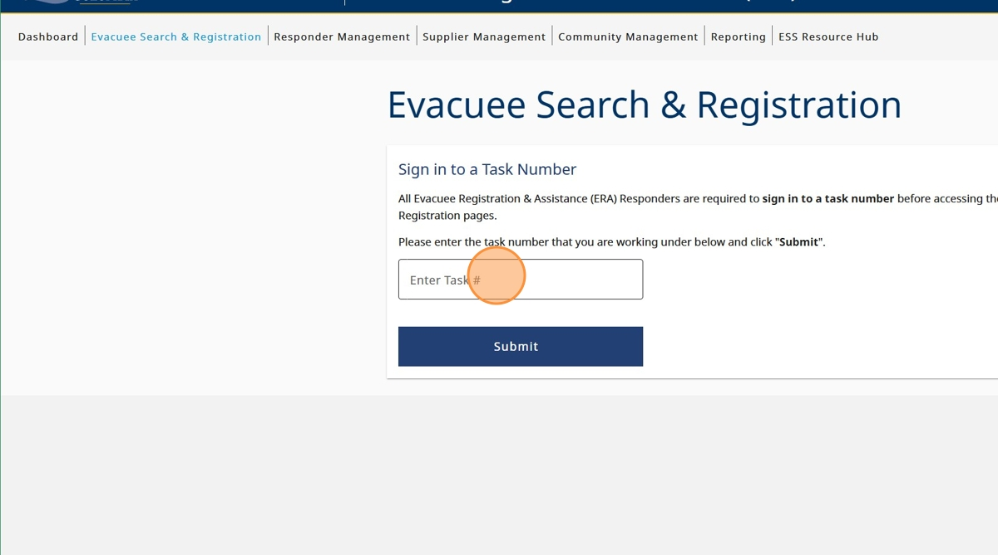

1. Click "Submit"

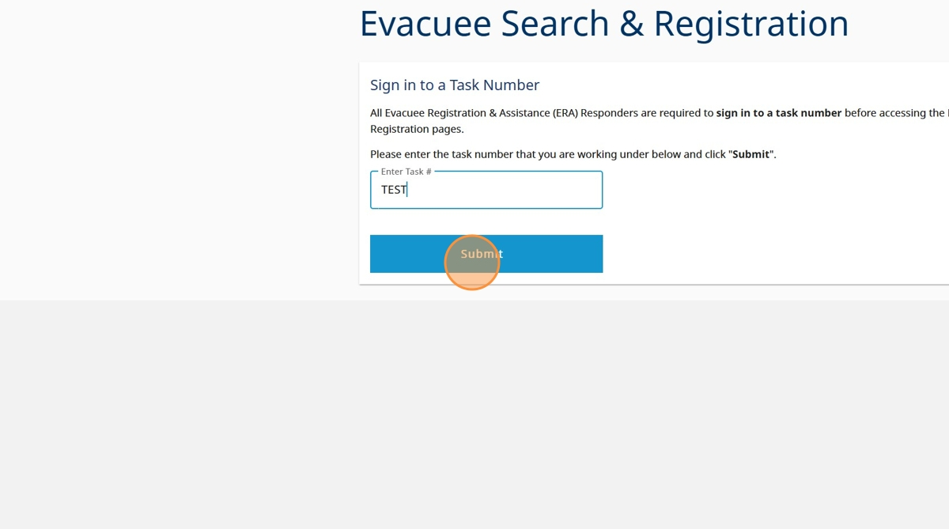

1. Click "Sign in to Task"

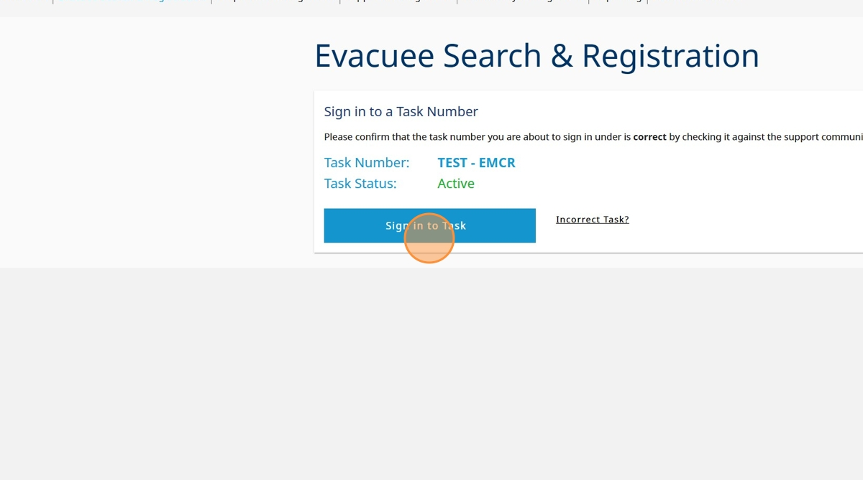

1. Click the "I am doing evacuee registration & extensions"

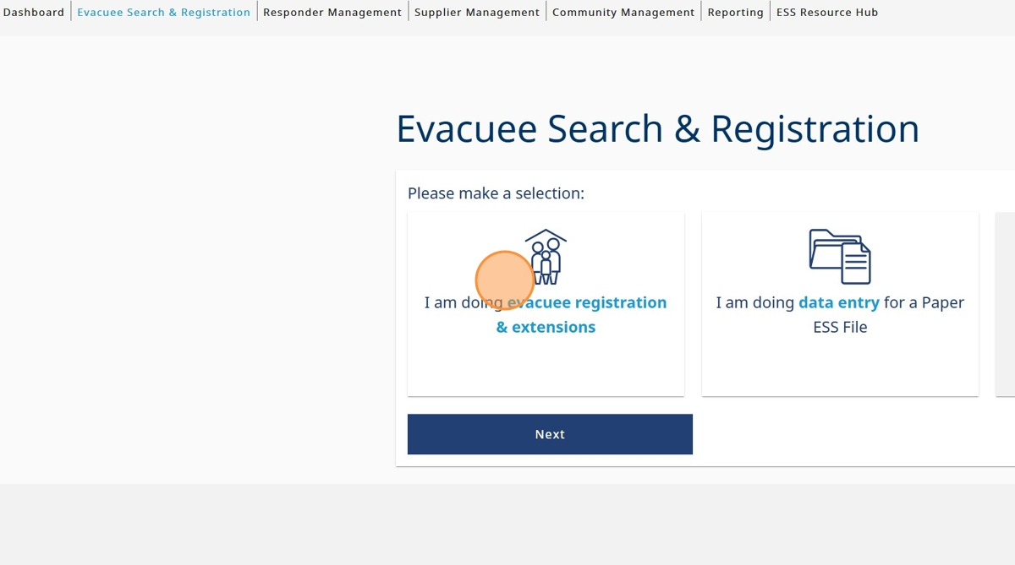

1. Click "Next"

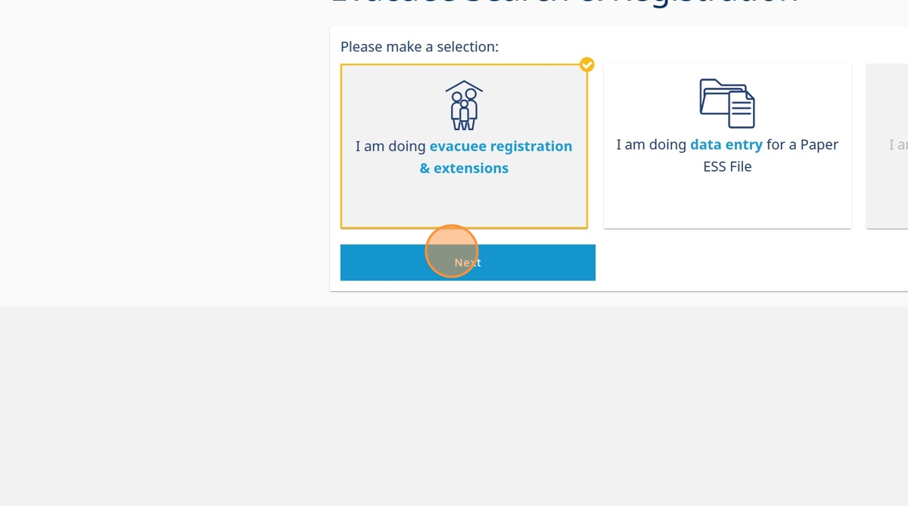

1. Click on the appropriate circle depending on if the evacuee provided valid government issued photo identification

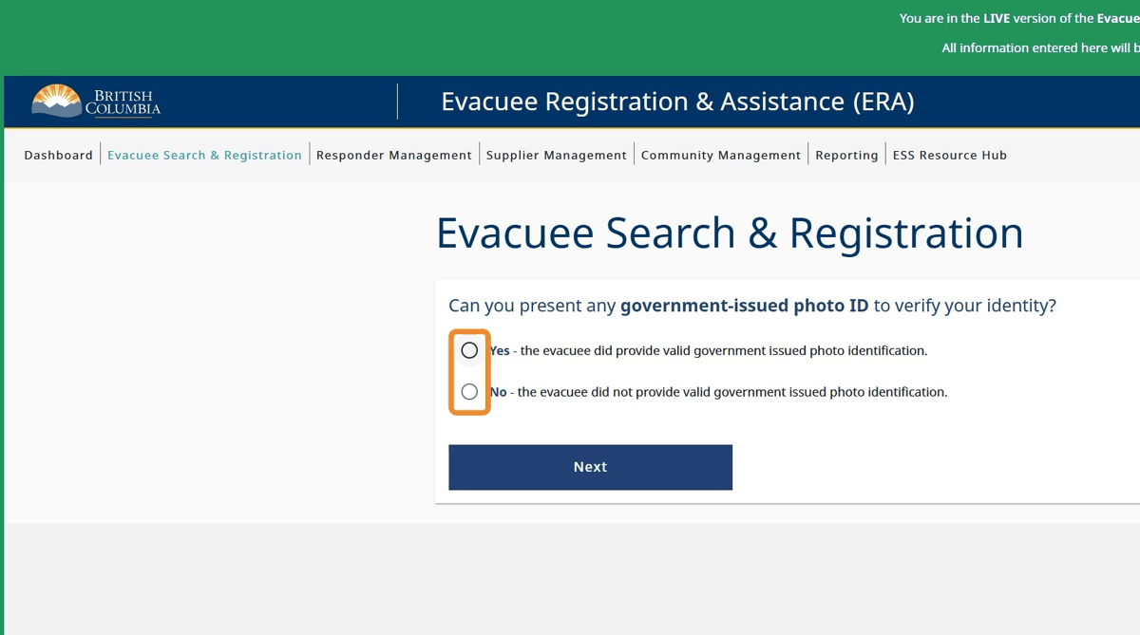

1. Click "Next"

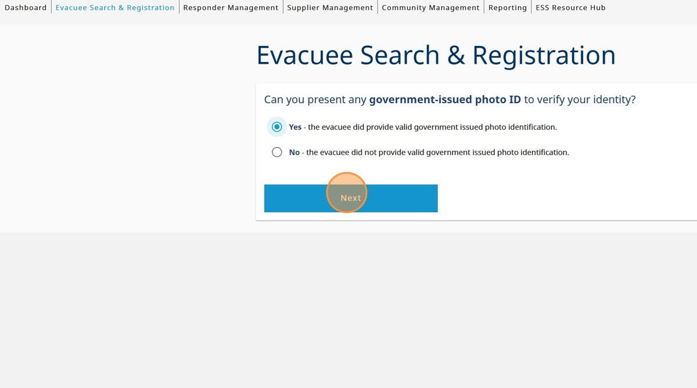

1. Click "Last Name" and enter evacuee last name

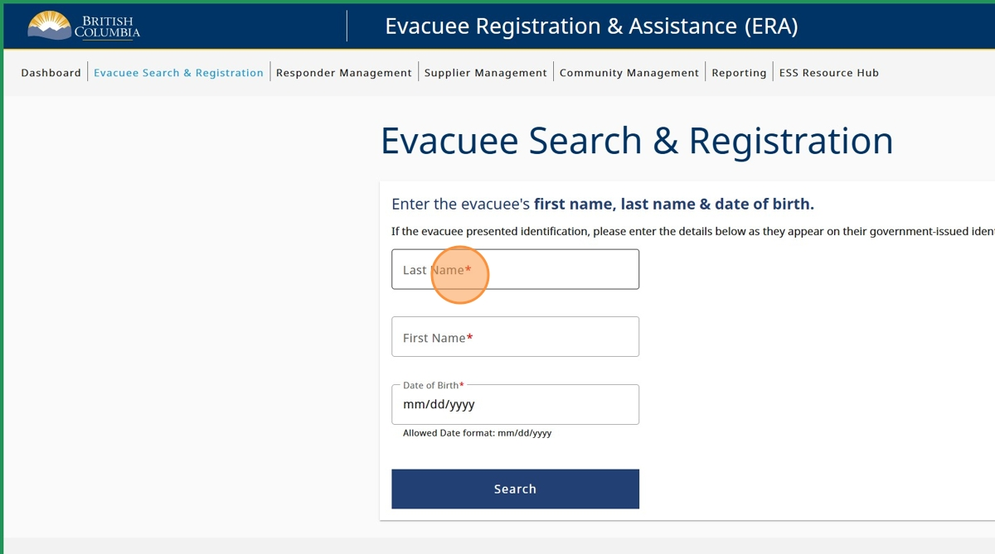

1. Click the "First Name" field and enter evacuee first name

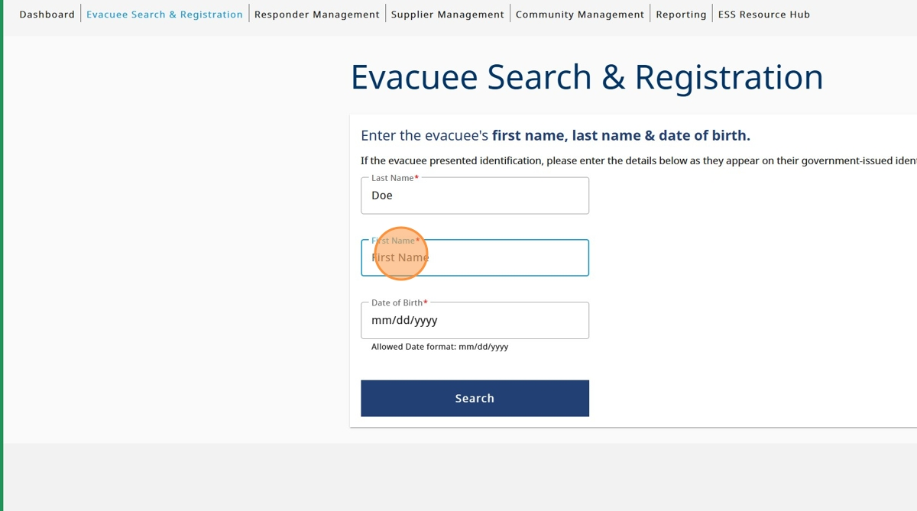

1. Click Date of Birth and enter the evacuee date of birth

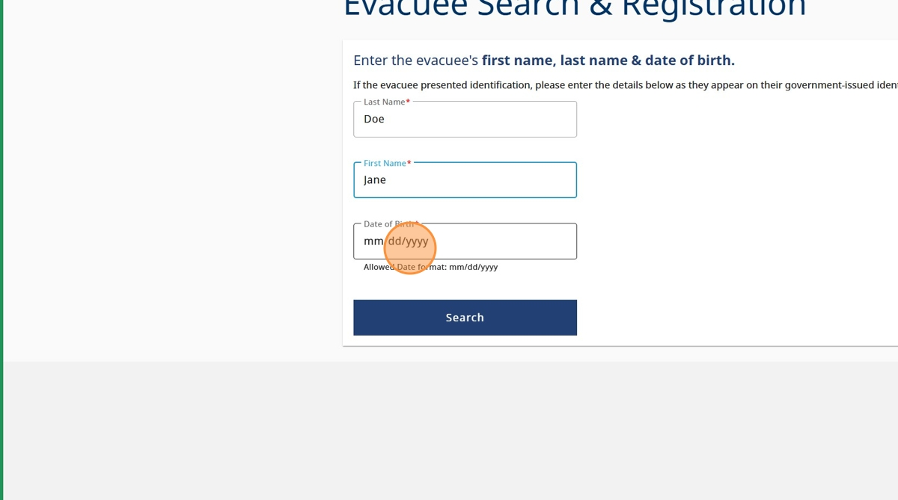

1. Click "Search"

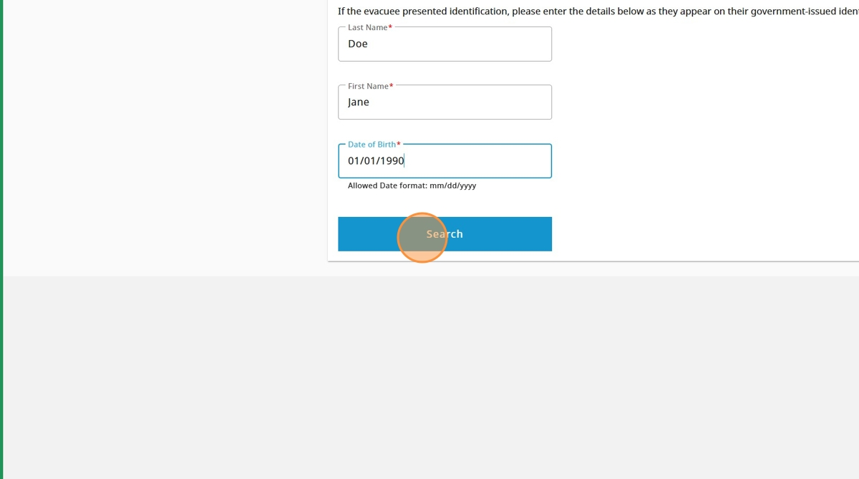

1. Click on the file with the referral you need to re-print

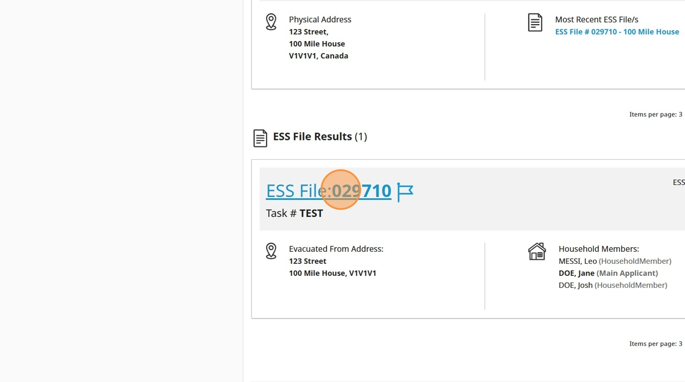

1. Click the "Provide Supports/Extensions" field

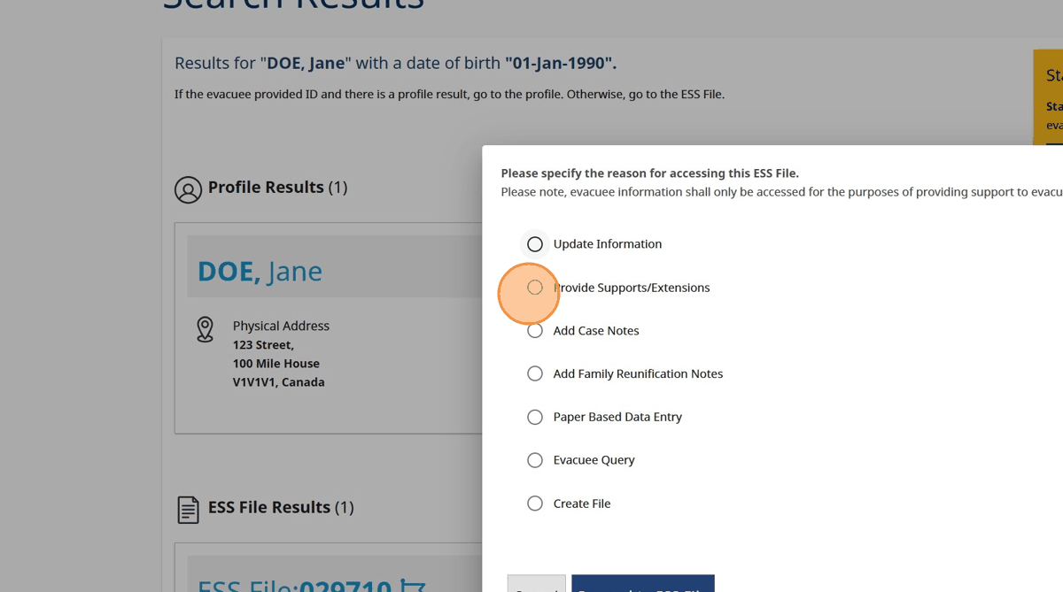

1. Click "Proceed to ESS File"

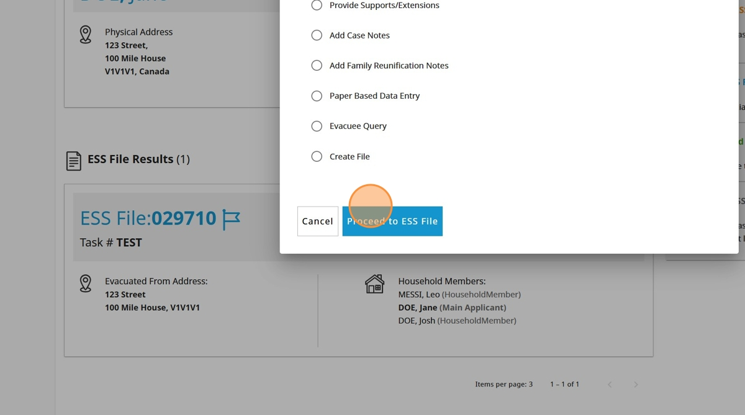

1. Click "Edit ESS File"

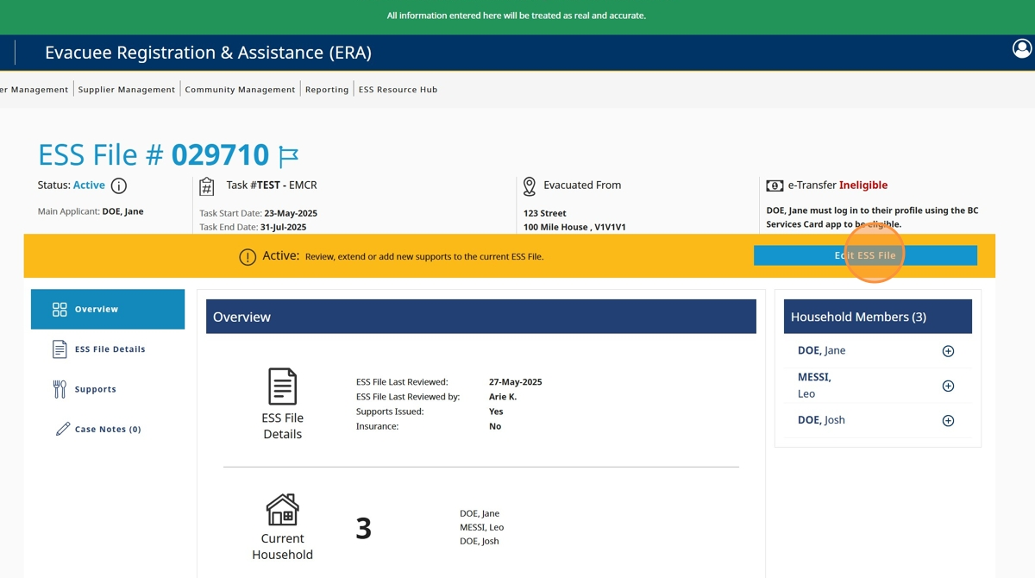

1. Click "Household Members & Pets"

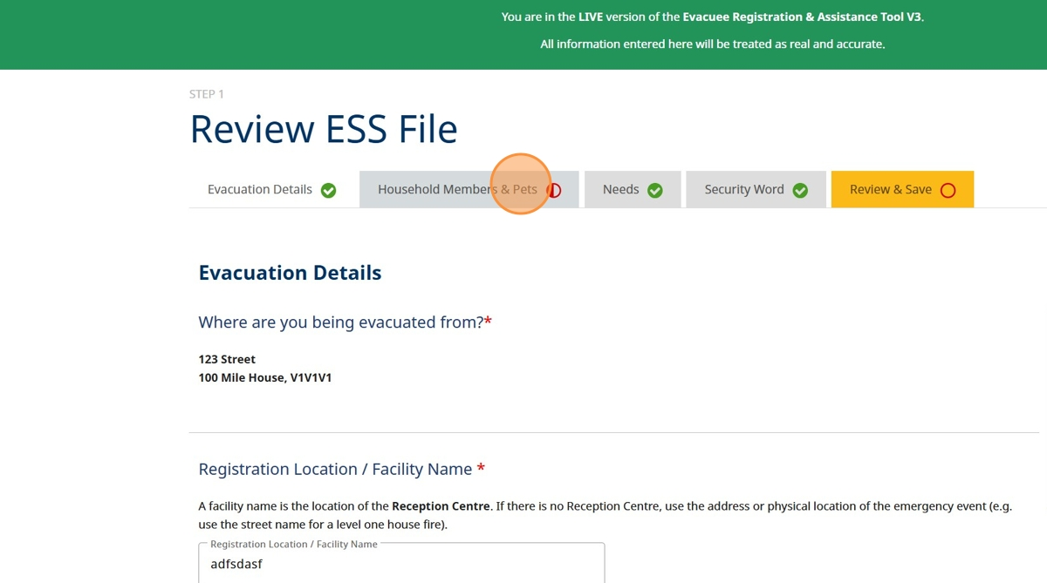

1. Click here to select all household members

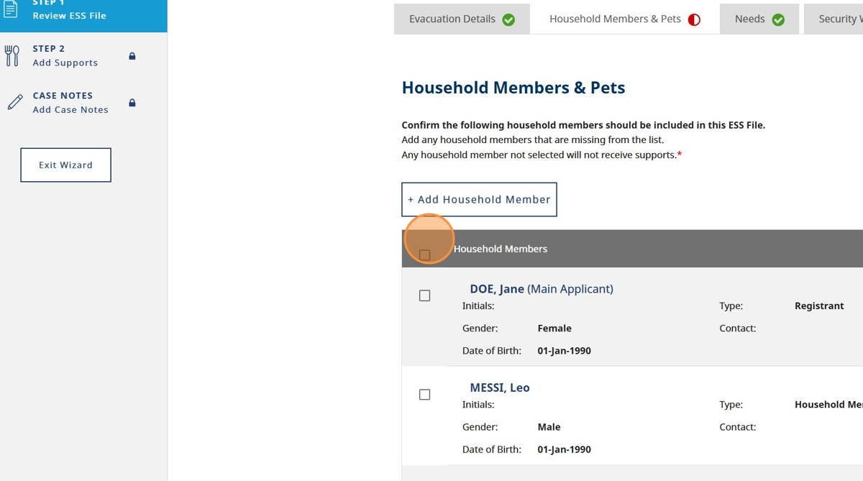

1. Click "Review & Save"

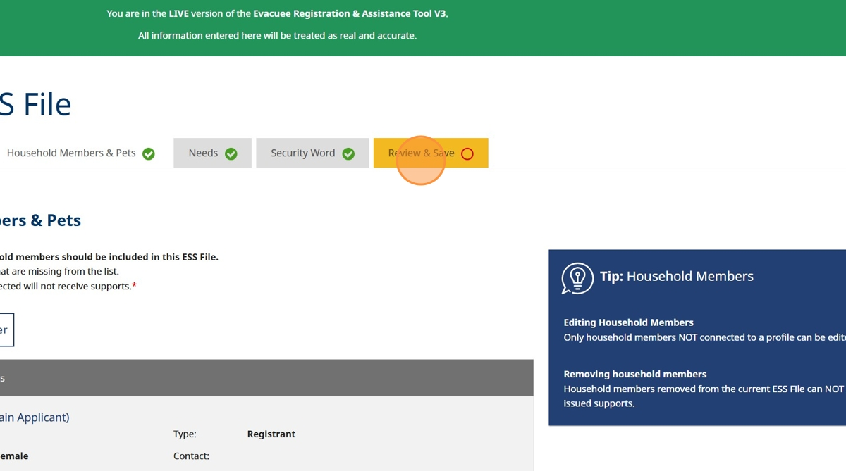

1. Click "Save ESS File"

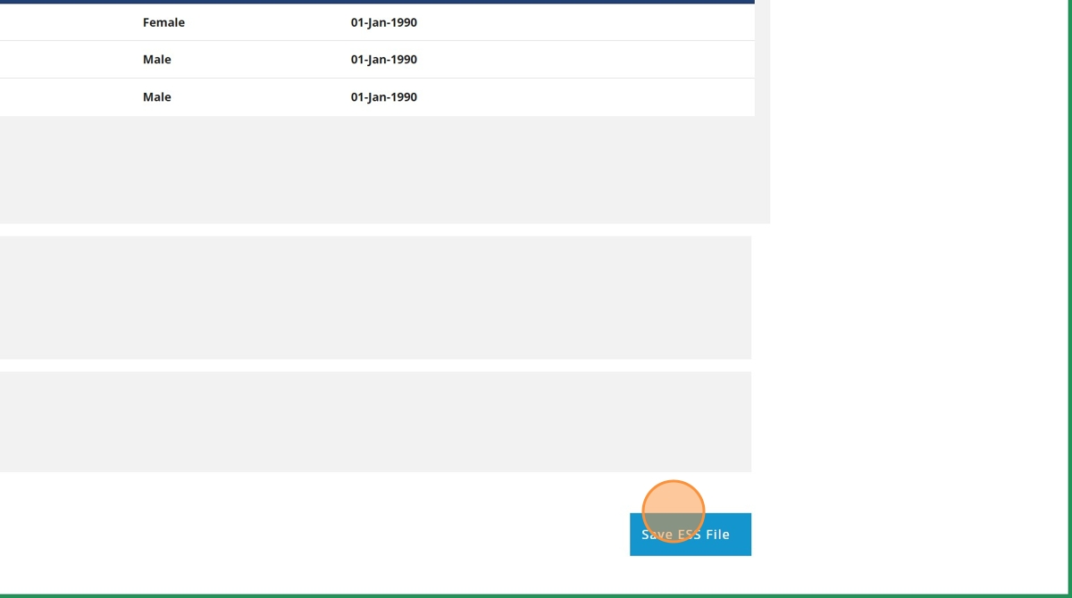

1. Click "Proceed to Next Step"

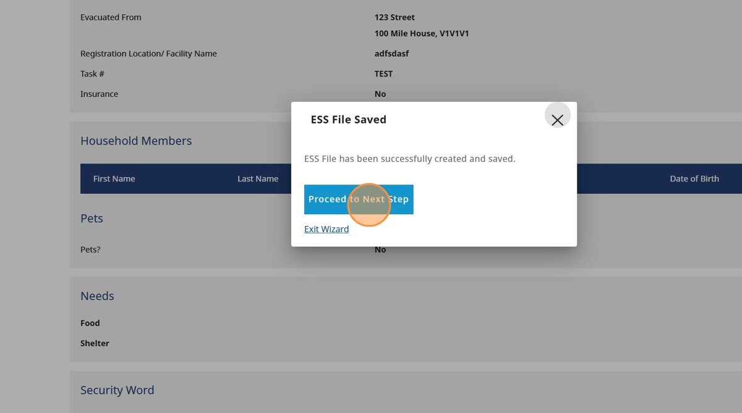

1. Click on the referral you'd like to re-print. Only Active referrals can be re-printed

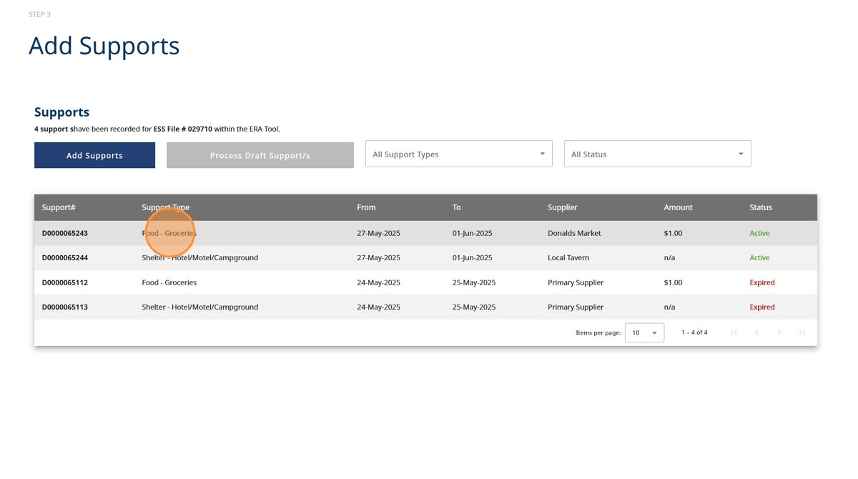

1. Click "Reprint Referral"

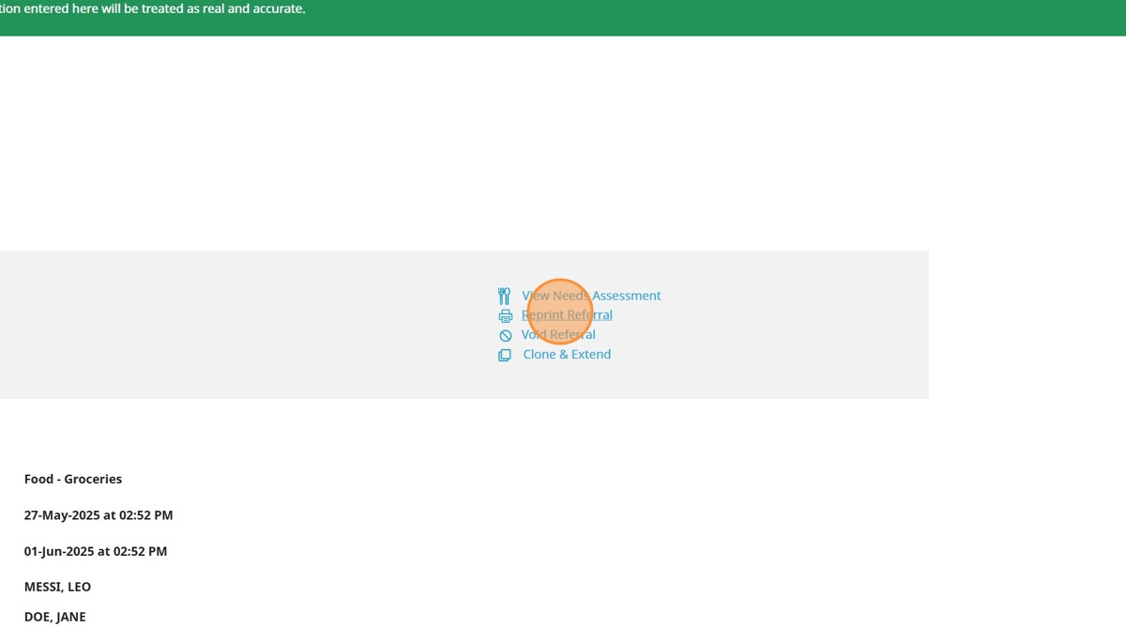

1. Click "Reason for reprint" field

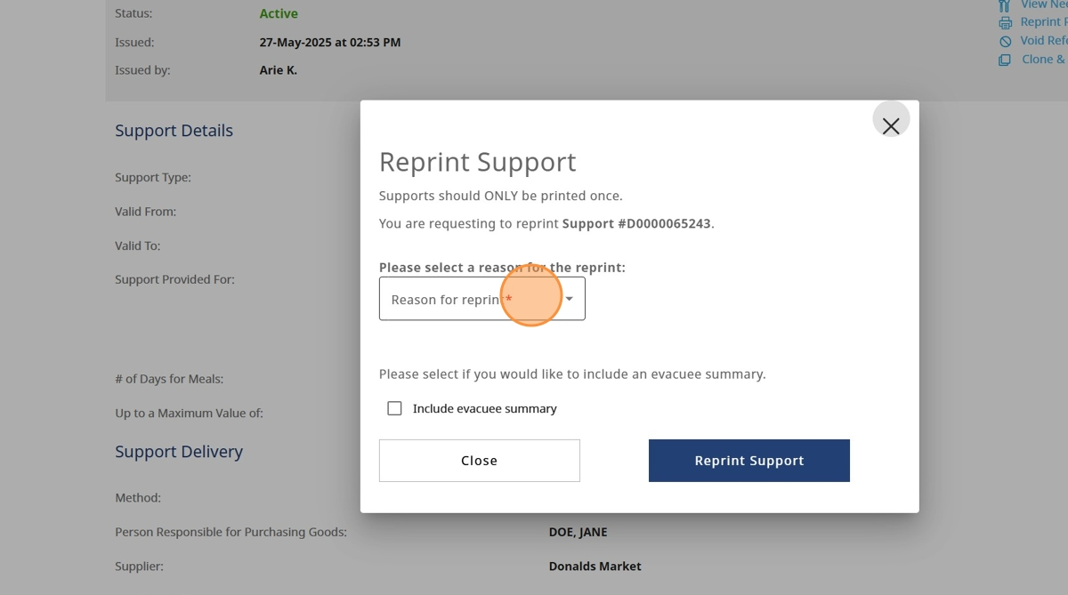

1. Click on the appropriate reason

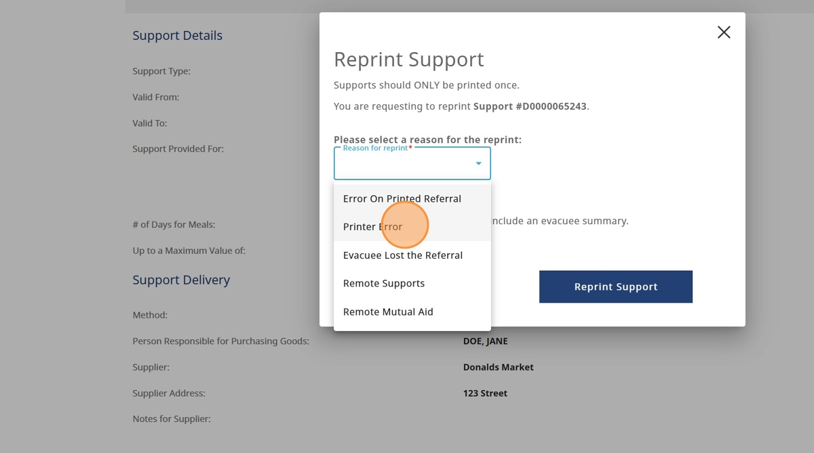

1. Click "Reprint Support"

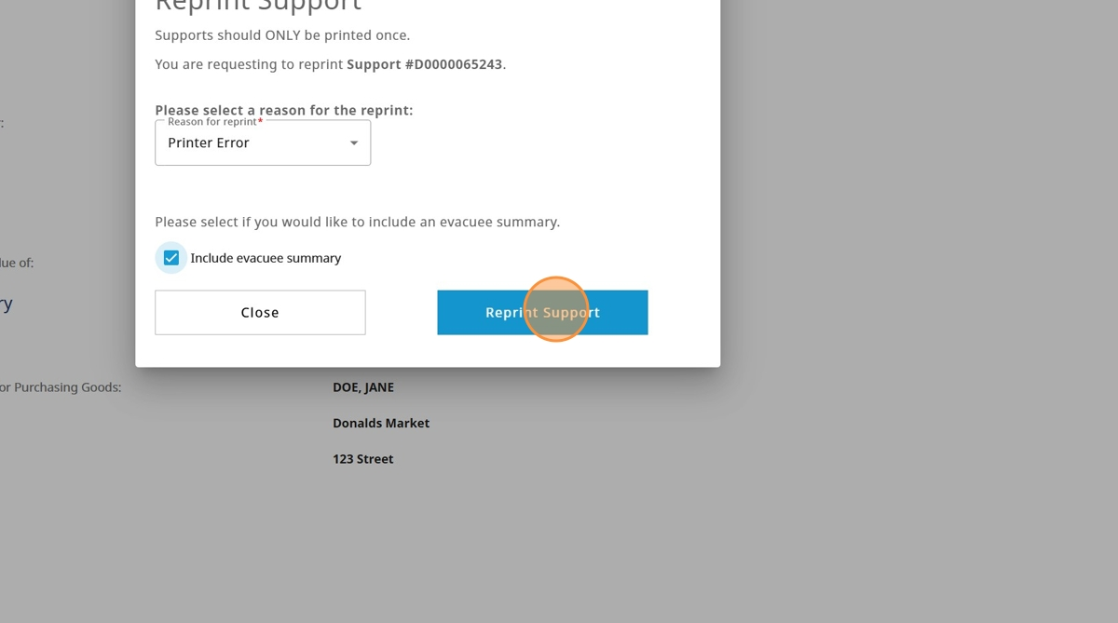

1. A pdf pop up will open that can be saved and printed

