# ERA User Guide: Editing a Supplier

## This guide provides a straightforward method for editing supplier details, ensuring you can efficiently manage supplier information. It outlines essential steps while highlighting limitations, such as the inability to change GST and RT numbers.

1. Navigate to <https://ess.gov.bc.ca/>

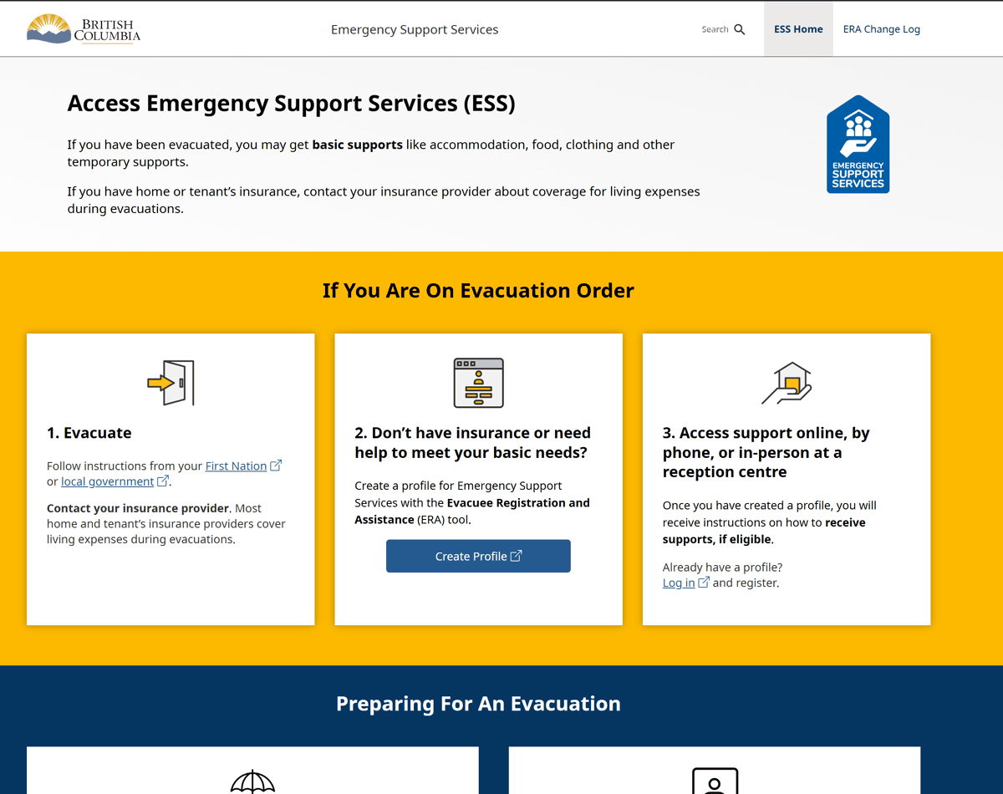

1. Scroll down and click "Responder Portal Login"

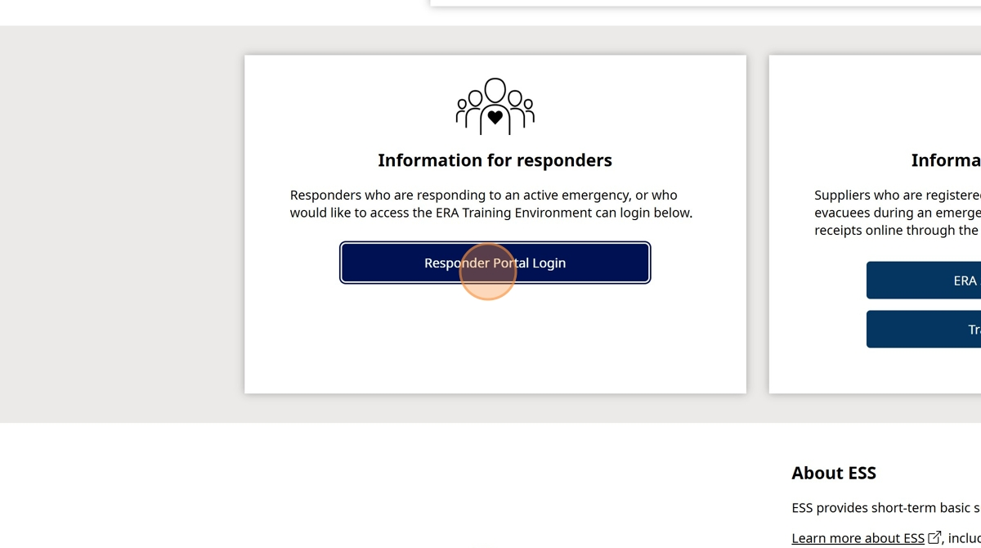

1. Click "Log in to Live"

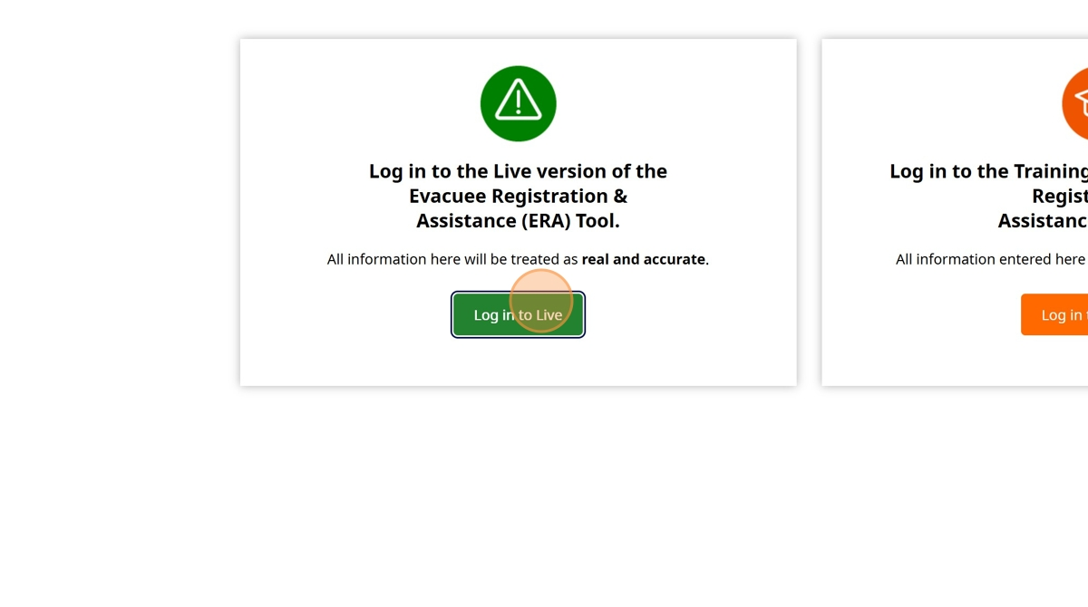

1. Enter your BCeID

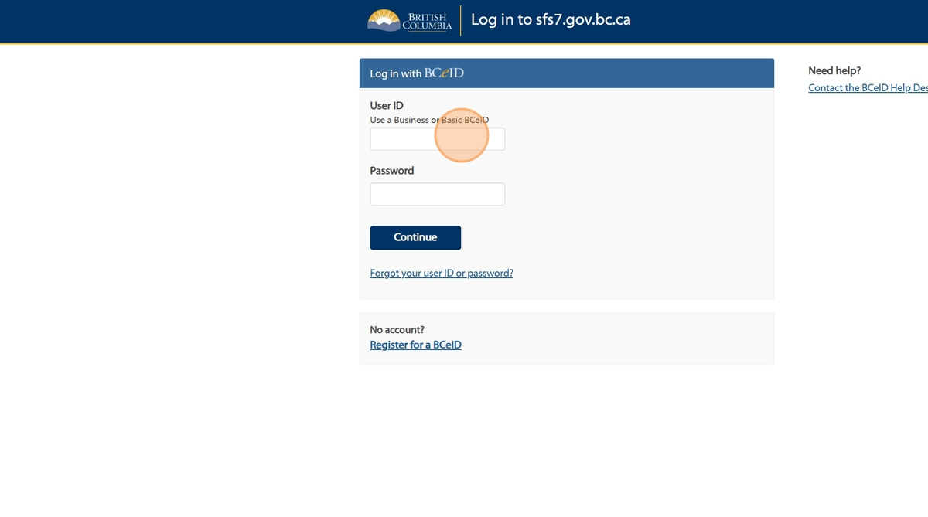

1. Enter your Password

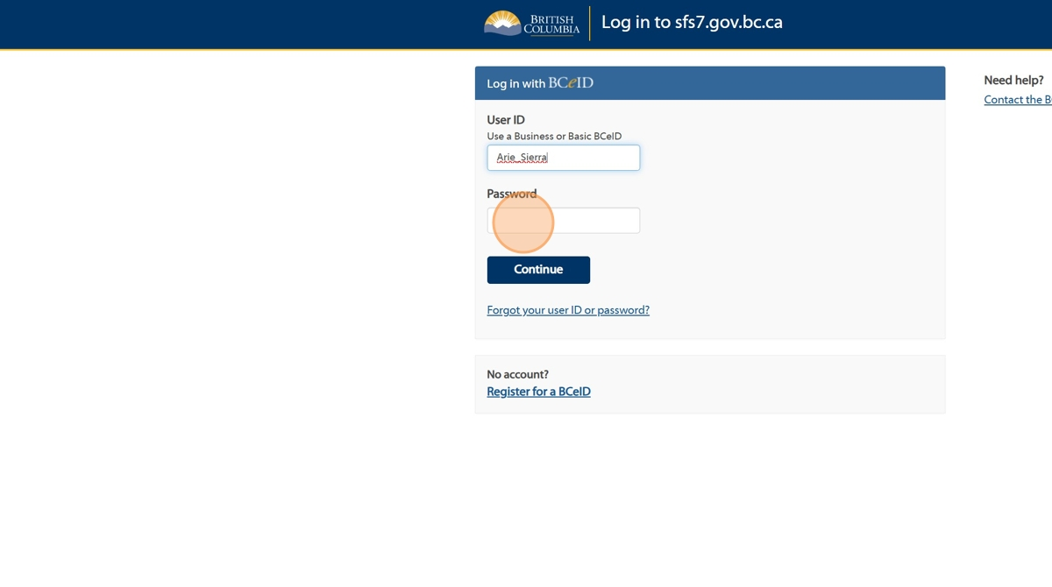

1. Click "Continue".

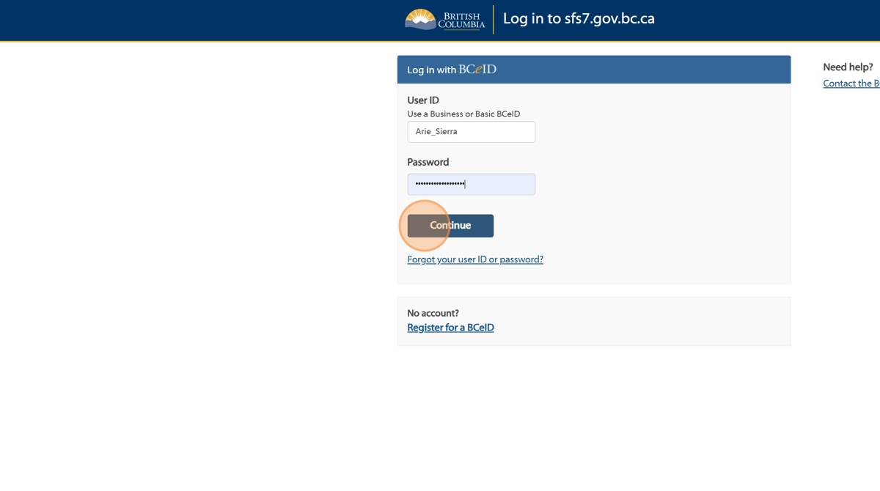

1. Click "Supplier Management"

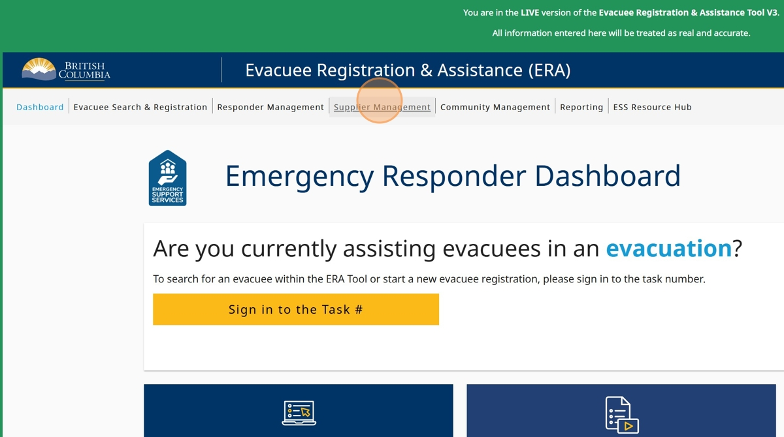

1. Click on the Supplier you'd like to Edit

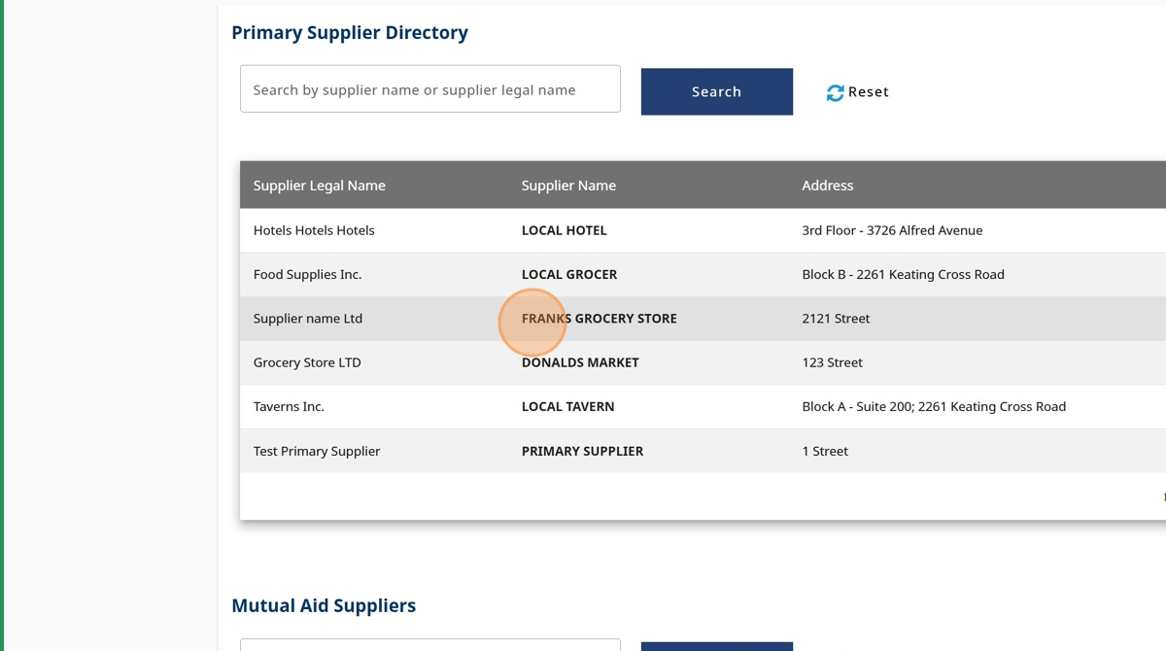

1. Click "Edit Supplier Details"

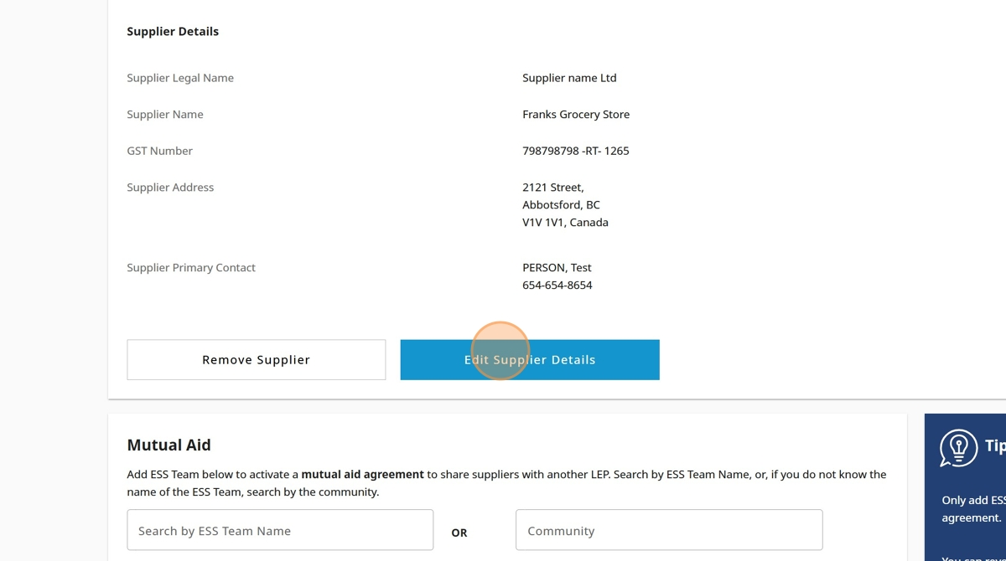

1. You can edit every detail of the Supplier with the exception of the GST and RT numbers that cannot be edited

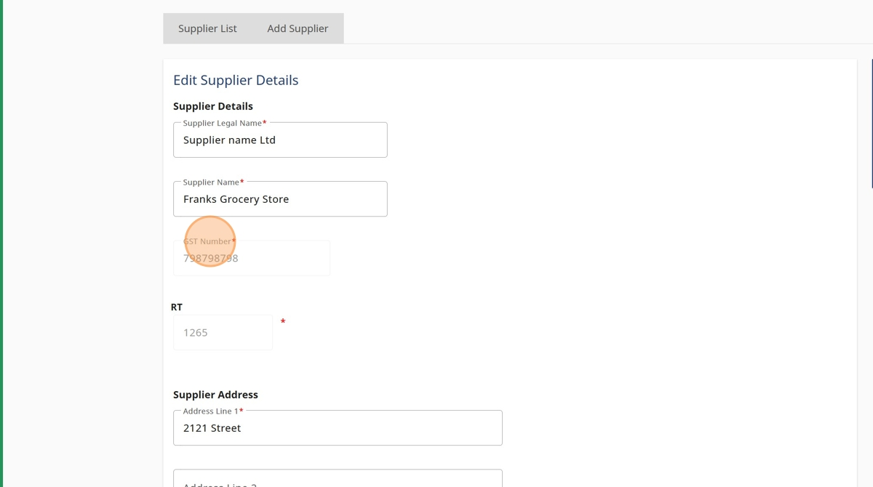

1. Once you are done editing the details, click "Next"

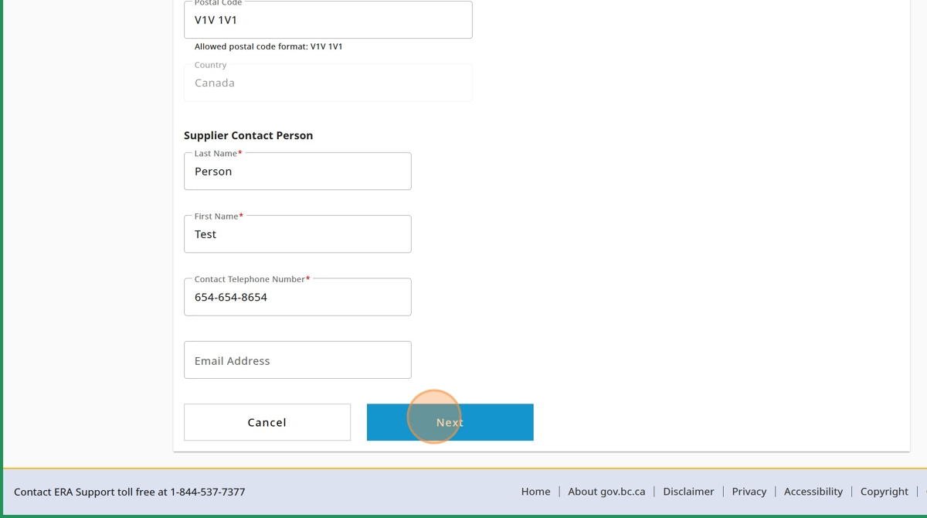

1. Click "Save Supplier".

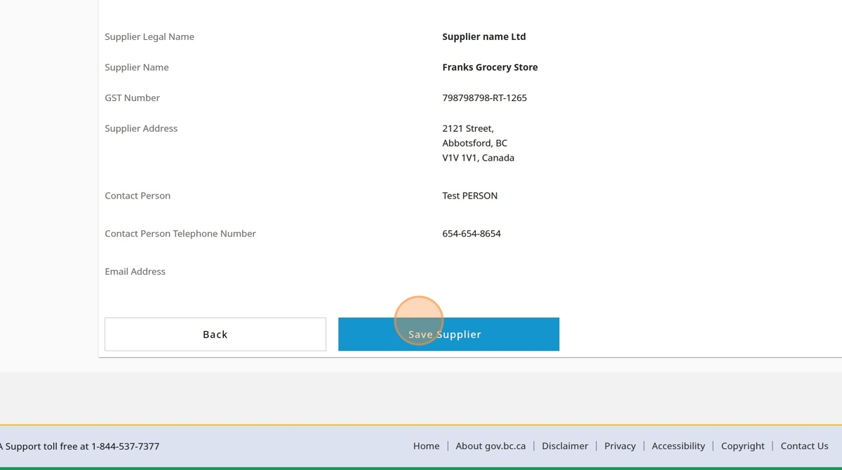

1. A confirmation message will notify you that the Supplier was edited, click "Close"

