# ERA User Guide: Deactivating a Supplier

## This guide provides essential instructions for efficiently deactivating a supplier, ensuring you understand the impact on shared suppliers.

1. Navigate to <https://ess.gov.bc.ca/>

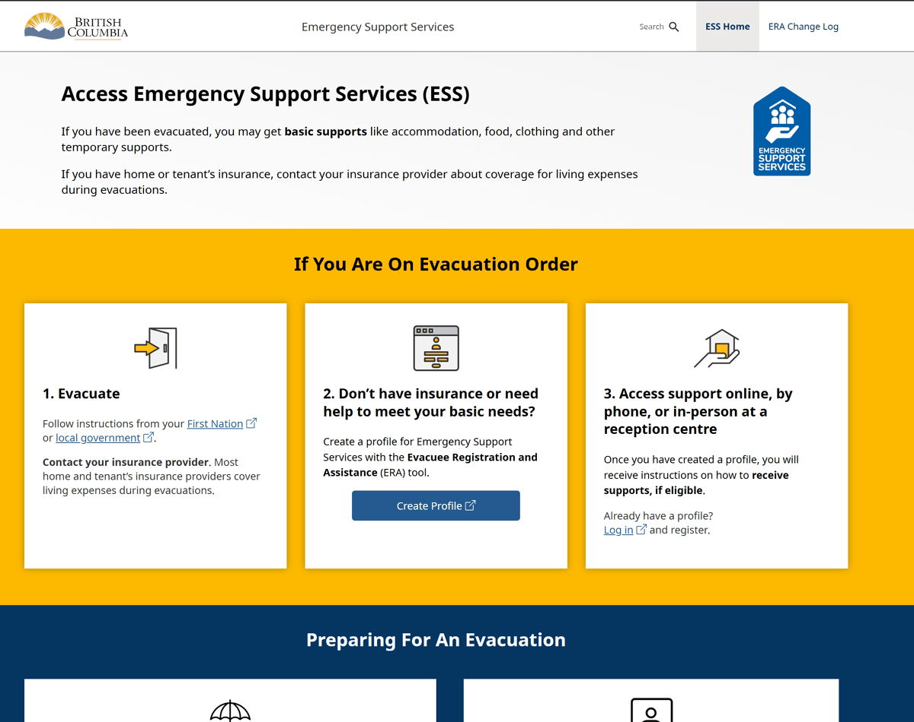

1. Scroll down and click "Responder Portal Login"

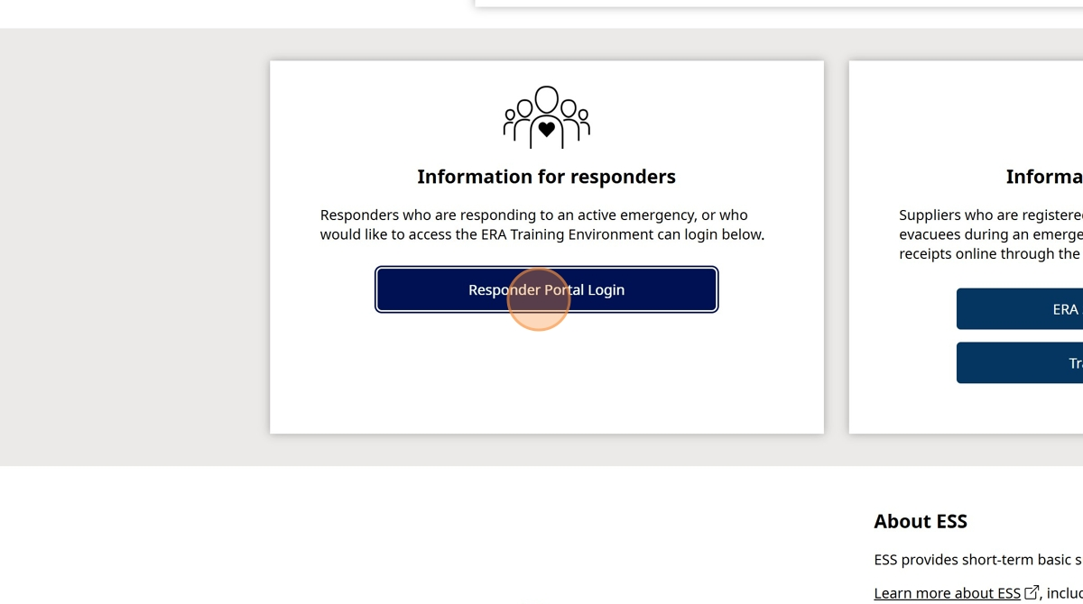

1. Click "Log in to Live"

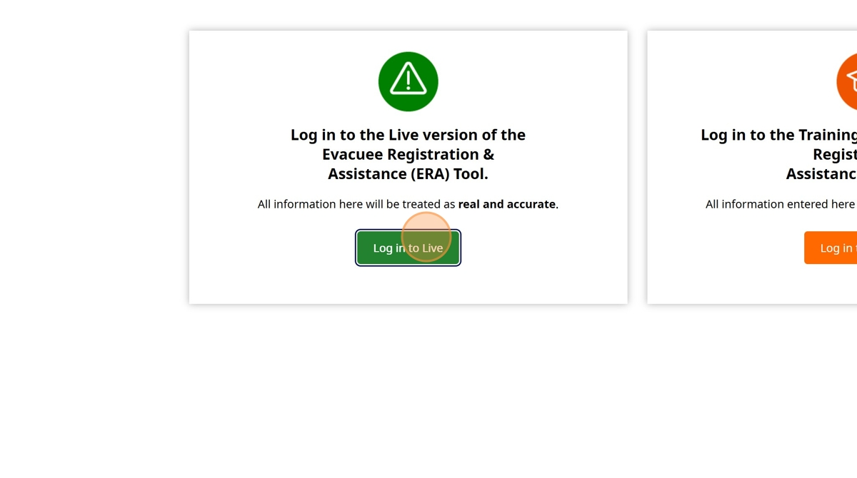

1. Enter your BCeID

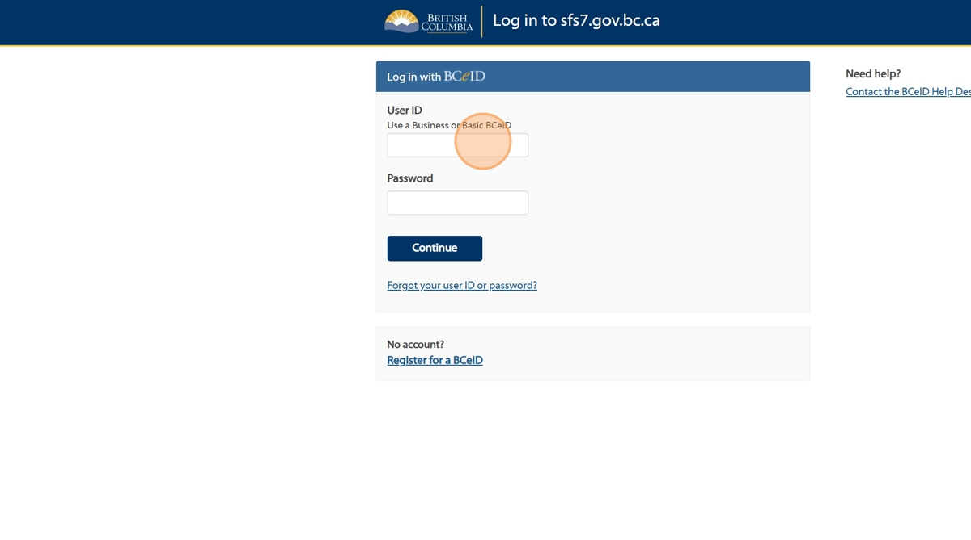

1. Enter your Password

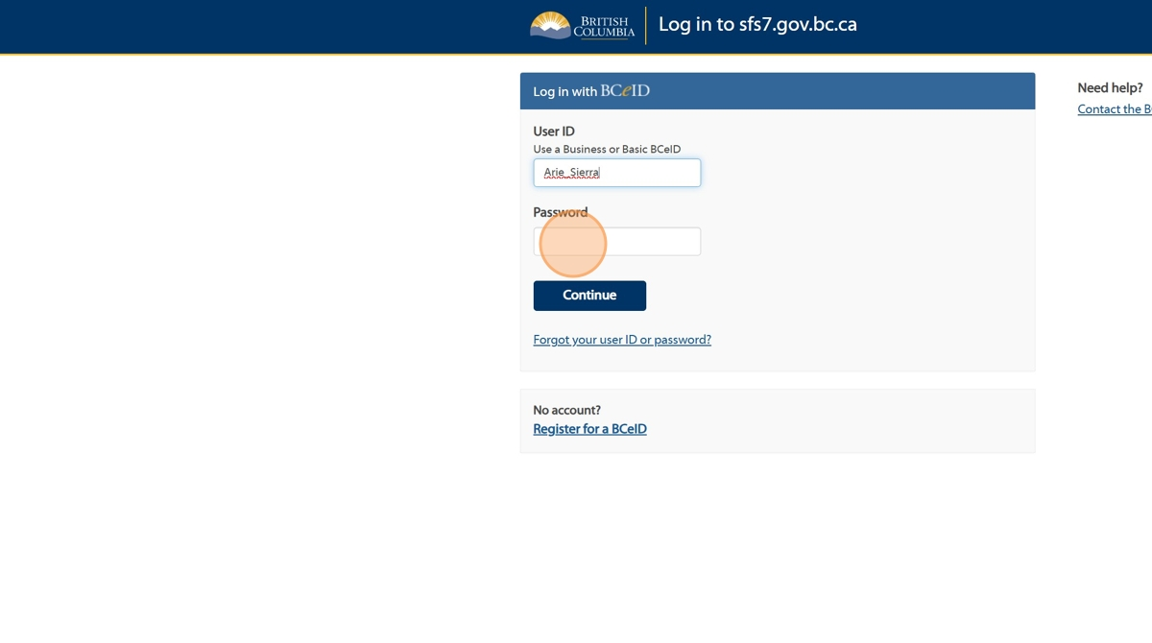

1. Click "Continue".

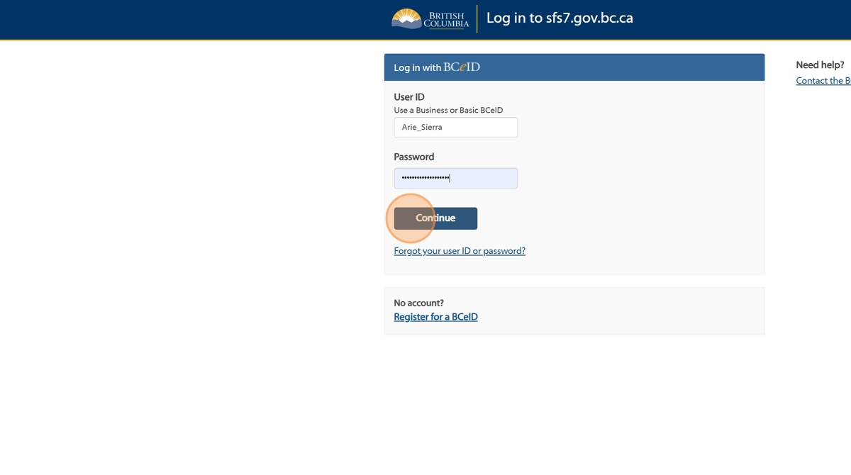

1. Click "Supplier Management"

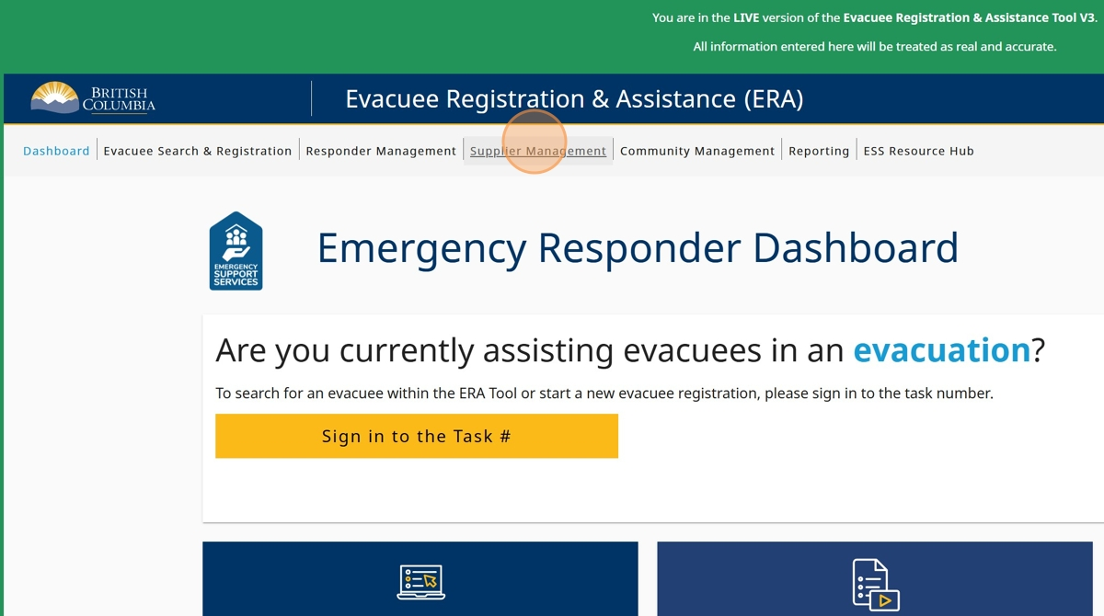

1. Click on the "Active" button under the 'Status' Column for the supplier you'd like to deactivate

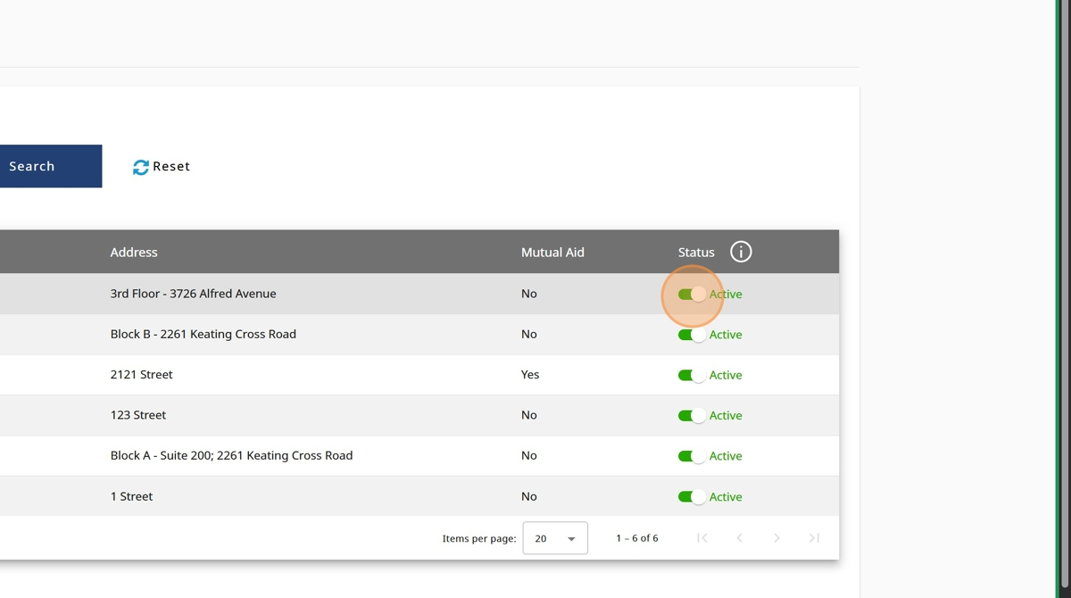

1. The suppliers status will change to "Deactivated"

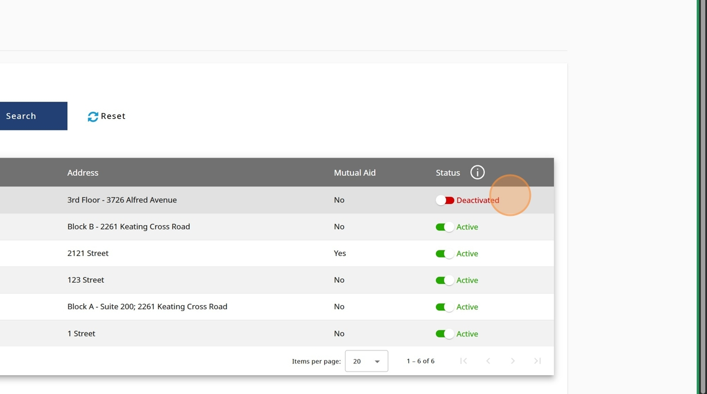

1. If you deactivate a supplier that was shared with another ESS Team via Mutual Aid, you will receive this notification. Click "Continue" if you'd like to proceed

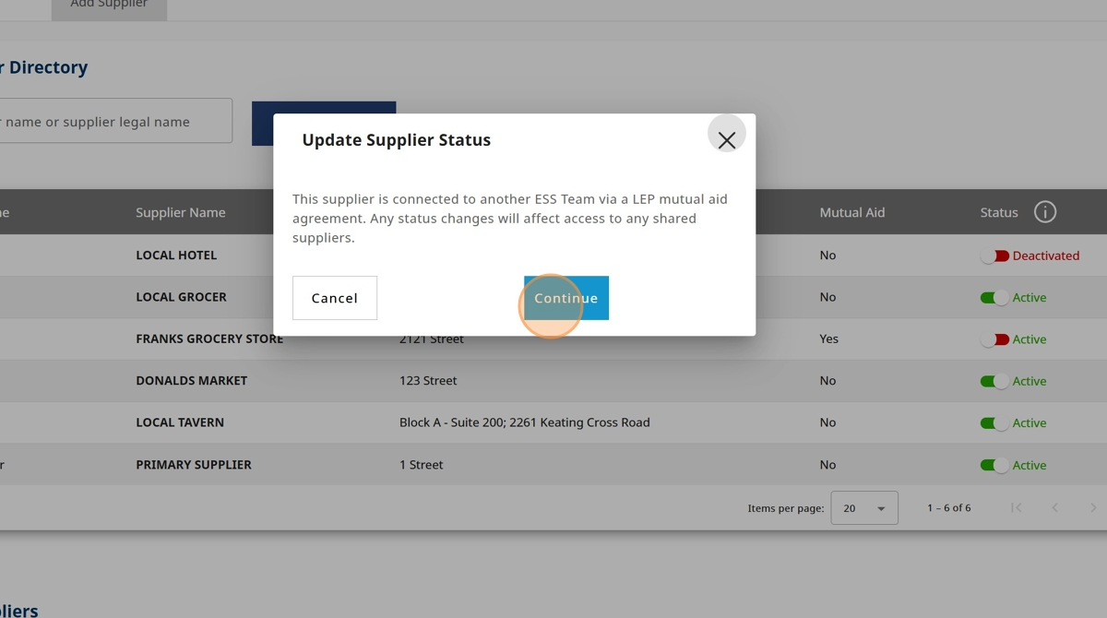

1. The suppliers status will change to "Deactivated"

