# ERA User Guide: Creating an ERA Profile with a BC Services Card Account

## This guide provides a step-by-step walkthrough for creating an Evacuee Registration and Assistance (ERA) profile using the BC Services Card app, ensuring that users can easily navigate the process.

1. Navigate to <https://ess.gov.bc.ca/> scroll down and click "Create Profile"

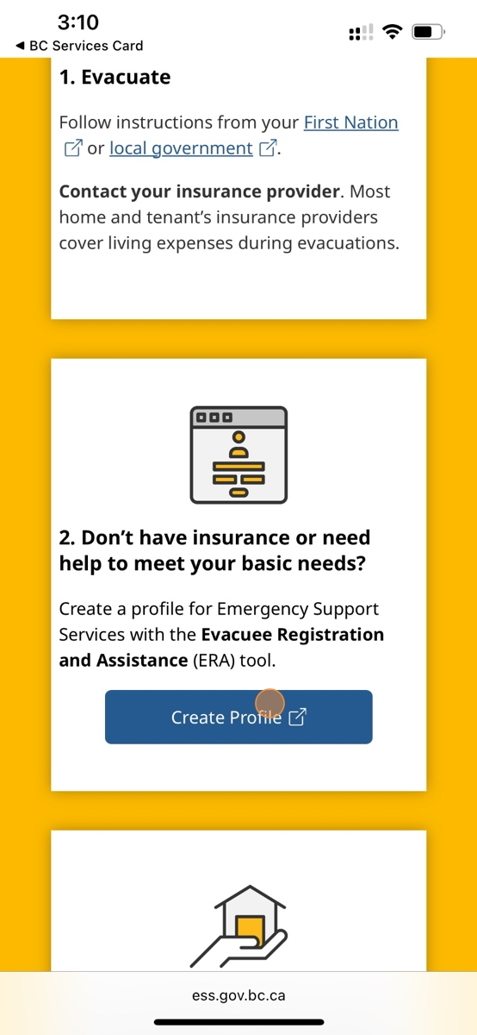

1. Click "Log in with BC Services Card"

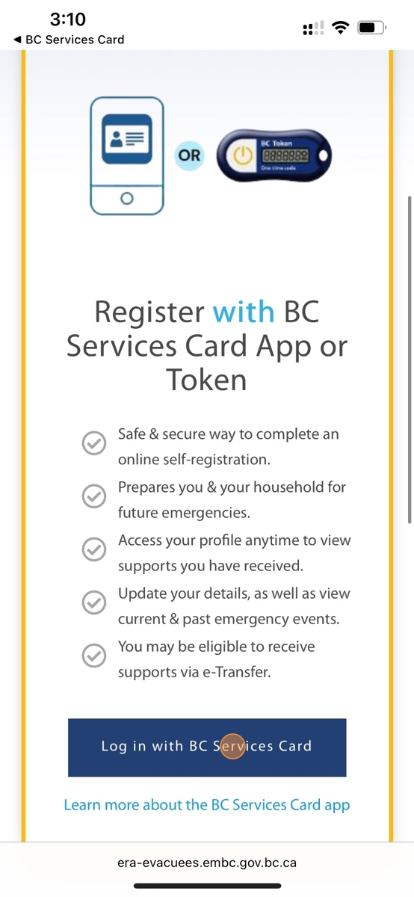

1. Click "BC Services Card App"

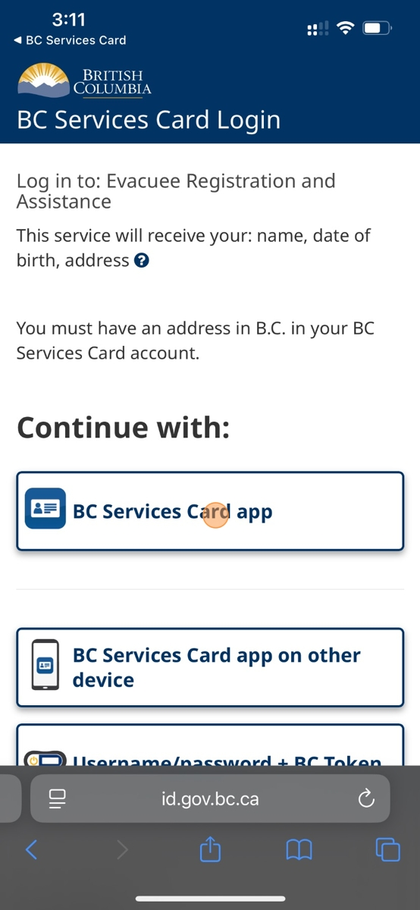

1. Tap "Open".

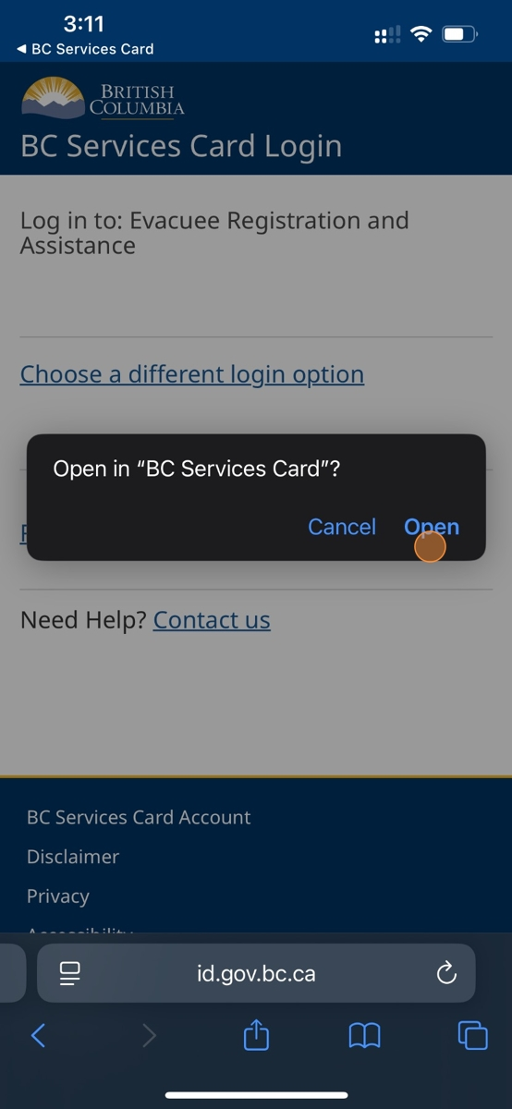

1. Your First Name will appear under the "Continue as" field, click on the name

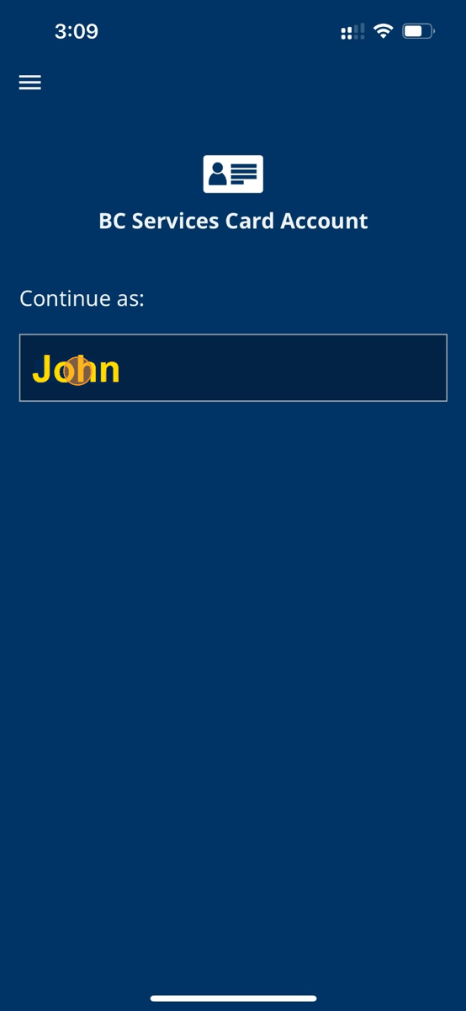

1. Tap here.

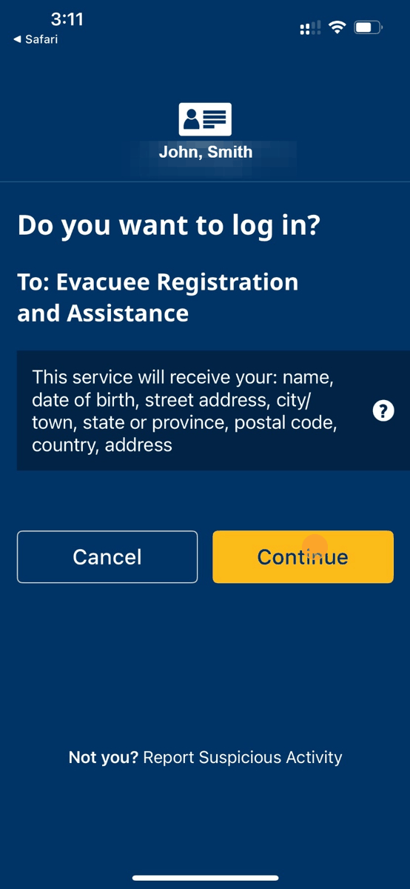

1. Tap here.

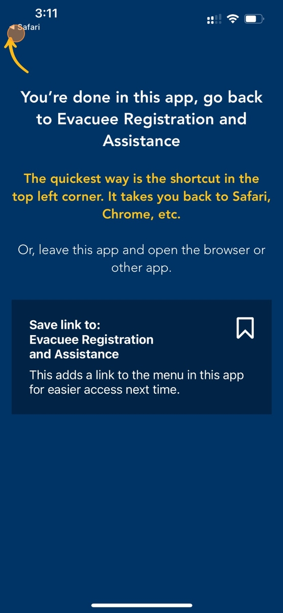

1. You will need to read the Data Collection Notice

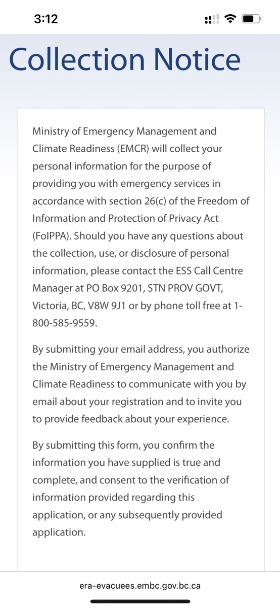

1. After reading the notice, scroll down and click "Next"

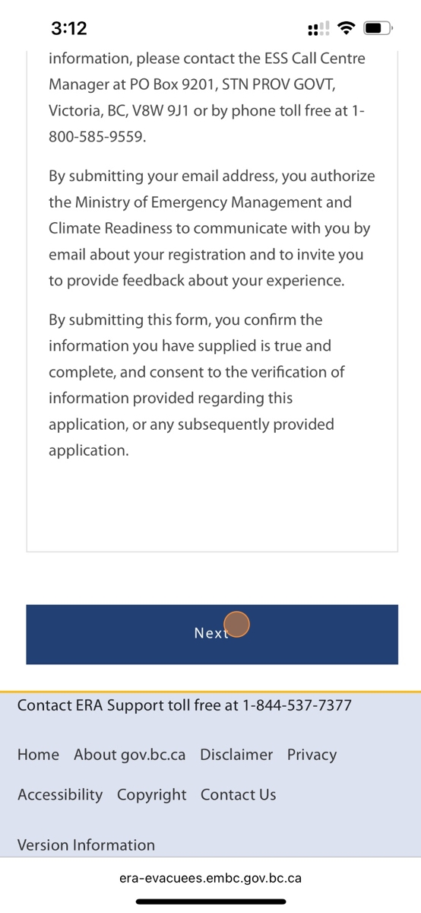

1. You will be asked if you wish to provide consent to share registration status, click on the circle besides the "Yes" or "No" options

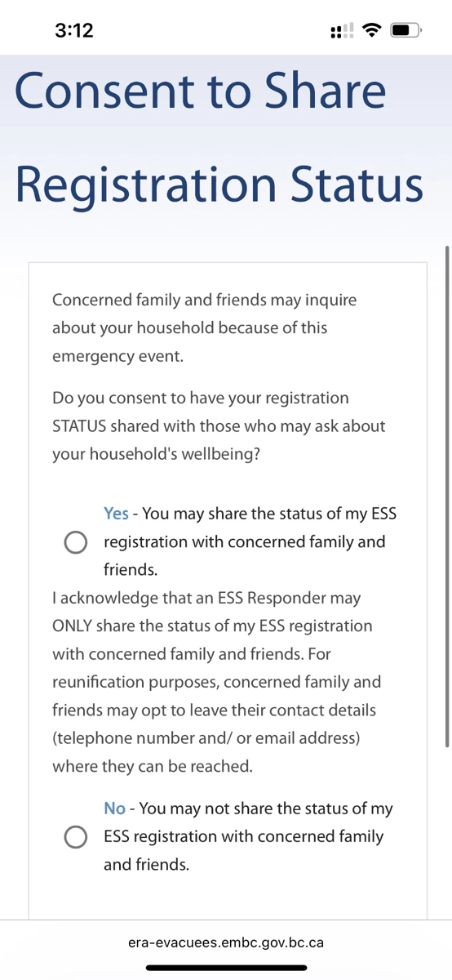

1. Review your Personal Details. Your First and Last Name will auto-fill from your BC Services Card and cannot be edited.

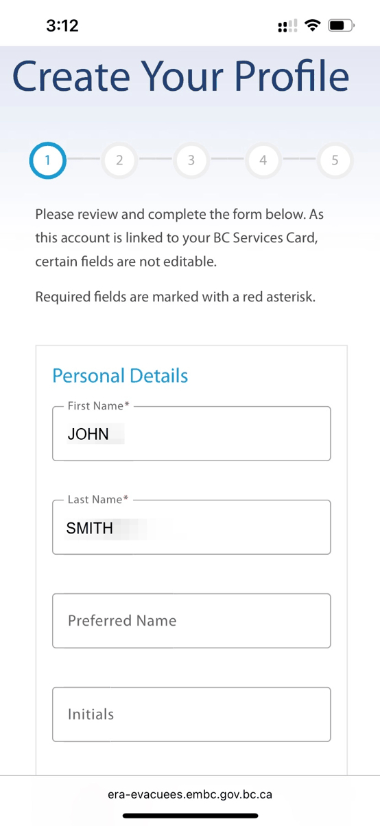

1. Click on the "Gender" field

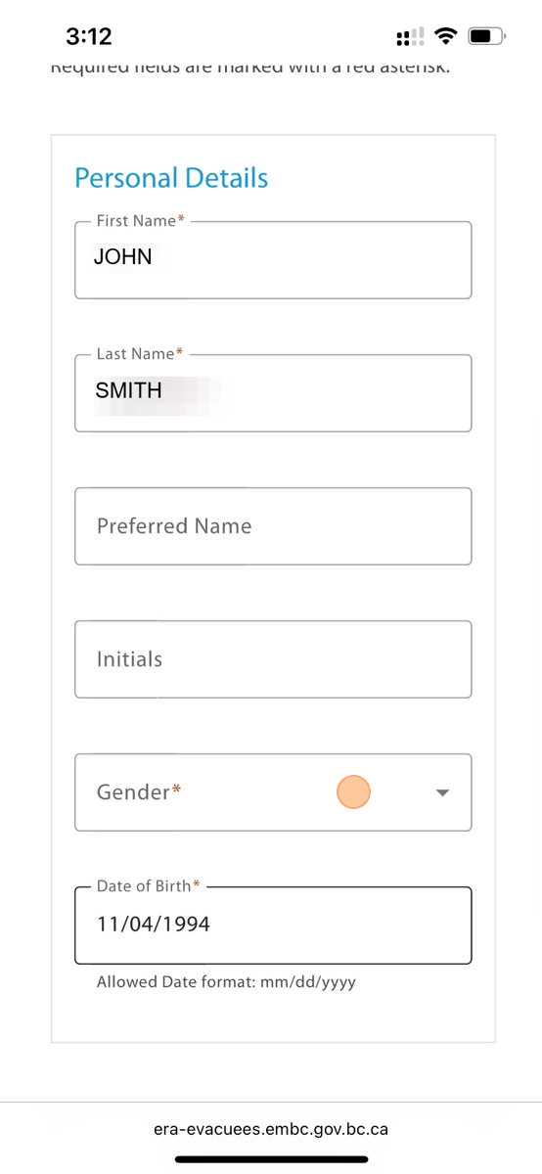

1. Select the Gender you identify as

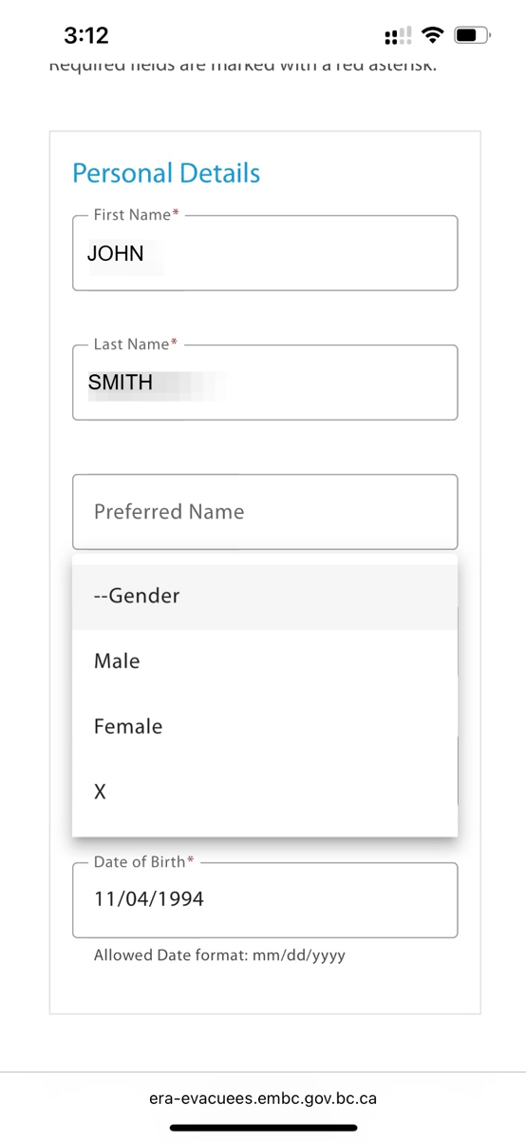

1. Your Date of Birth will auto-fill from your BC Services Card and cannot be edited.

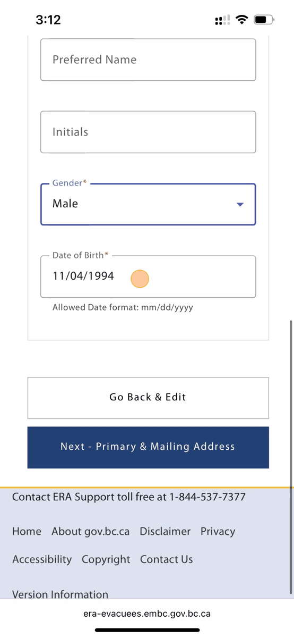

1. Click "Next - Primary & Mailing Address"

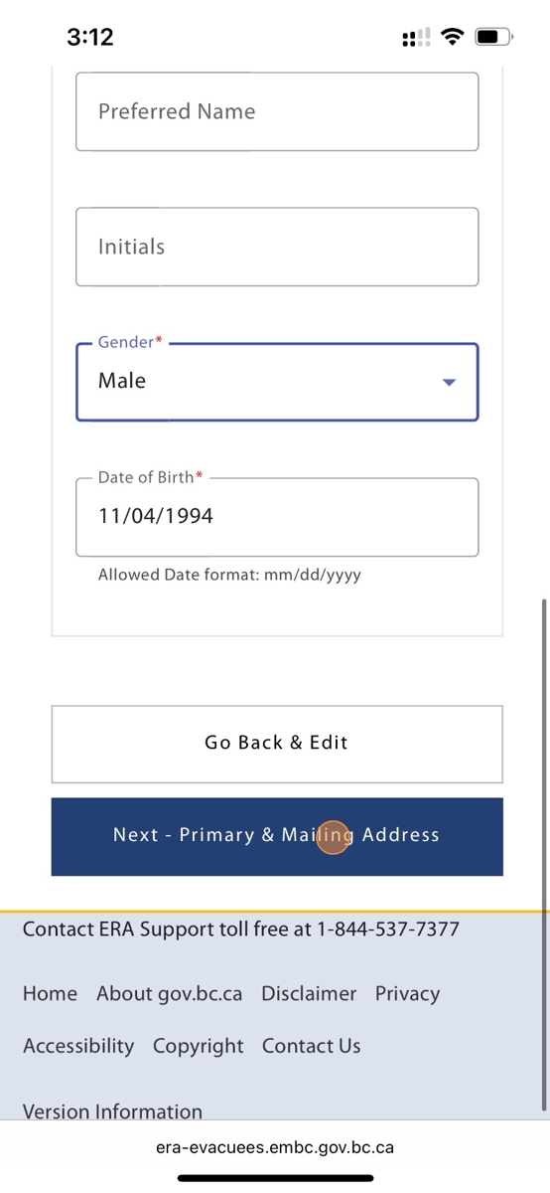

1. Review your Primary Address. Address Line 1 will auto-fill from your BC Services Card. Click on the "City" field to continue.

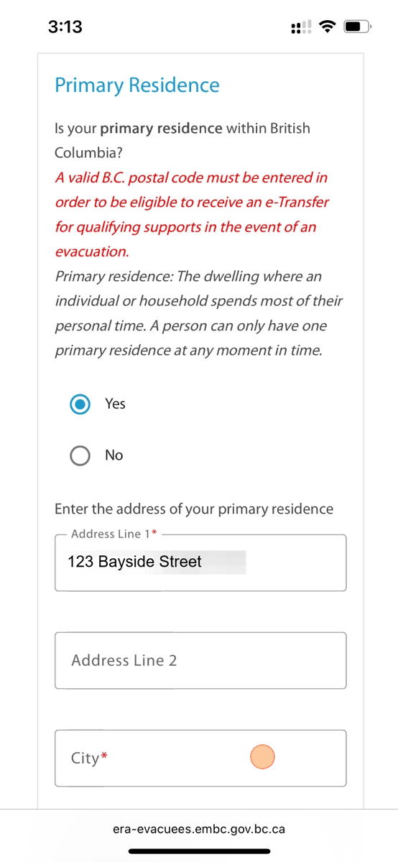

1. Search for the City and select it from the Drop Down options

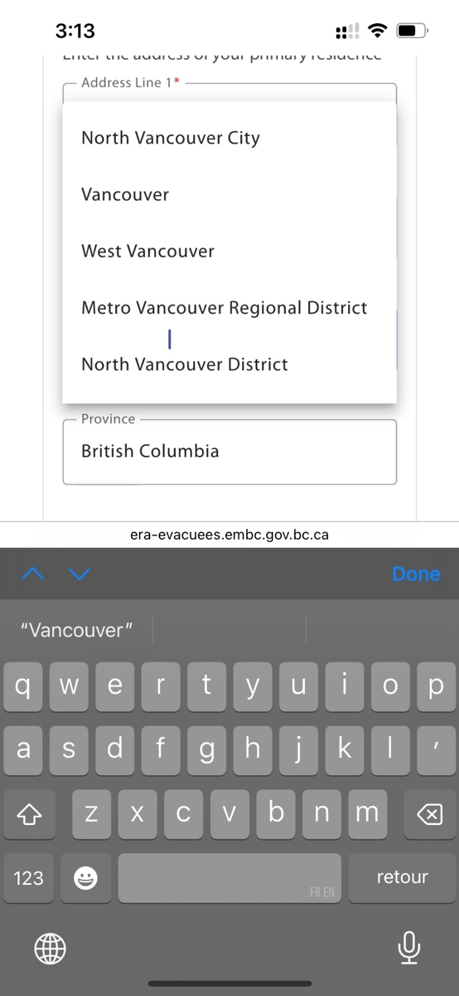

1. Enter your postal code

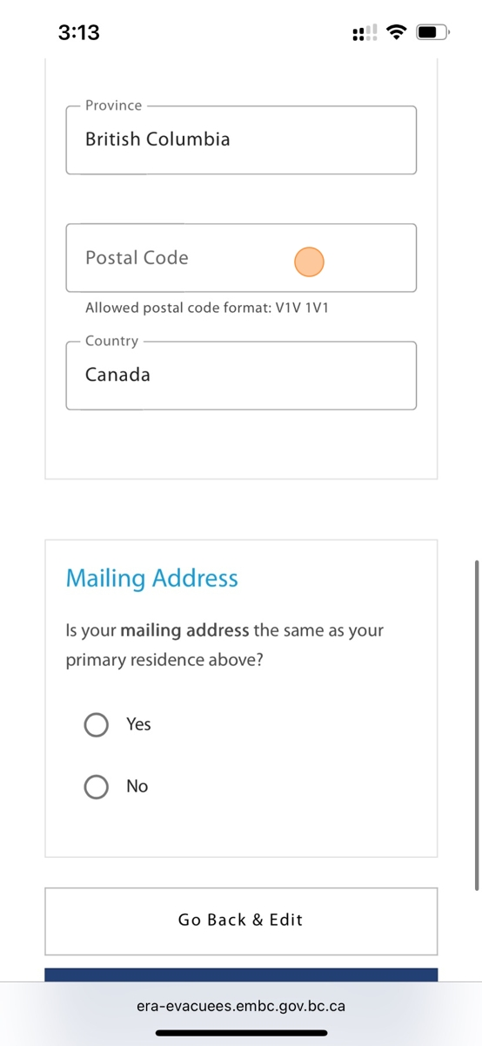

1. Confirm if your Mailing Address is the same as your Primary Address. If not, you’ll be prompted to enter it.

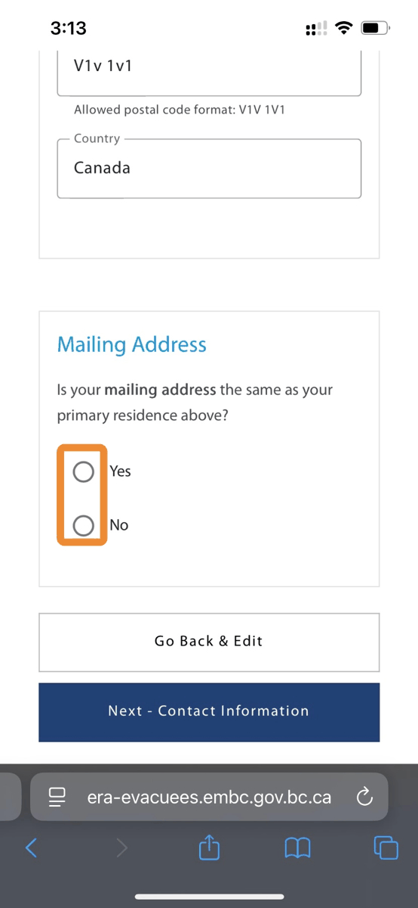

1. Click "Next - Contact Information"

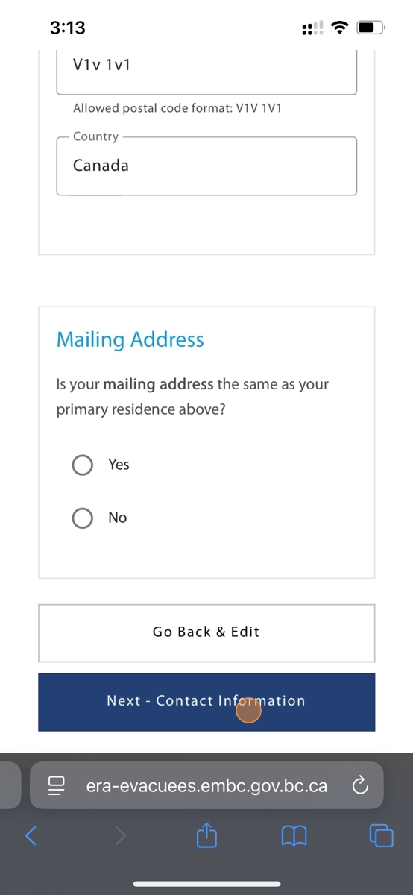

1. Confirm if you wish to be contacted regarding emergency situations

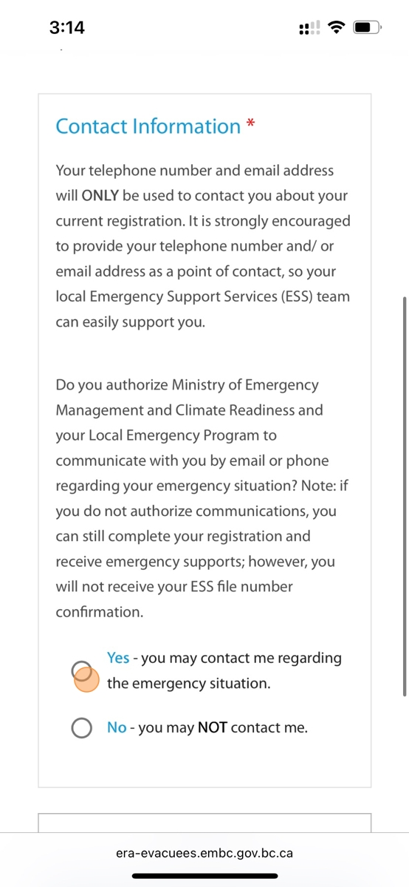

1. If you selected Yes, provide your Telephone Number and Email Address

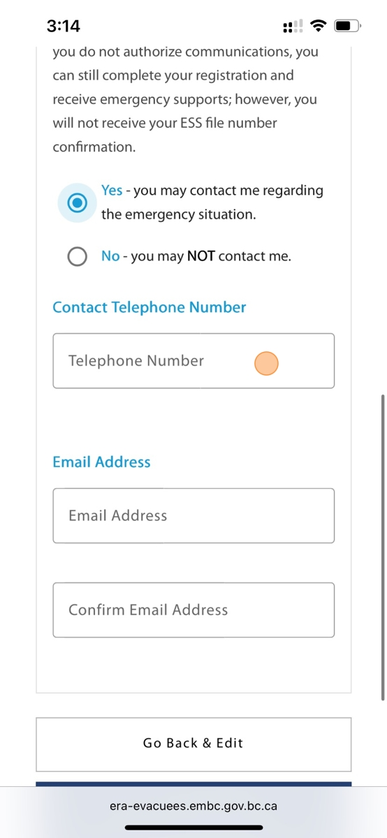

1. Once you are finished providing your contact information, click "Next"

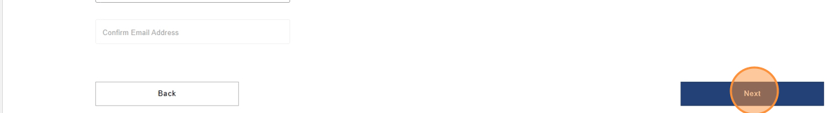

1. Set up security questions for your profile. An ESS Responder may ask these to access your information. Click on the first "Security Question" field

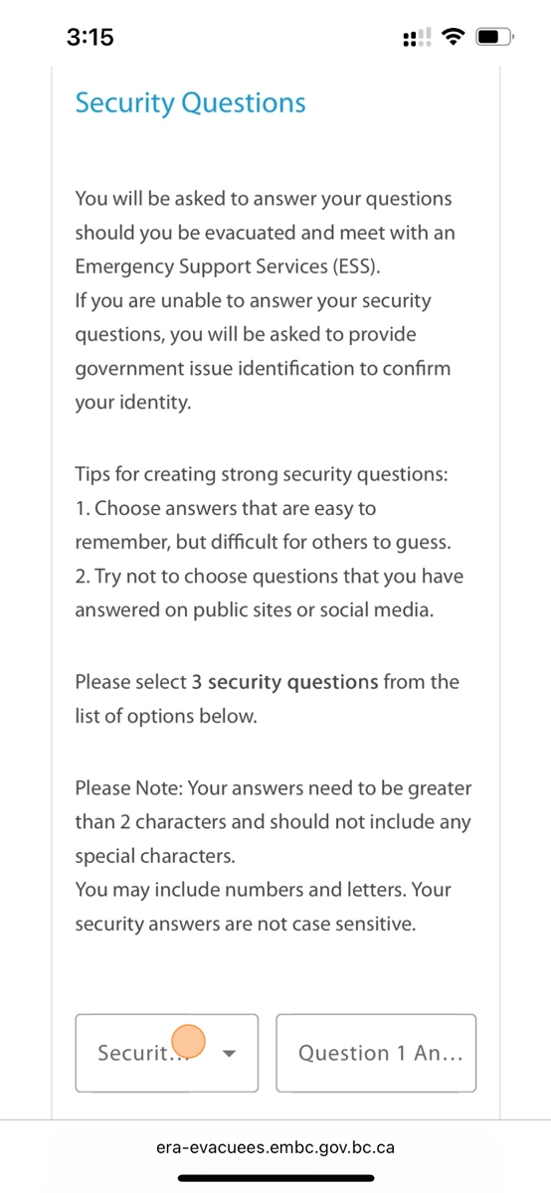

1. Select an option from the drop down list of security questions

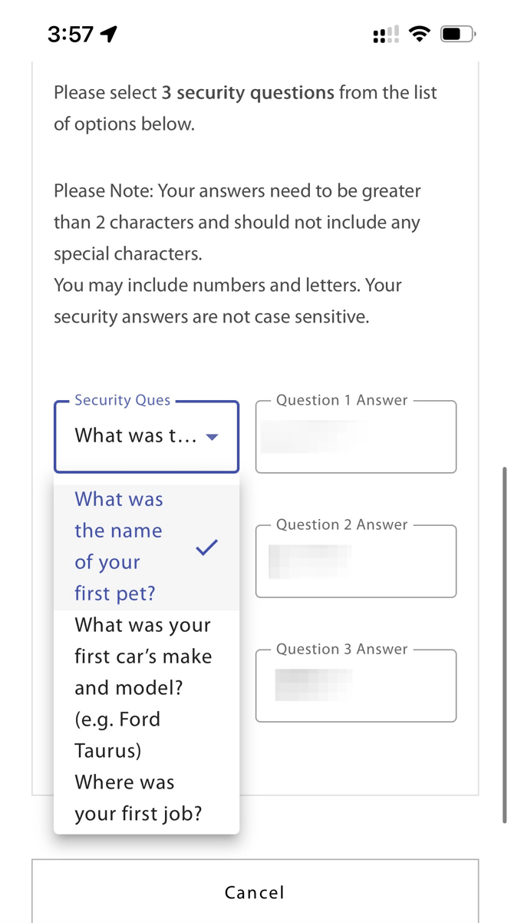

1. Enter your security question answer

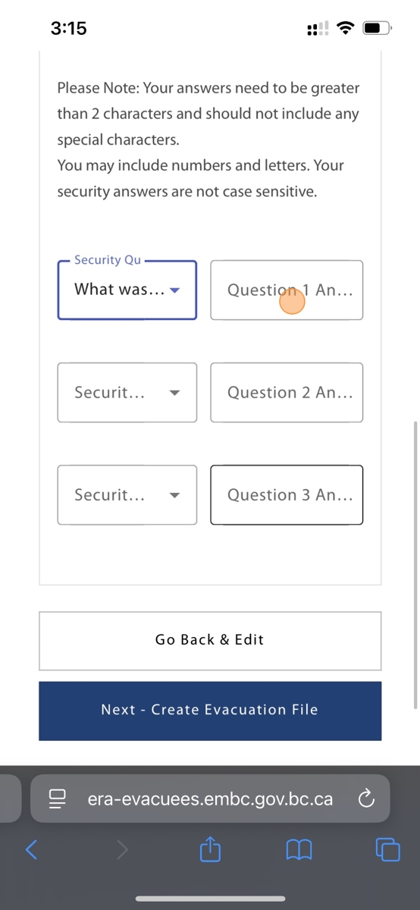

1. Once you have finished selecting 3 security questions and 3 security answers, click "Next"

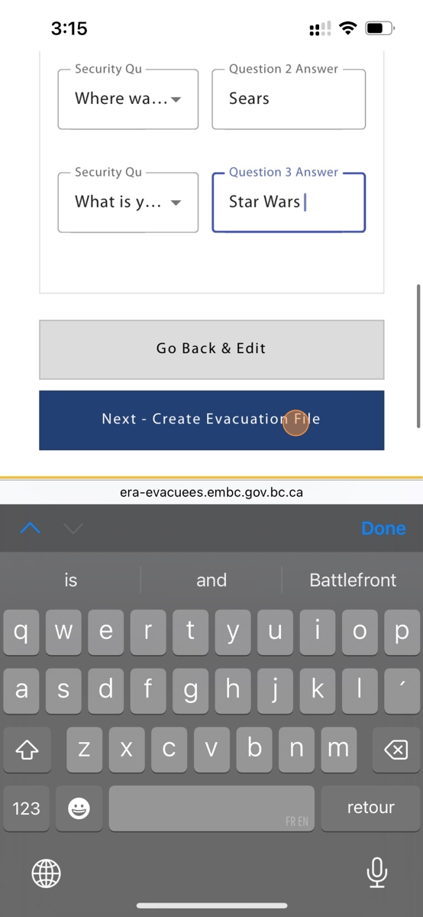

1. You will now be able to review your profile information. If you need to make changes, click on the blue pencil icon

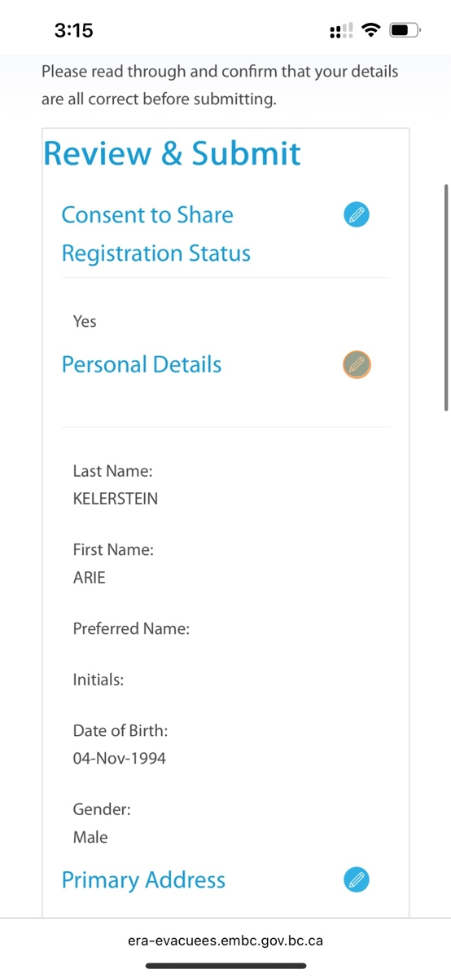

1. If everything is correct, click "Save & Submit"

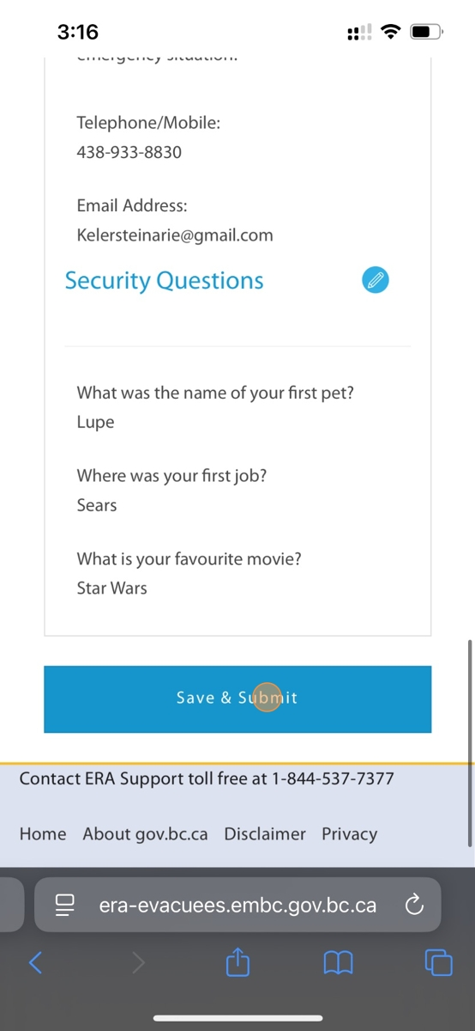

1. You will now be re-directed to your ERA Profile Homepage

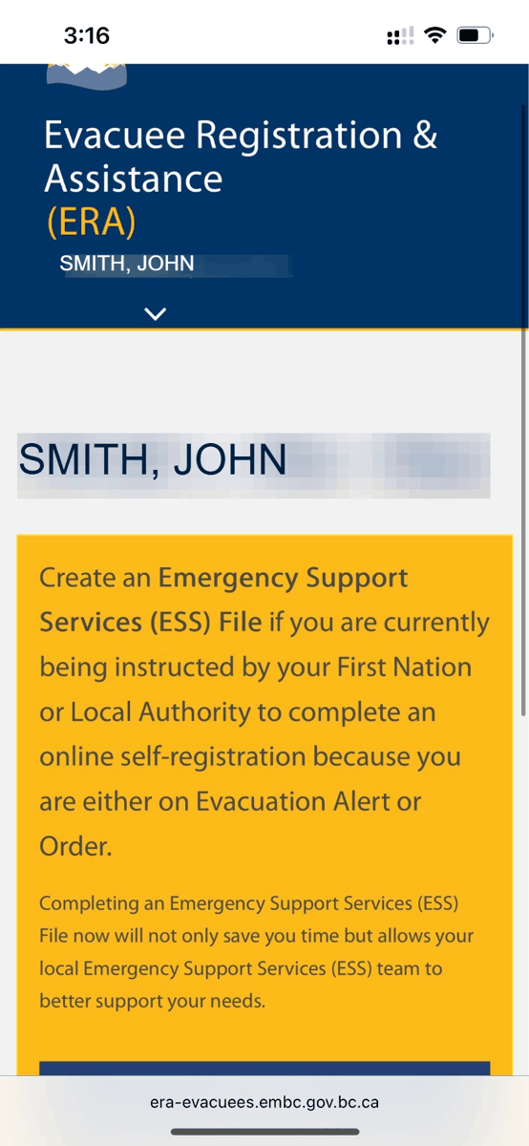

1. You will also receive an email confirming your User Profile has been created

