# Adding a New Supplier

1. Navigate to <https://ess.gov.bc.ca/>

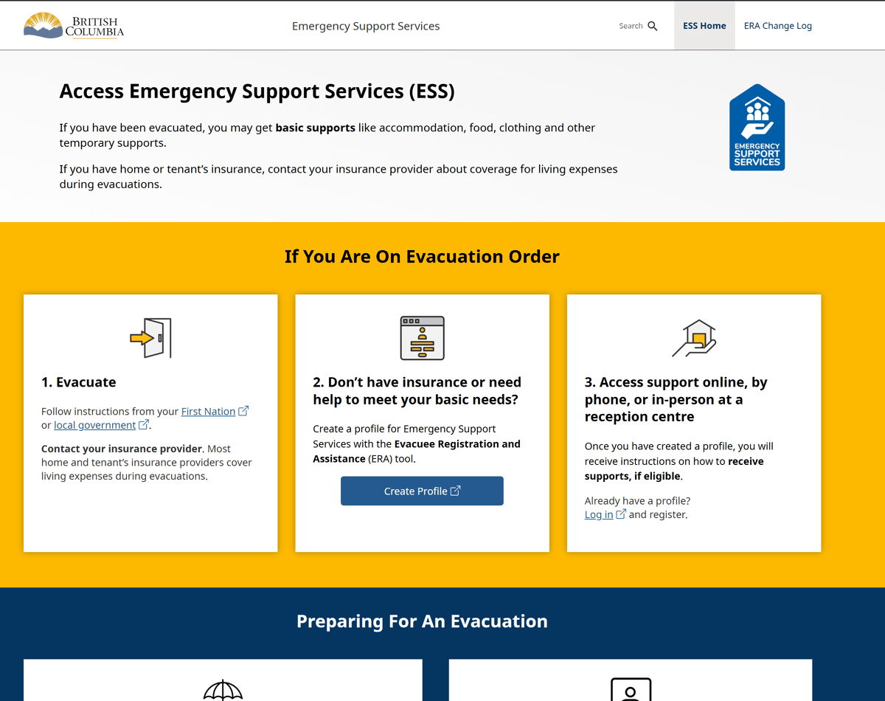

1. Scroll down and click "Responder Portal Login"

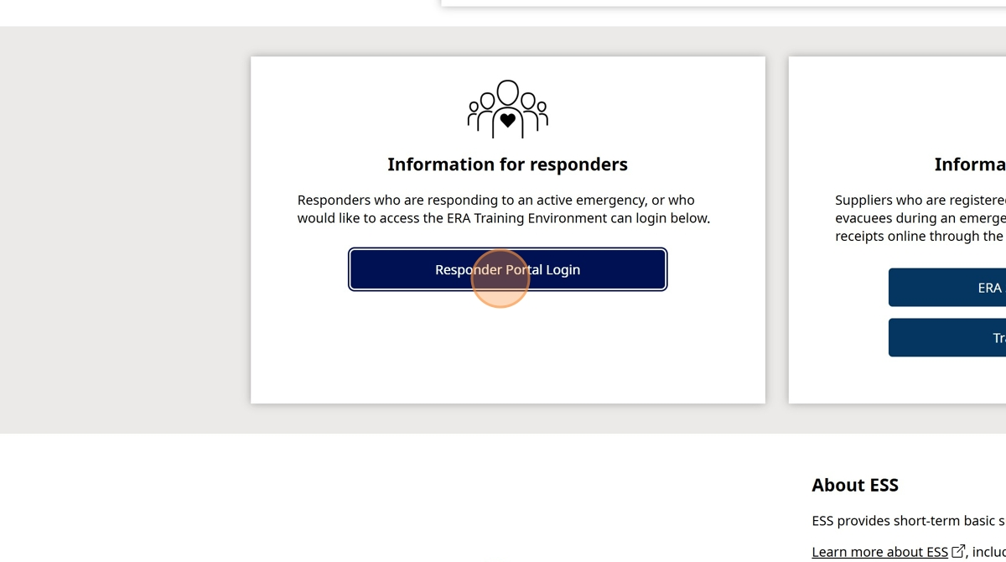

1. Click "Log in to Live"

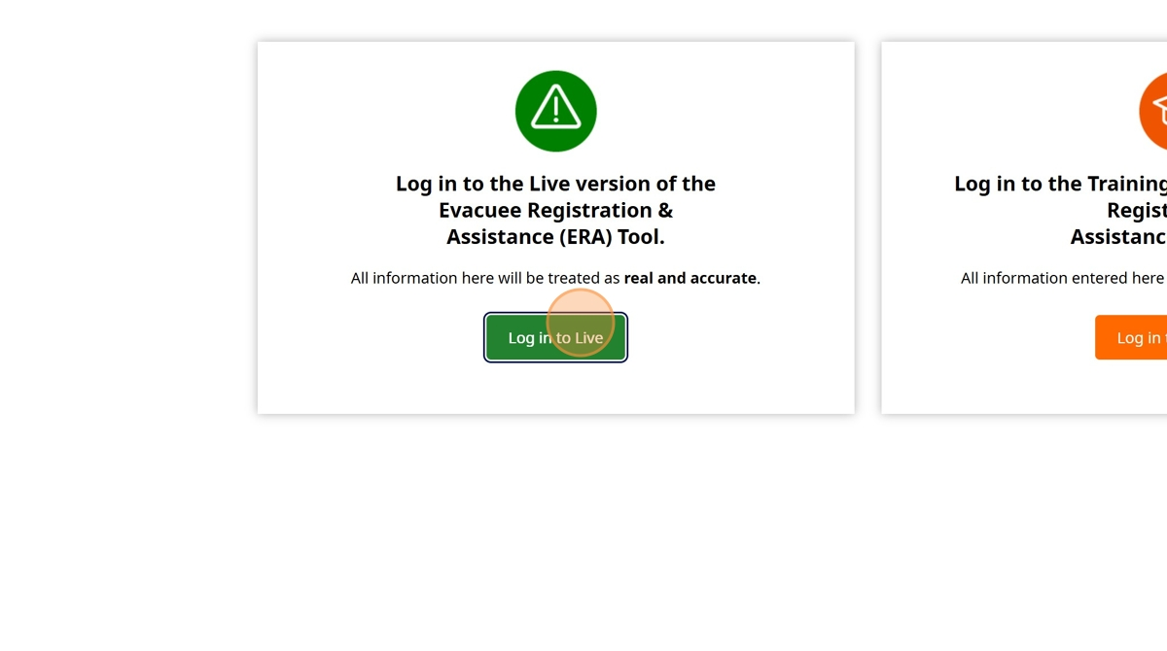

1. Enter your BCeID

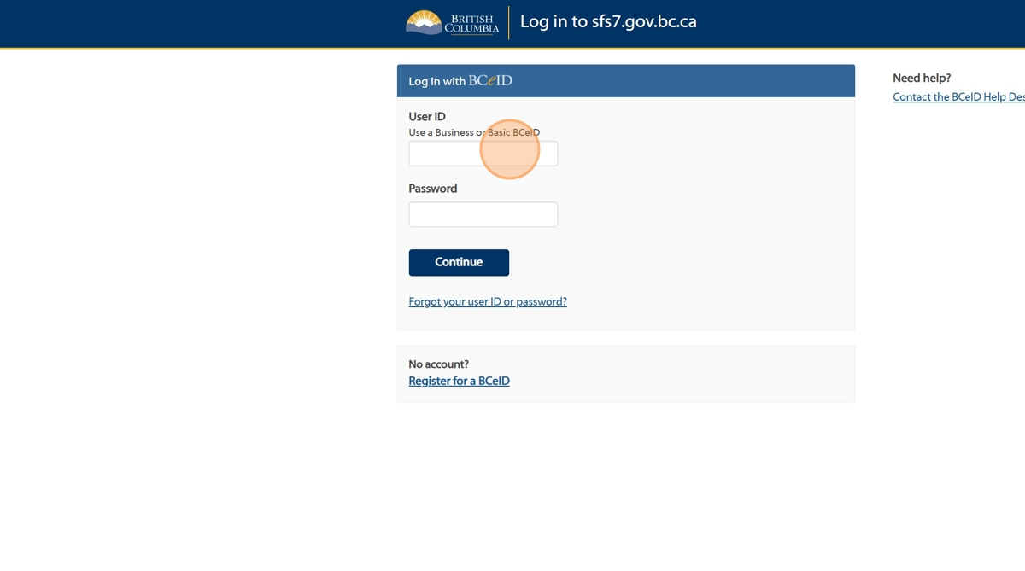

1. Enter your Password

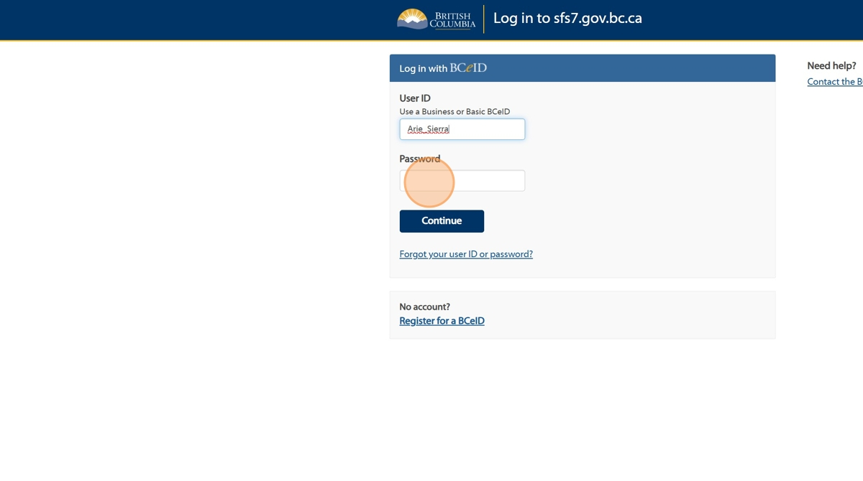

1. Click "Continue".

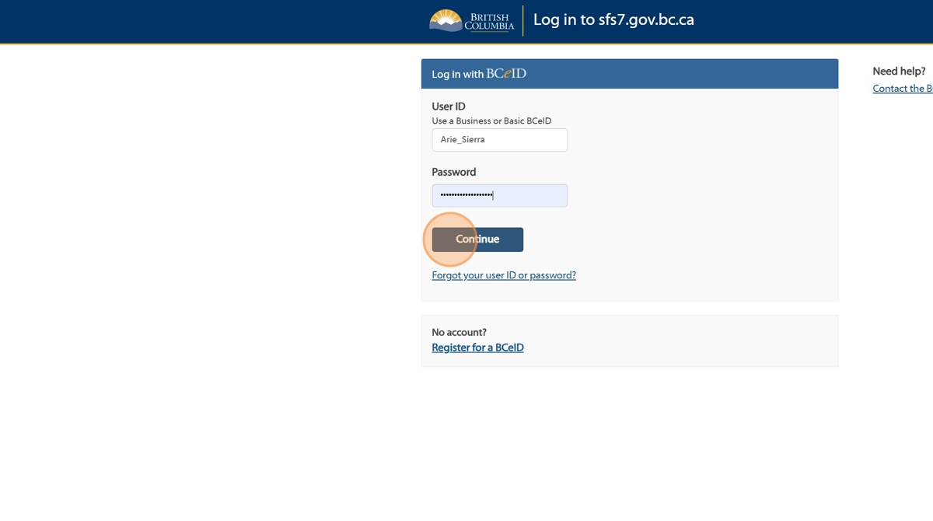

1. Click "Supplier Management"

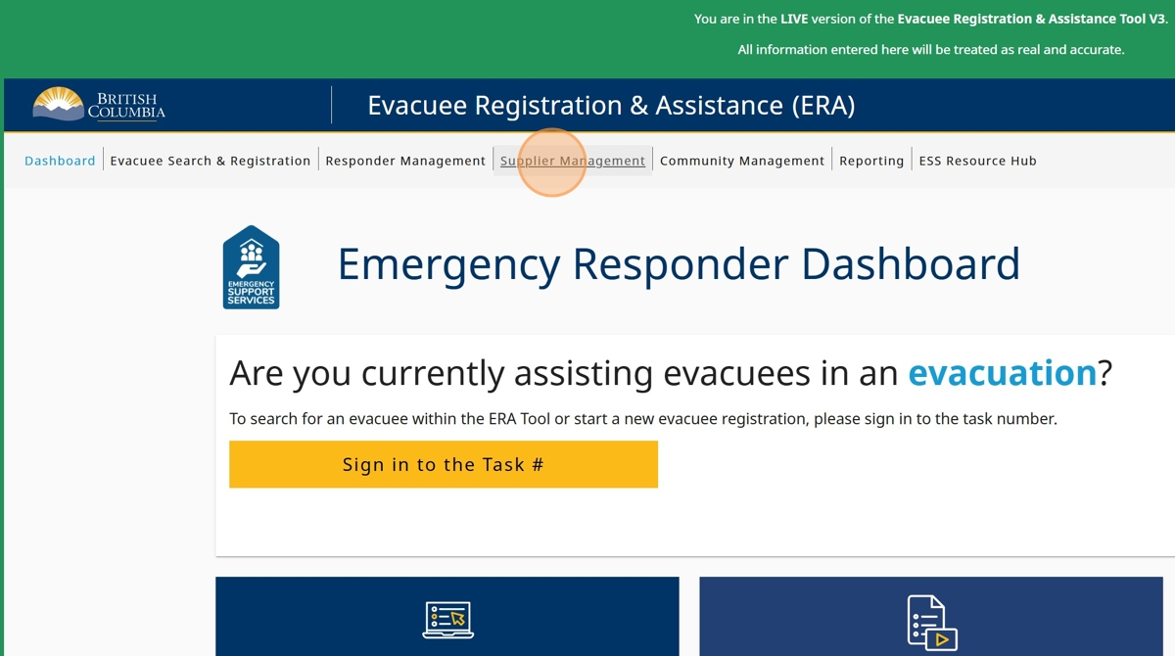

1. Click "Add Supplier"

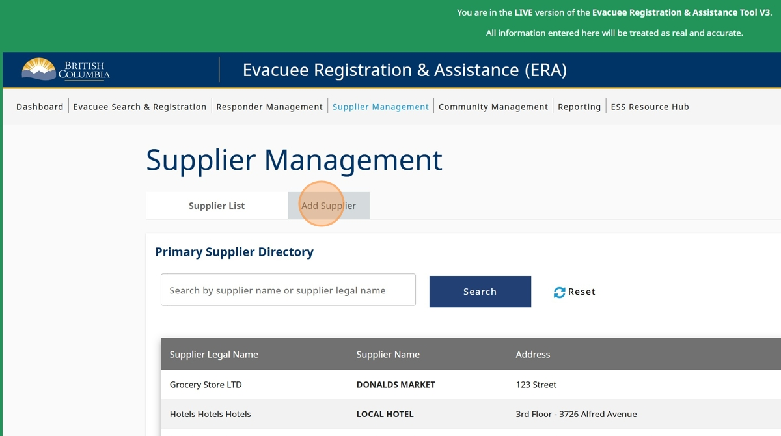

1. Enter the "Supplier Legal Name"

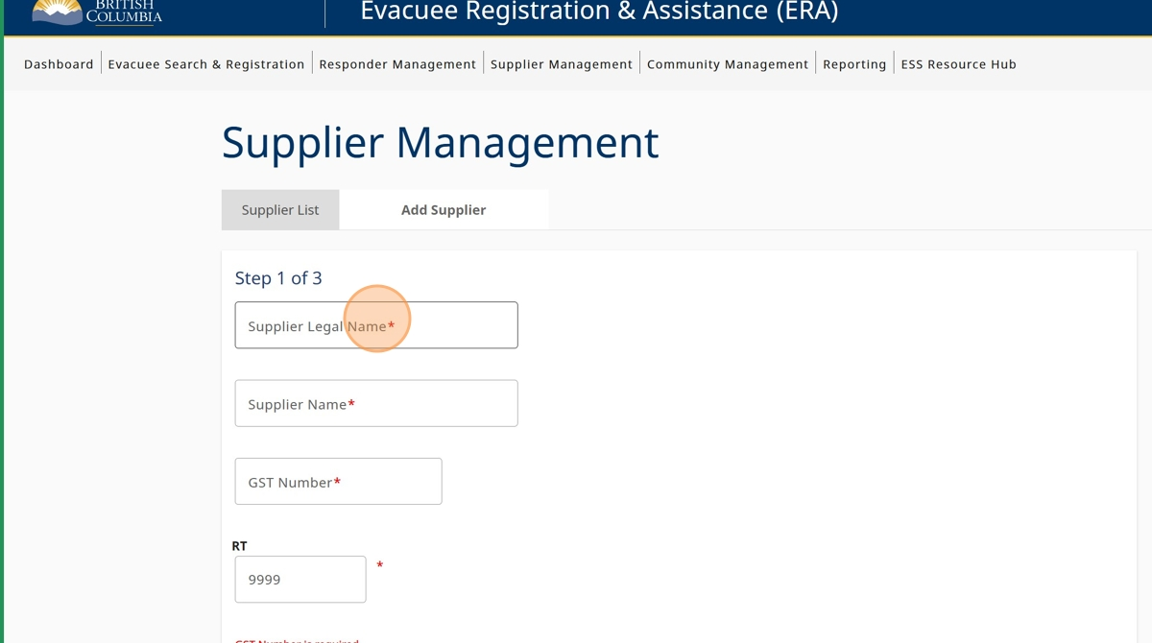

1. Enter the "Supplier Name"

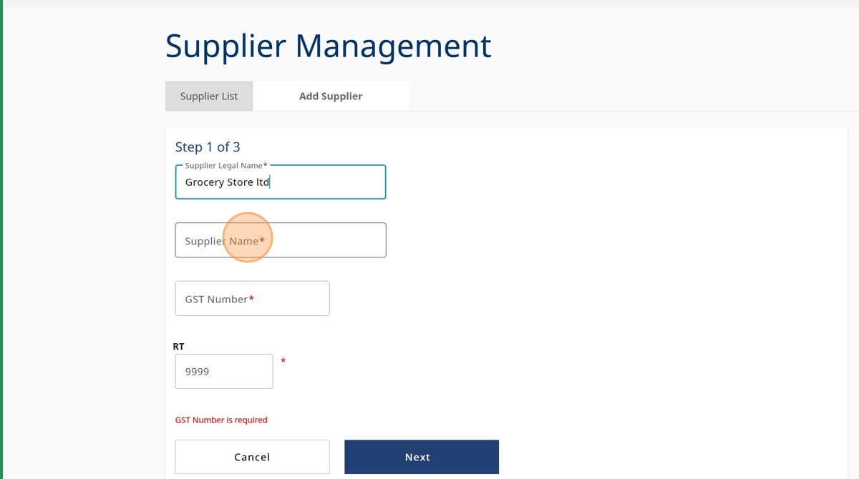

1. Enter the "GST Number" - If the supplier does not have a GST number contact emcr.ess@gov.bc.ca for further instructions

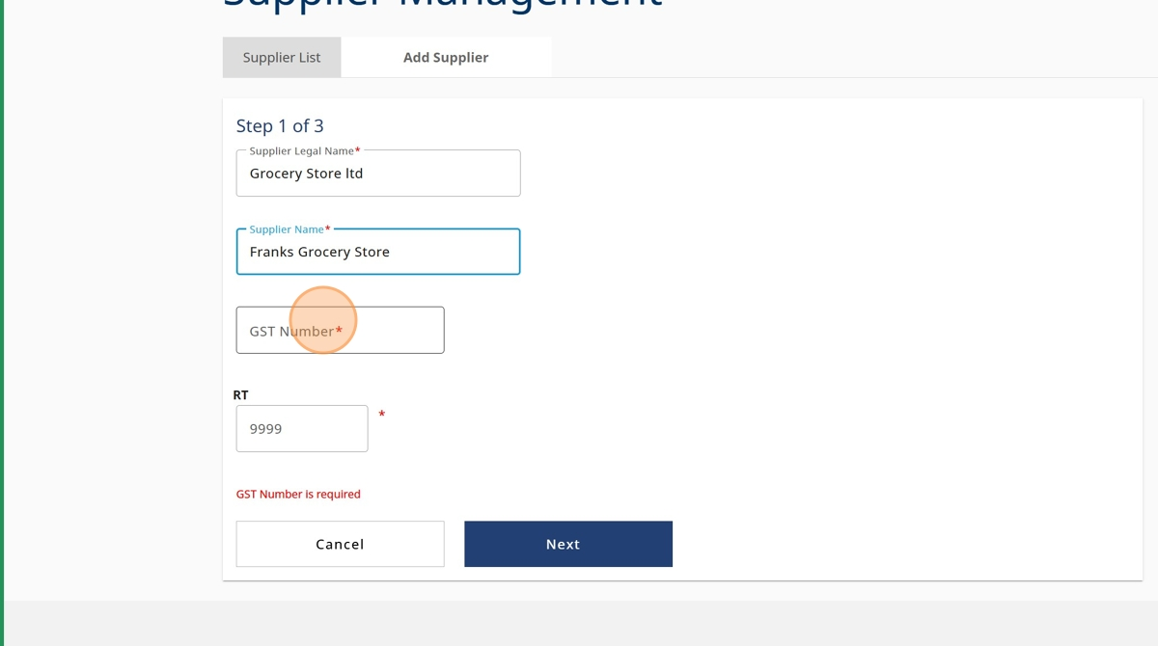

1. Enter the "RT Number" - If the supplier does not have a RT number contact emcr.ess@gov.bc.ca for further instructions

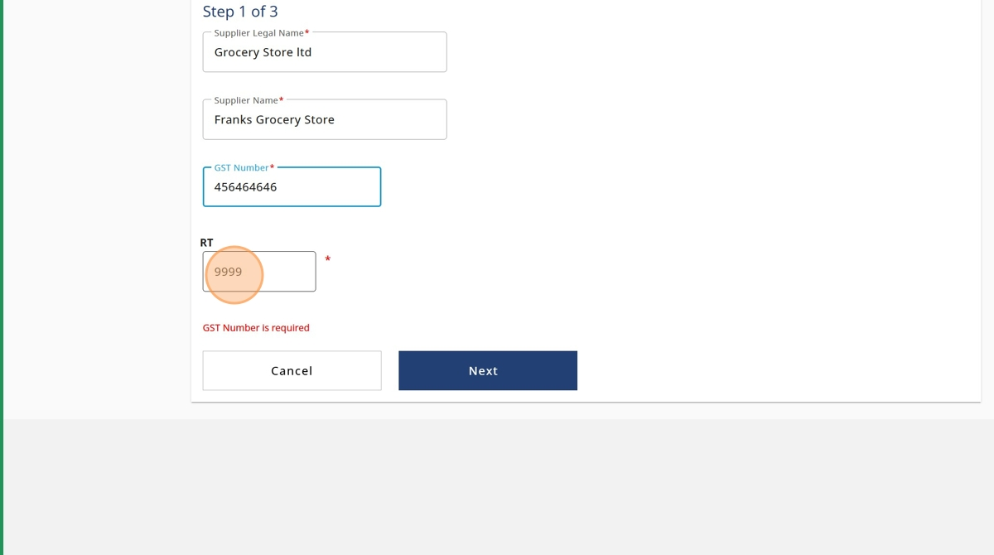

1. Click "Next"

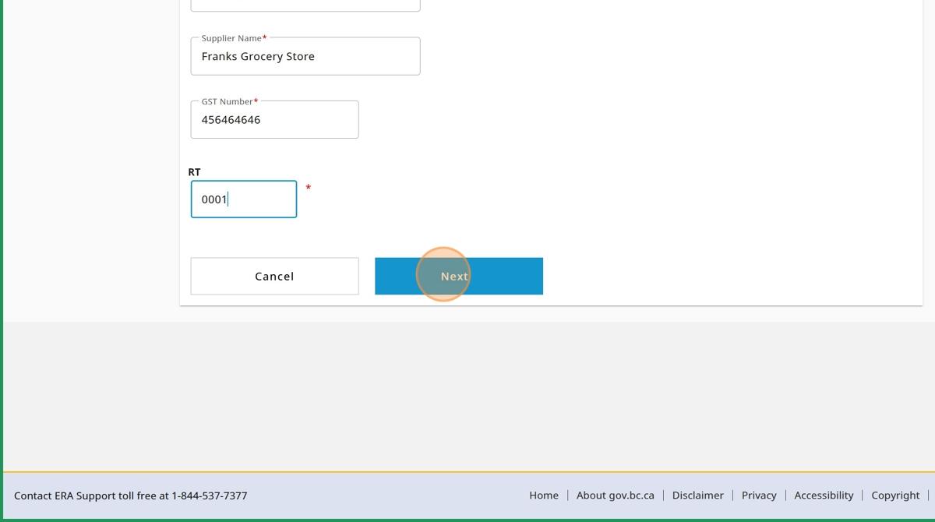

1. Enter the Address

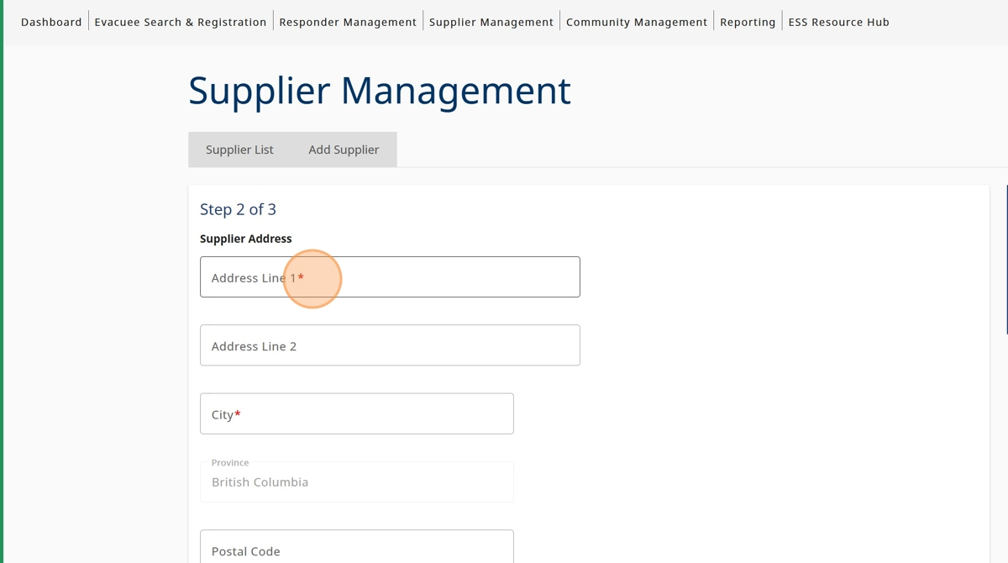

1. Click the "City" field.

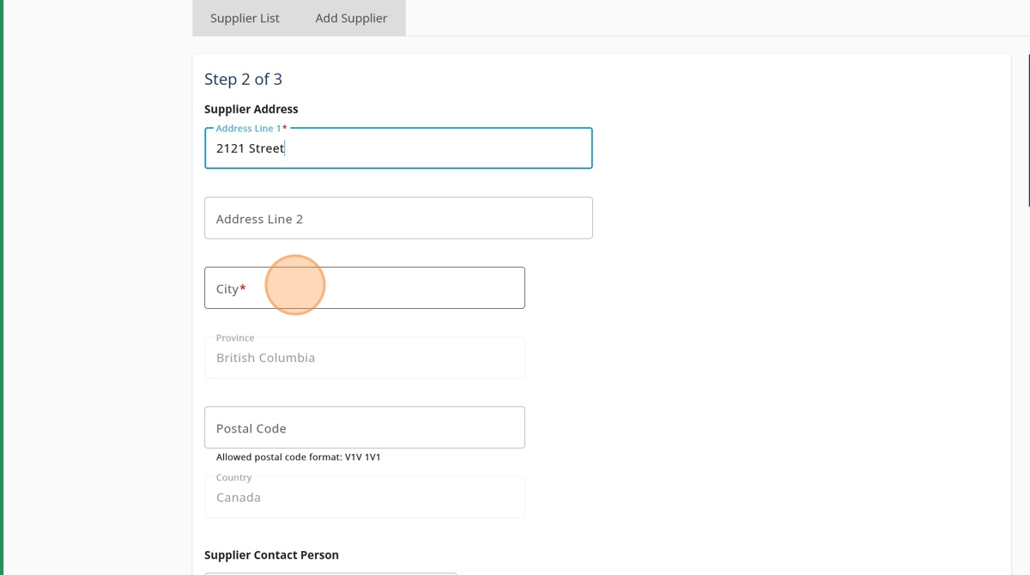

1. Search for the Suppliers City Address
2. Click on the appropriate drop down option

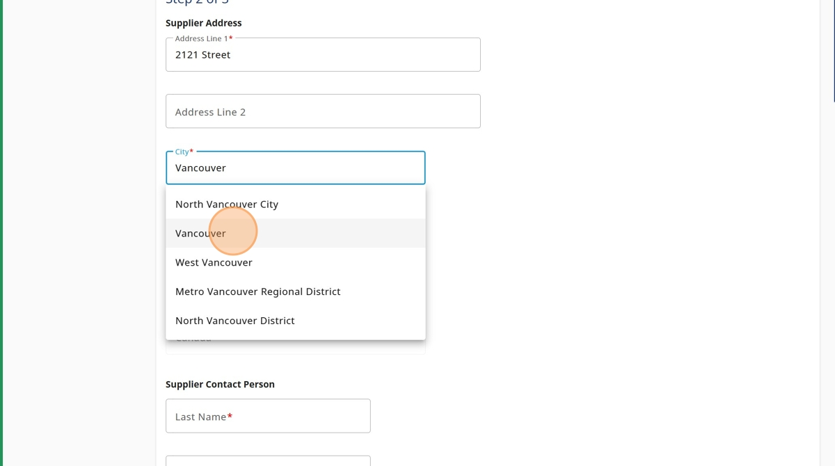

1. Enter the postal code

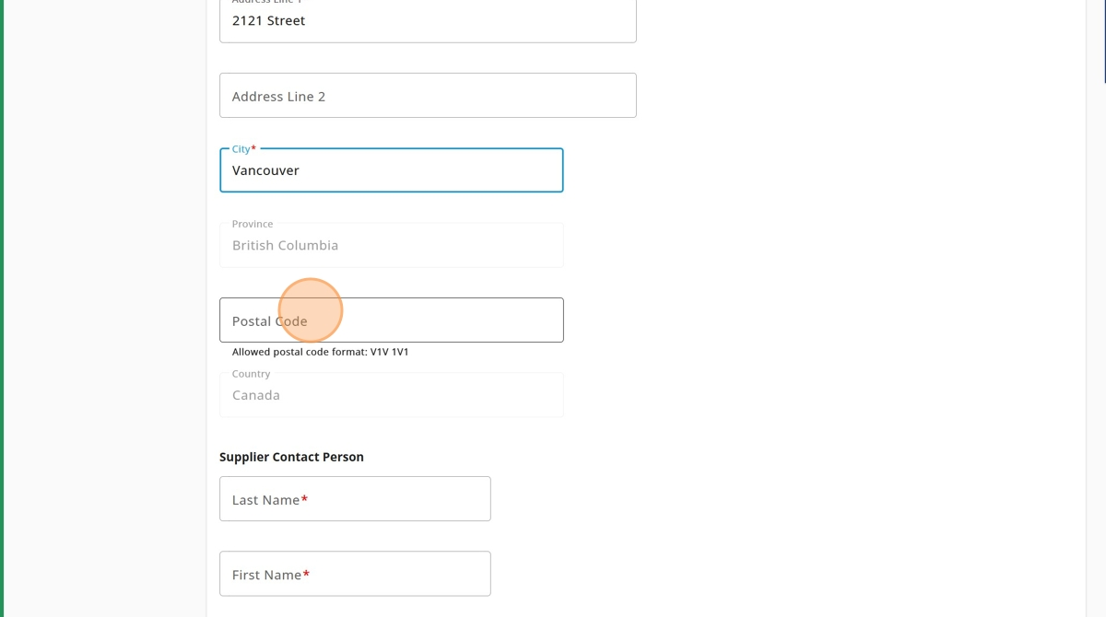

1. Enter the Supplier Contact Person Last Name

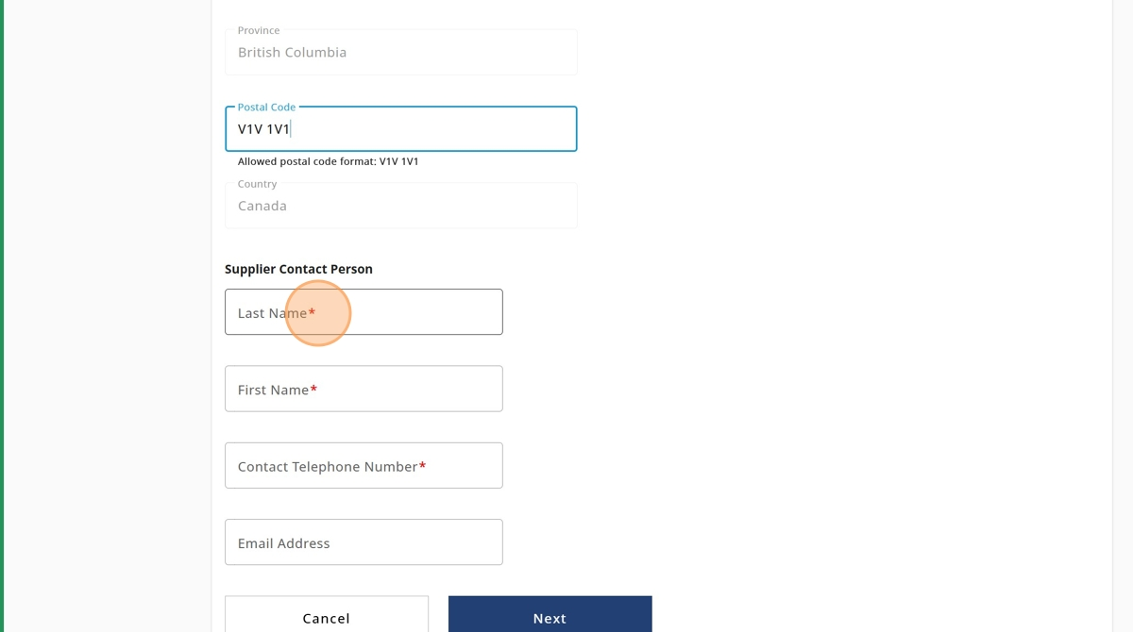

1. Enter the Supplier Contact Person First Name

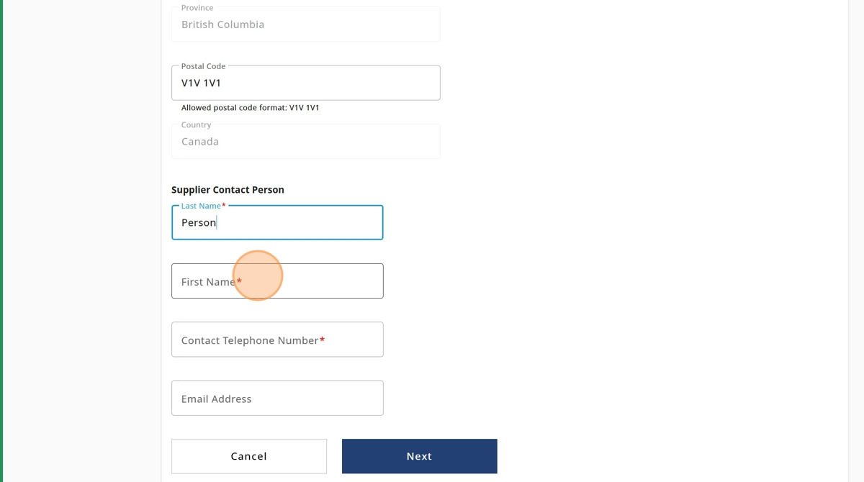

1. Enter the Supplier Contact Person Telephone Number

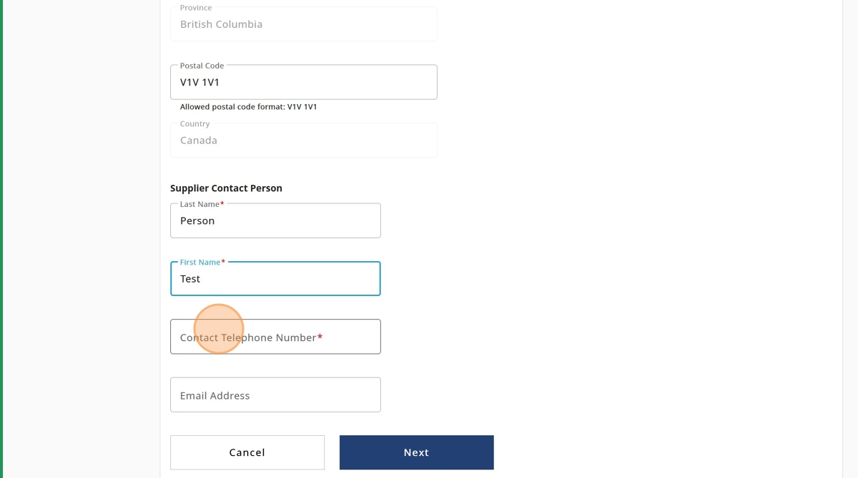

1. Click "Next"

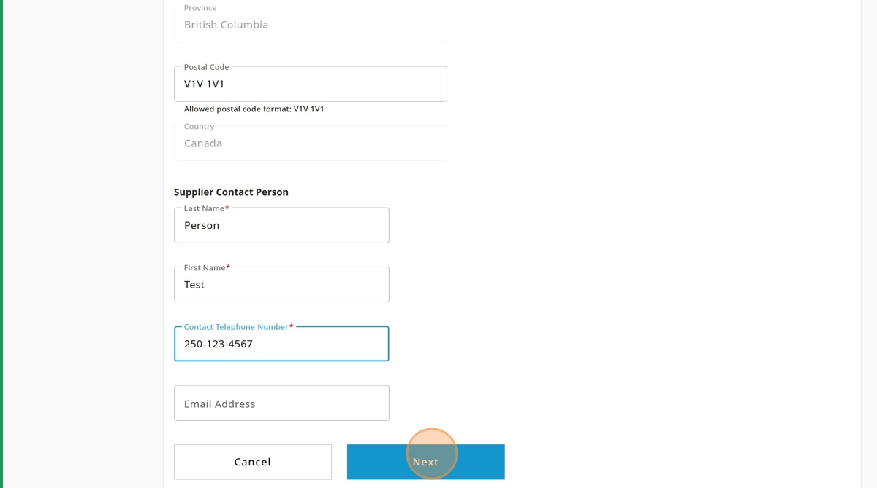

1. Click "Save Supplier".

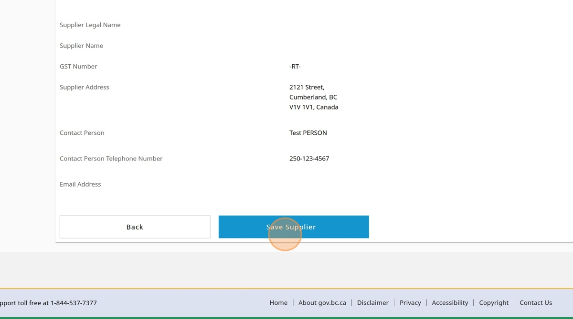

1. You will receive a pop up message notifying the Supplier was added, click "Close"

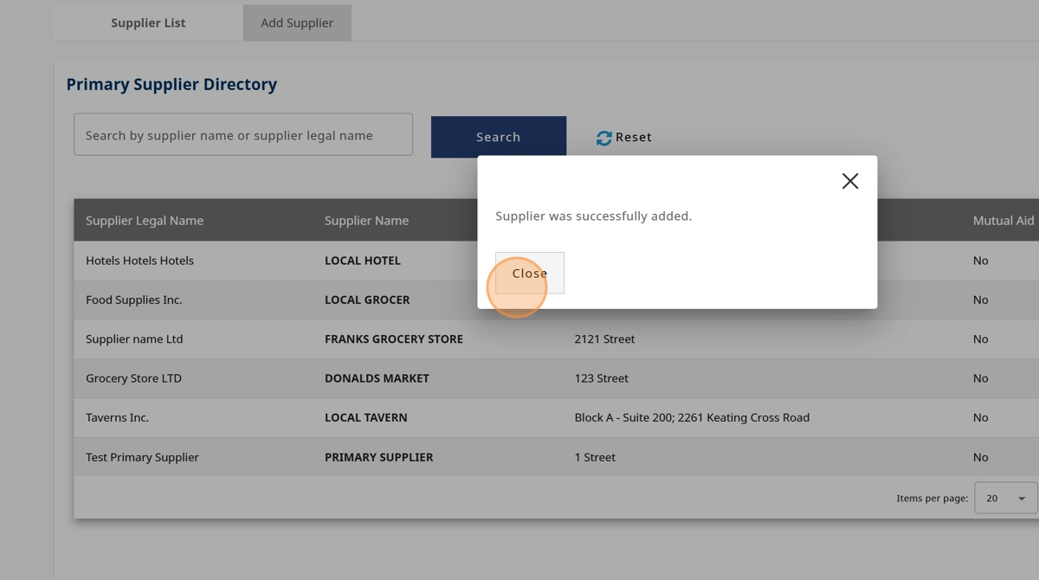

1. You will now see the Supplier you added under the "Primary Supplier Directory

