# ERA User Guide: Adding Responders under Responder Management

## This guide provides a straightforward process for adding responders to the Responder Dashboard, ensuring efficient team management.

1. Navigate to <https://ess.gov.bc.ca/>

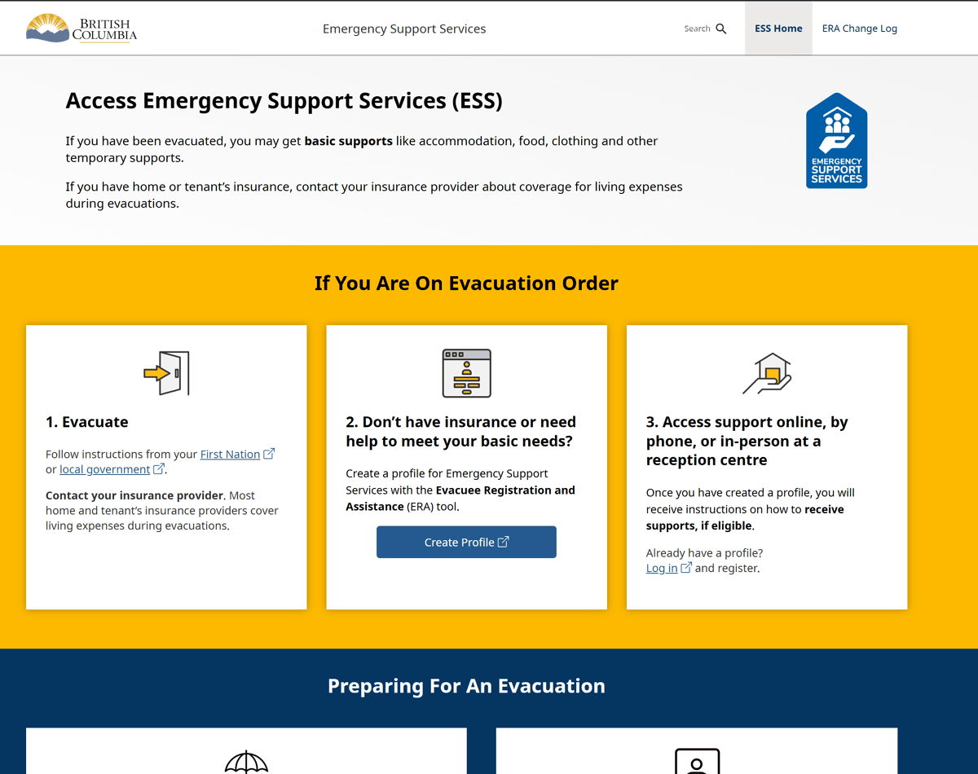

1. Scroll down and click "Responder Portal Login"

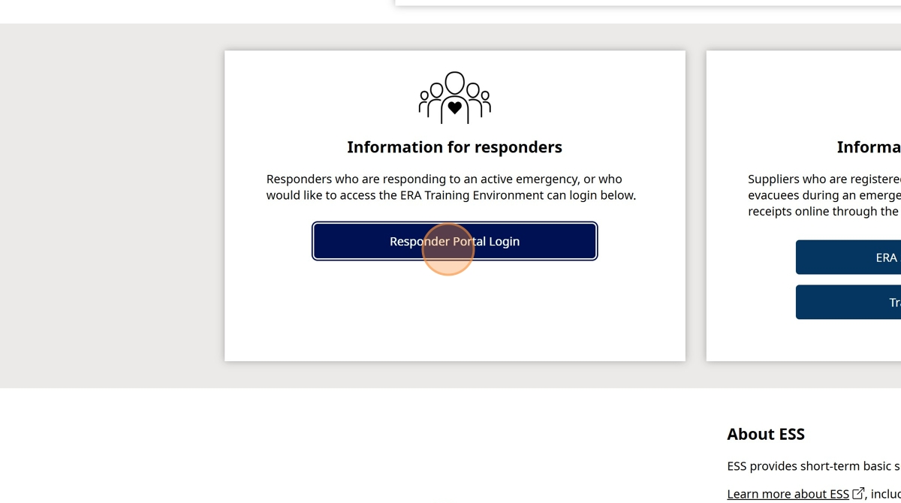

1. Click "Log in to Live"

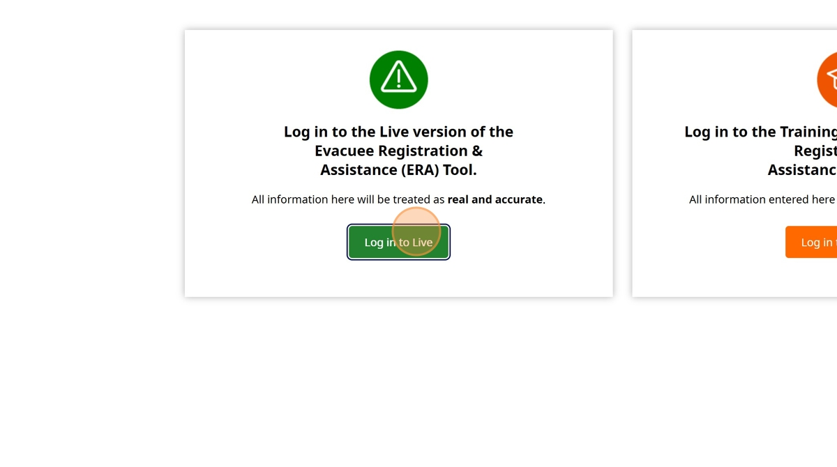

1. Enter your BCeID

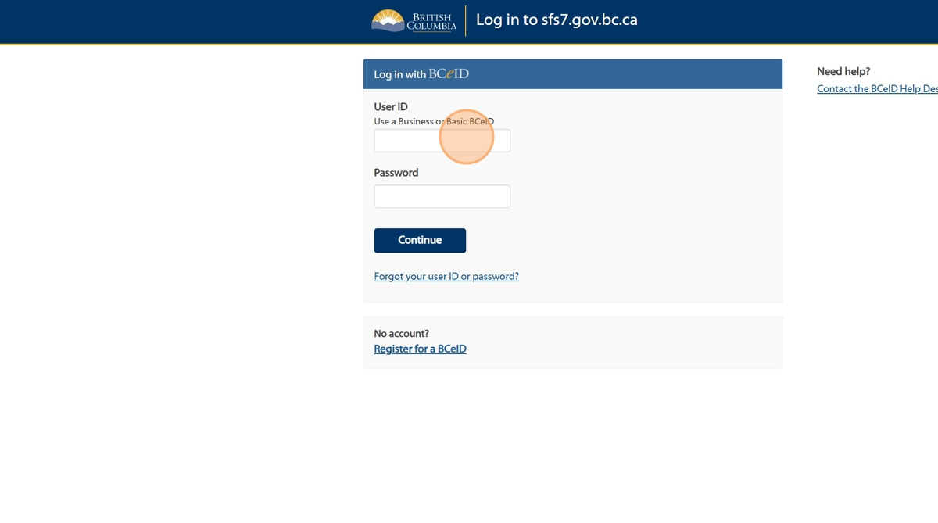

1. Enter your Password

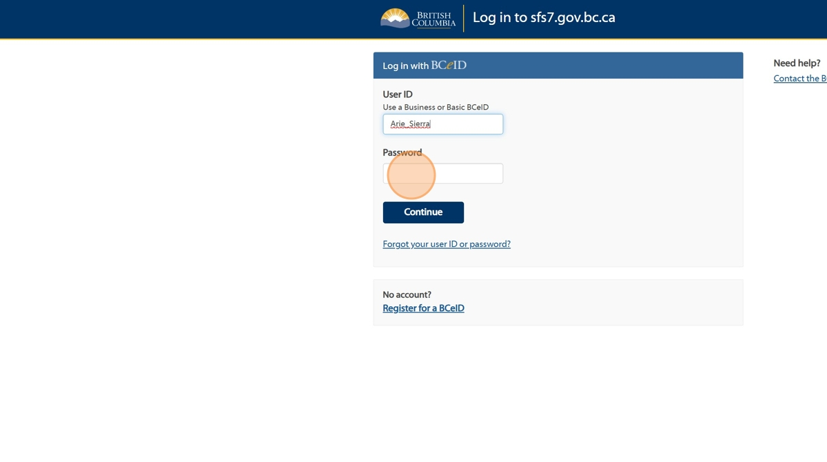

1. Click "Continue".

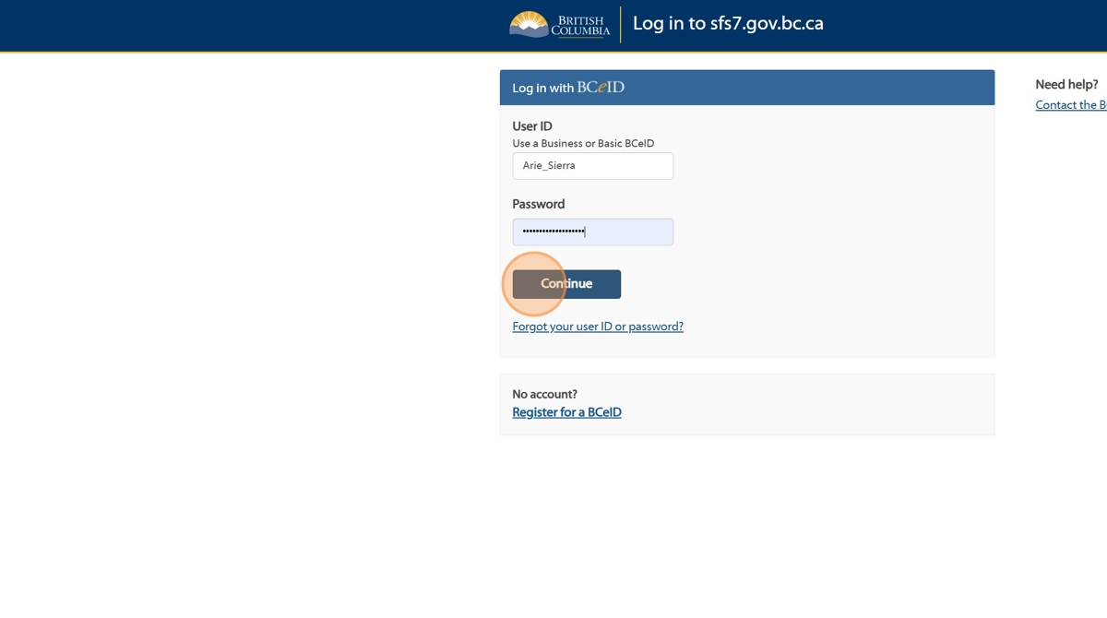

1. Click "Responder Management"

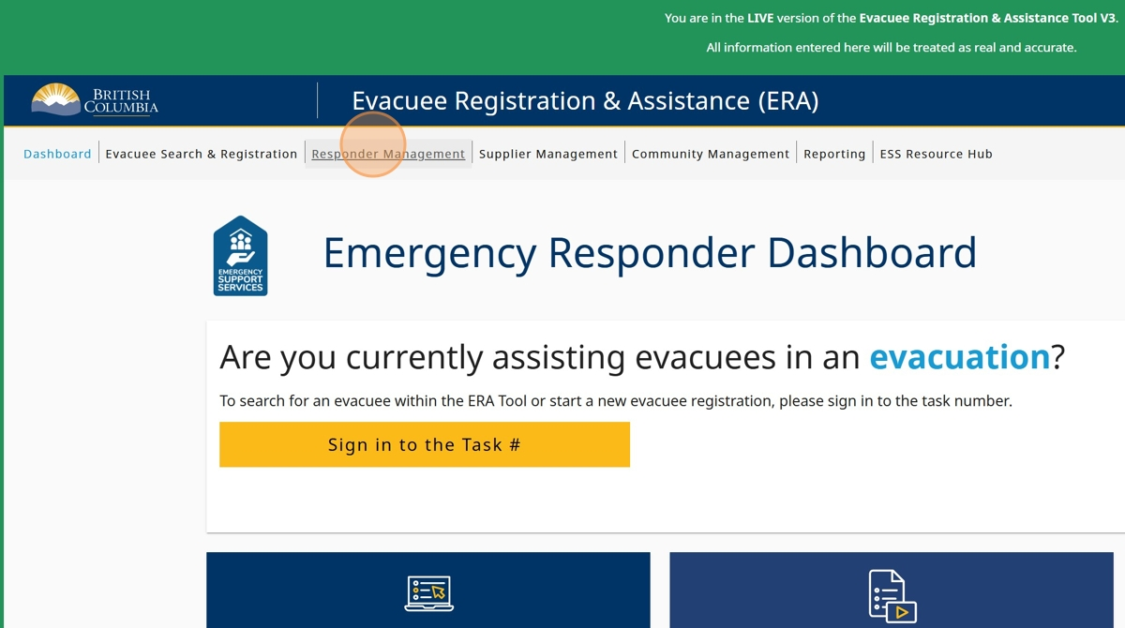

1. You will see a list of responders added to your ESS Team

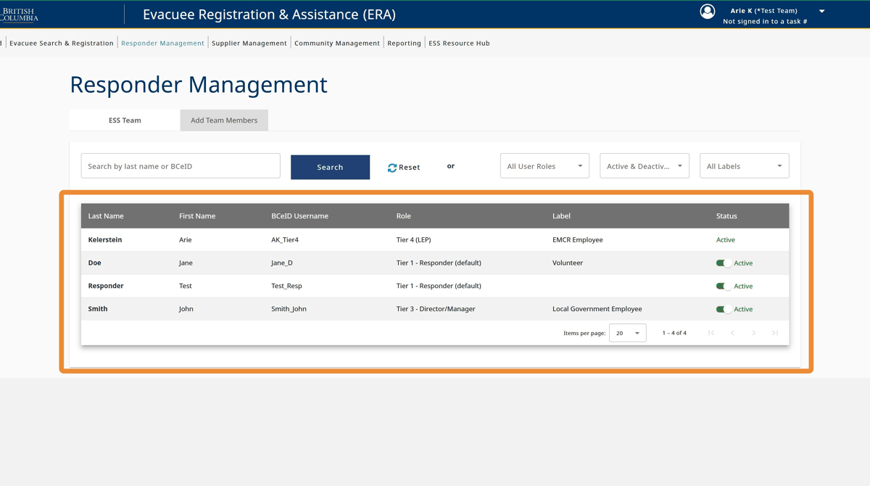

1. Click "Add Team Members"

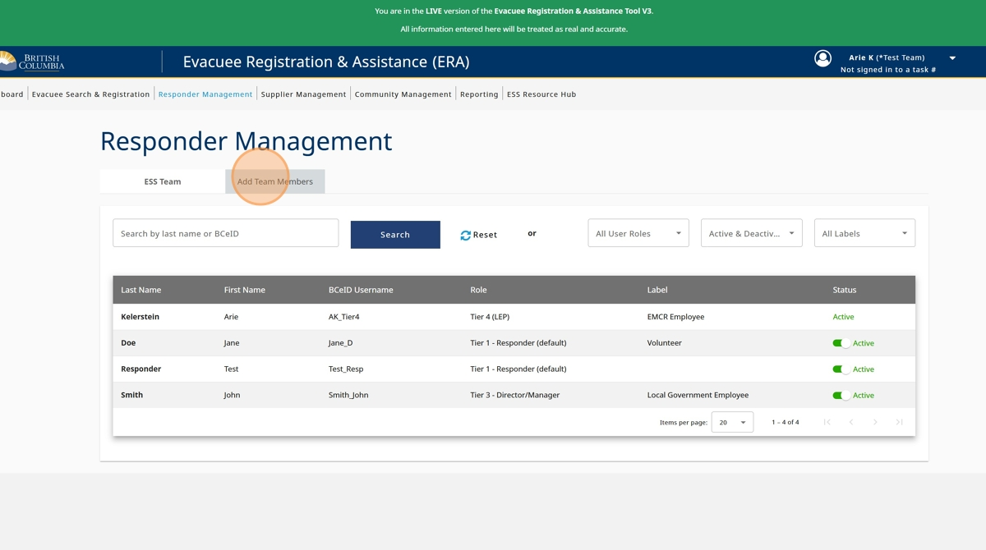

1. Click the "First Name" field and enter the responders first name

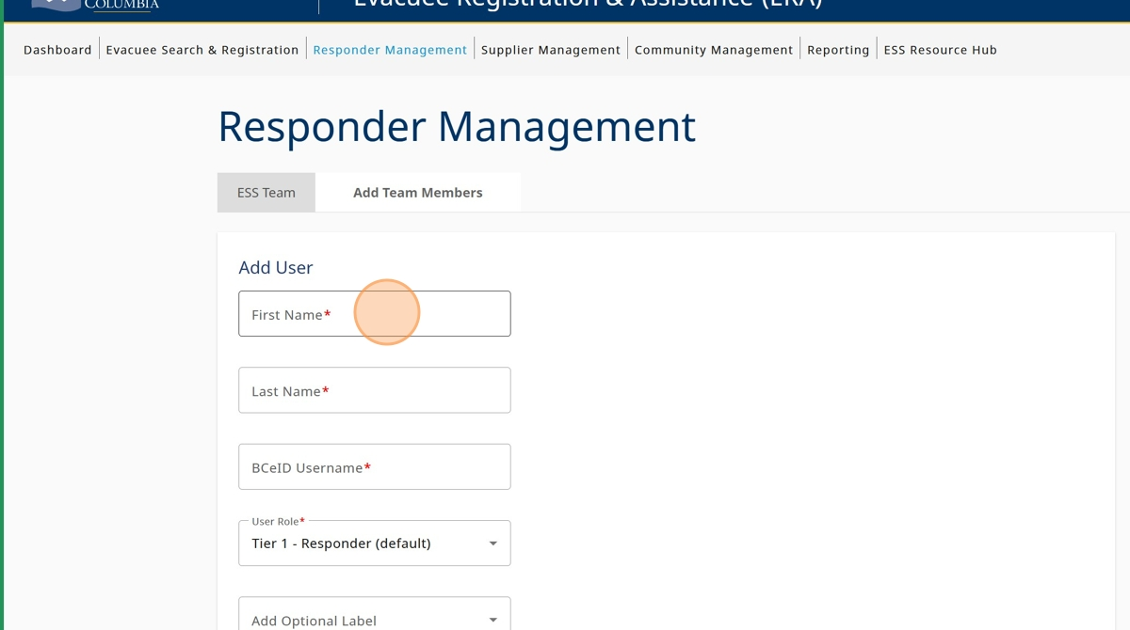

1. Click the "Last Name" field and enter the responders last name

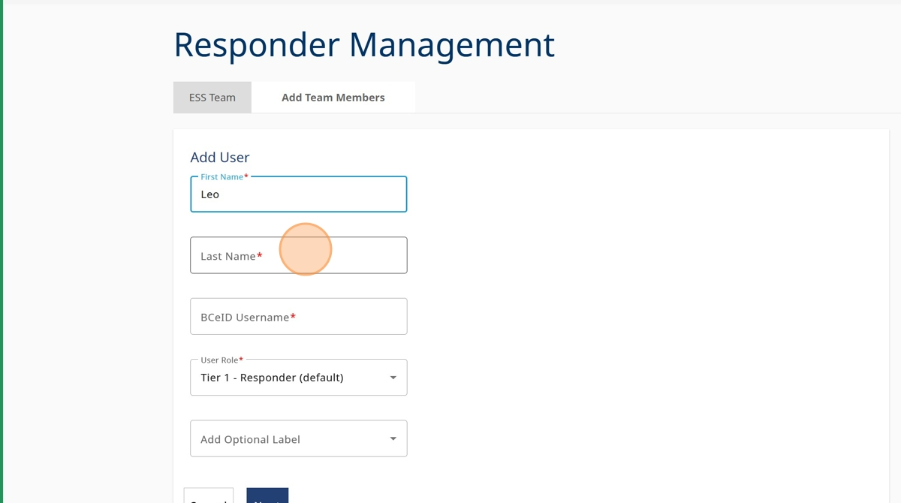

1. Click the "BCeID Username" field and enter the responders Basic or Business BCeID .

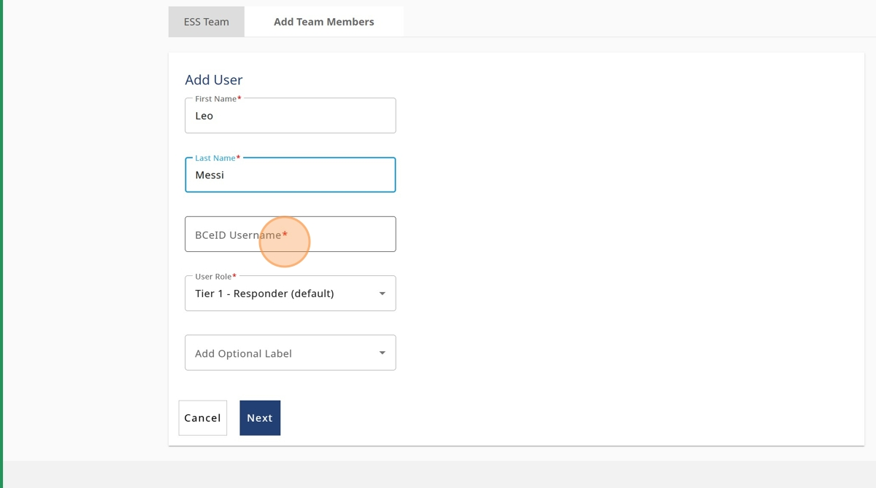

1. Click on the "User Role" field.

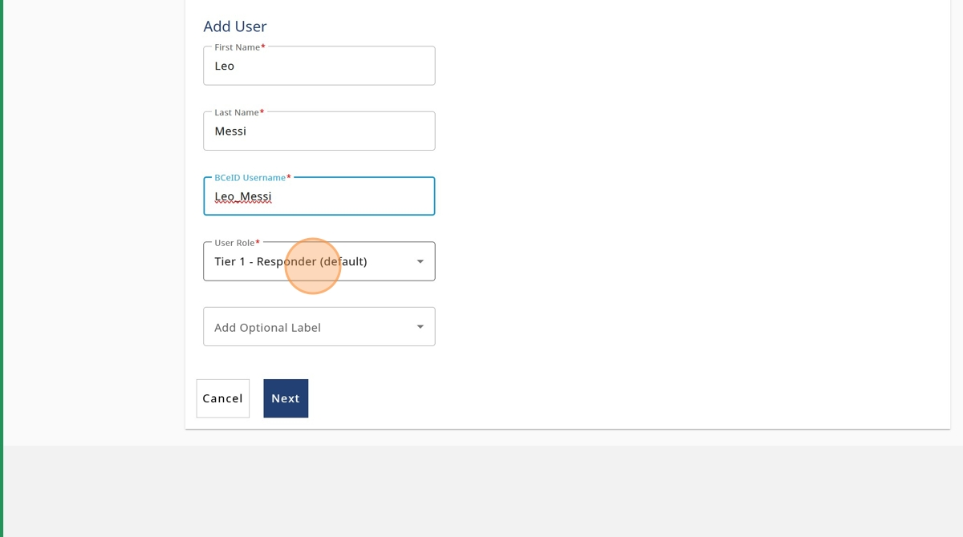

1. Select the appropriate User Role Tier Status

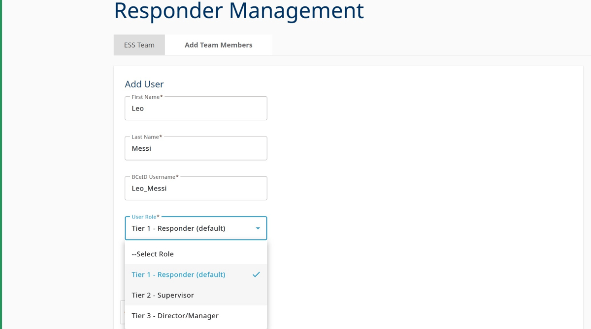

1. If needed, click on the "Add Optional Label" field.

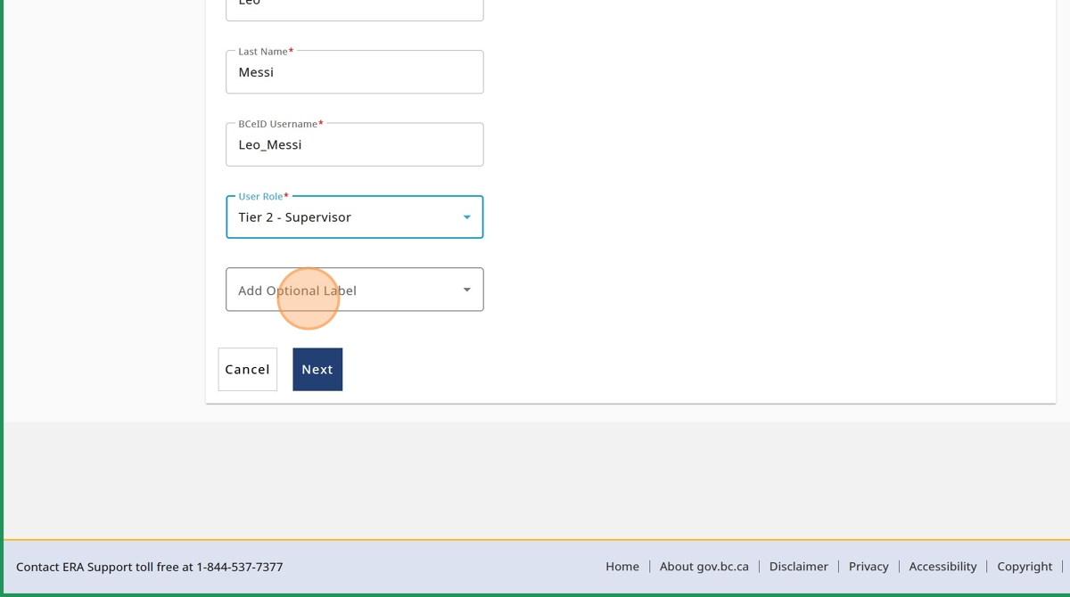

1. Select the appropriate label

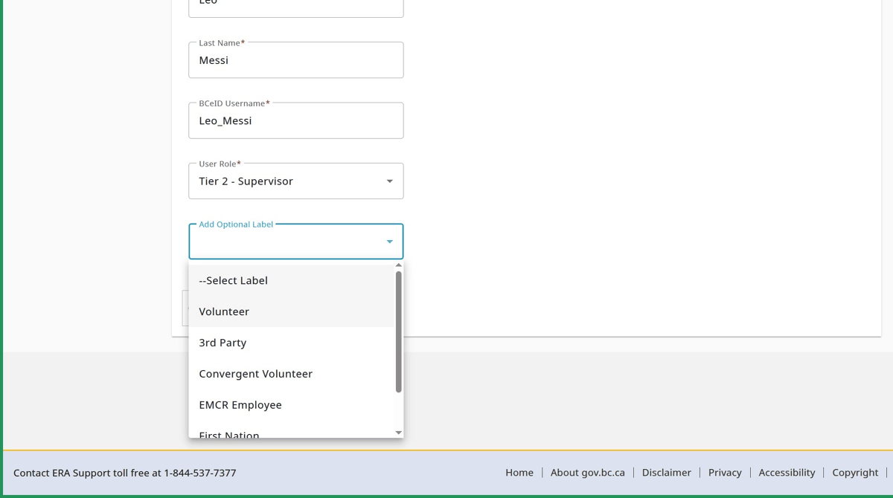

1. Click "Next"

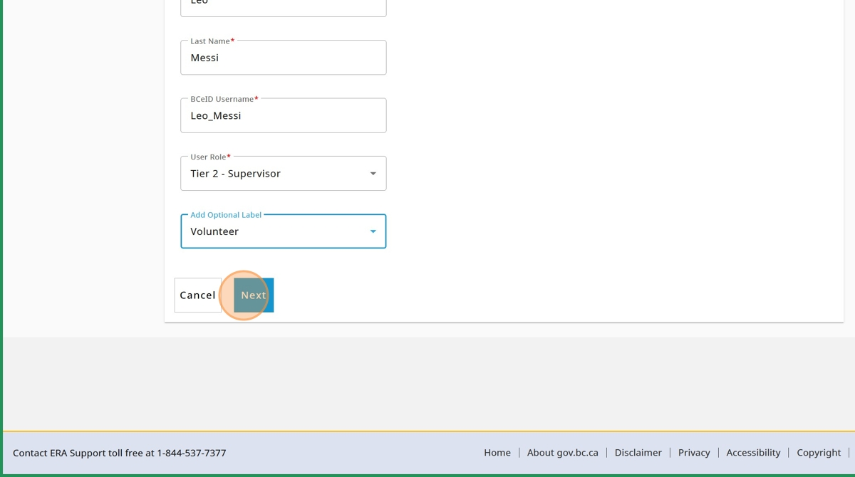

1. Click "Save"

